

West Midlands Clinical Senate

Assembly Event

28th November 2018
Coventry University

Post-Event Evaluation

(Jamila Hussain, Kiran Dhariwal, Angela Knight Jackson)

Finalised: 27/03/2019
Contents

1. Introduction 3
2. Aims and Objectives 3
3. Event planning Promotion / Communications 4
4. Attendance 4
5. Lessons Learned For Future Events/Recommendations 4
6. Post-Event Survey Evaluation 7
7.1 Appendix 1: Agenda 15
7.2 Appendix 2: Storyboard 17
7.3 Appendix 3: Save the Date Flyer 18
7.4 Appendix 4: Online Registration Form 19
7.5 Appendix 5: Event Banners 20
7.6 Appendix 6: Survey 21
7.7 Appendix 7: Survey Comments 23
7.8 Appendix 8: Photos 25

Introduction

West Midlands Clinical Senate Assembly Event
This West Midlands Clinical Senate Assembly Event focused on integrated care systems exploring shared responsibilities for population health, in practice and the implications this has for leadership skills and behaviours at all levels of the system [agenda can be found in Appendix 1].
This event was held on Wednesday 28th November 2018 (half a day) at Coventry University and was CPD accredited (3 points).
The event was targeted at:
- CCGs
- Sponsoring organisations
- Consultants
- Associate Specialist Doctors
- Current Senate Council and/or Assembly members
- Health and Social Care Professional, patients and the public interested in the work of the Clinical Senate
- Anyone interested in becoming members of the Assembly including clinicians, professionals from public health & social care, academic health and science networks, and leaders with responsibility for the delivery of STP programmes.

Aims and Objectives

Aims of the Event

- Provide an overview of the Clinical Review Process, led by Senate, and the mechanism for inputting into different stages of clinical model development
- Understand the value of sitting on a Clinical Review Panel
- Understand current developments taking place across integrated health and care services and systems
- Gather learning from the West Midlands and beyond, taken from research, evidence and working practices. Reflections obtained from researchers, system leaders and practitioners.
- Raise profile and promote the work of the West Midlands Clinical Senate, helping to increase the role for Senates in clinical reviews of STP led large scale service change.
- Event aims and objectives were developed via a storyboard [see Appendix 2]

Event planning Promotion / Communications

Event promotion was conducted with the help and support of the NHSE Communications Team. Details were circulated to all communications professionals working within CCGs and Trusts across the whole of the Midlands and East region. For the West Midlands, this amounted to approximately 160 individual contacts, representing 40 separate organisations [see ‘save the date’ in Appendix 3].

Delegates benefitted from online registration, allowing for quick and easy registration and tracking [Appendix 4].

Attendance

Council Members | 12
Presenters | 6
Other | 15
Total Attendance* | 33

* Not including West Midlands Clinical Senate employees (x5 delegates)

Lessons Learned For Future Events/Recommendations

Event Speakers/Presentations

- Most delegates commented positively about the quality of the presentations
- One of the aims of the event was to promote the West Midlands Clinical Senate
- IT - Microphones were made available during the second half of the event
- We were notified a few weeks before the event that one of the presenters was unable to attend.
- The Chair for this event was also presenting during the second half of the programme
- A comment from the evaluation requested more table-based discussions

Recommendations:

- Have a list of confirmed back-up speakers to provide cover for any cancellations
- Continue providing a variety of topics
- Ensure audio and visual equipment is ready before the event starts. Check that microphones are available and functional, conduct a sound check to ensure all delegates can hear. Have 2 microphones: 1 for the speaker, 1 for audience questions/the Chair.
- Ensure the Chair is not a presenter. The Chair’s role should be to facilitate, help the event run smoothly, and to encourage participation.
- Circulate the delegate list to all speakers prior to the event. This will help them pitch their presentations to the audience more effectively.
- Dedicate more presentation time on providing information and support on Assembly membership, associated roles and responsibilities, and the benefits of being a member.
- Incorporate table discussion for future events, this would allow delegates to interact during discussions.
- Distractions - ask the Chair to kindly remind the audience to turn any mobile devices to silent/vibrate during presentations

Marketing/Communications

The number of delegates that attended this event was reasonable. Out of the 33 delegates 15 were non-council members or presenters.

Recommendations:

- In order to attract a wider audience utilise social media (in particular, Twitter). Employ the use of hashtags to help anchor the event and keep it within people’s minds. West Midlands Communications Team can facilitate this.
- Promote on LinkedIn, especially useful when attempting to attract a professional audience. Share event information in relevant groups. Encourage speakers to promote on their pages. The West Midlands Communications Team is able to publish this on the National NHS England LinkedIn page (stating it is a West Midlands Event).
- Ask Communications Team to promote and announce speakers as they are confirmed to create interest

Event Venue

- Not all delegates were aware that parking passes were available
- In terms of the actual room, the temperature dropped during the event
- Lack of visual displays such as pull-up banners - this will help to make the event more professional and will provide a helpful background for social media photo opportunities.

Recommendations:

- Parking passes – notify delegates beforehand that parking passes will be available on the day. Ensure the Chair reminds delegates of this at the event’s start and close.
- Room temperature – speak to venue staff regarding adjusting room temperature, which may vary throughout the day.
- NHS England Events and Expo team owns a corporate NHSE exhibition stand, with a selection of interchangeable panels with generically branded designs. The stand is flexible and can fit within different spaces. If the Clinical Senate wishes to display specific messaging on the stand to advertise our work, the team can help us design and order new panels with the approved exhibition stand supplier.
- The events and expo team (england.nhsevents@nhs.net) also own a number of corporate NHSE pull- up banners which can be used for smaller events. The Clinical Senate can request banners with messaging specific for our event, the team can forward us to a preferred supplier who can produce the banners at a substantial discount [Appendix 5].

POST- EVENT

Aims and Objectives

Aims and objectives for the event were met. This was evidenced by the feedback survey which showed an increased awareness of the Clinical Senate and its current developments, as well as having raised the profile of the work that the Clinical Senate is conducting.

Post-Event Survey Evaluation

Evaluation Methods

Delegates were asked to complete a short survey at the end of the event.

The survey contained 13 questions encompassing 9 rating scales and 4 open ended questions [see Appendix 6]. Delegates were also encouraged to provide comments for each presentation. This mixture provided a useful balance of quantitative and qualitative data.

The following rating scale was utilised:

1
2
3
4
5
Not directly relevant in current post but of interest
Not useful
Fairly useful
Useful
Extremely useful

A follow up email, containing a digital version of the survey, was circulated a few days after to capture those who did not have a chance to complete and return their evaluations on the day.

Survey Analysis: Quantitative Data

17 completed surveys were returned (16 on the day, 1 from the follow-up email). The event attracted 33 delegates in total, resulting in a 52% response rate.

Figure 1, on the next page, shows the following information:

- The individual tallied scores for each presentation (a graph displaying this information can be found on page 10)
- The aggregated score for each presentation (a graph can be found on page 11)
- The number of responses e.g. presentation 1 received 16 responses from a possible total of 33 delegates

Figure 1: Combined Scores for Each Presentation

Presentations |  |  |  |  |  | Combined Score | Total Responses
Presentation 6: An overview of the work of the West Midlands Clinical Senate |  |  |  |  |  | 72
Blank | 1 | 2 | 3 | 4 | 5 | 72 | 17
0 | 0 | 0 | 1 | 11 | 5 | 72
Presentation 7: Local Exemplar  Stage 2 Clinical Review - Shropshire Future Fit |  |  |  |  |  | 71 | 17
Blank | 1 | 2 | 3 | 4 | 5 | 71
0 | 0 | 1 | 2 | 7 | 7 | 71
Presentation 1: Clinical Leaders Shaping STP and ICS |  |  |  |  |  | 67
Blank | 1 | 2 | 3 | 4 | 5 | 67 | 16
1 | 0 | 0 | 1 | 11 | 4 | 67
Presentation 2: Integrated Primary Care Teams working together in partnership with internal and external services to provide patient-centred care  The role of GP’s and Community Nursing |  |  |  |  |  | 67 | 16
Blank | 1 | 2 | 3 | 4 | 5 | 67
1 | 0 | 0 | 1 | 11 | 4 | 67
Presentation 3: How Local Authorities are supporting and working with Integrated Care Services. |  |  |  |  |  | 66 | 16
Blank | 1 | 2 | 3 | 4 | 5 | 66
1 | 0 | 0 | 1 | 12 | 3 | 66
Presentation 4: Coventry University Simulation |  |  |  |  |  | 62
Blank | 1 | 2 | 3 | 4 | 5 | 62 | 16
1 | 0 | 3 | 1 | 7 | 5 | 62
Presentation 5: West Midlands Academic Health Science Network  Benefits to integrating care that have come out of the 100,000 Genome Project and the RAIDPlus testbed |  |  |  |  |  | 53 | 15
Blank | 1 | 2 | 3 | 4 | 5 | 53
2 | 1 | 1 | 5 | 5 | 3 | 53
Presentation 8: Innovation in Care Homes |  |  |  |  |  | 52 | 14
Blank | 1 | 2 | 3 | 4 | 5 | 52 | 14
3 | 1 | 0 | 4 | 6 | 3 | 52 | 14
The following can be denoted from figure 1:

- Presentation 6 was the highest scoring presentation, closely followed by presentation 7

- Presentation 7 received the most ‘5’ ratings

- Both presentation 8 and presentation 5 received a '1' rating, indicating their sessions lacked relevance, but were still of some interest.

- Only two presentations received scores from all 17 responders, either due to responders missing certain presentations or human error. These gaps are denoted in the ‘blank’ column. Only presentations 6 & 7 received scores from all 17 responders.

Along with the individual presentations, delegates were also asked to rate the overall event. The results can be found below:
Overall Event |  |  |  |  |  | Combined Score | Total Responses
How useful did you find this event (overall)? |  |  |  |  |  | 57 | 13
Blank | 1 | 2 | 3 | 4 | 5 | 57 | 13
4 | 0 | 0 | 0 | 8 | 5 | 57 | 13

Individual Presentation Scoring Breakdown: Pulled from Figure 1

Survey Analysis: Qualitative Data

- The survey provided space for feedback to be left for each presentation. A dearth amount of comments was noted with either 1 or 2 received for each presentation [see Appendix 7 for the full list of comments].

Comments pertaining to the event overall were more fruitful:

What were the best and/or worst aspects of this event? | What impact will this event have on your future practice? | To what extent did the presenters provide a balance (evidence based where possible) view of the topics? | Any comments regarding the event overall?
12 | 10 | 6 | 9

All of the received comments [see Appendix 7 for full list] were generally positive, particularly those which related to the event in general.

The main themes identified were:

The broad spectrum of topics covered

- “Wide variety of topics covered. Both positive experiences and challenges for integration”
- “A good variety of speeches”
- “Good time keeping. Good variety of speakers across the range of professions represented”
- “Excellent multidisciplinary representation”
- “Excellent programme”

Praise of the organisation of the event

- “Best - everything on time - with a monitor controlling speeches”
- “Good venue. Well organised”
- “Good event. Well presented. Good tea/coffee and food”
- “Very useful and enjoyable. Excellent venue. Thank you for inviting me”

Increased awareness of the topics presented

- “Makes one think about different aspects of healthcare”
- “Good topics - especially the use of digital innovations. Has made me think about future projects applicable to my service”
- “Has been thought provoking. All talks broadened my understanding of challenges within the NHS”
- “Now more aware of the various groups to contact in the future”
- “Will take back some ideas into practice”
- “Very enlightening event”
Key words, pulled from the full list of comments, have been transformed into a word cloud on the following page. The sizes relate to how frequently each word was mentioned within the comments.

Three main areas stood out which can help improve future events:

- Providing more information and support on assembly membership, roles and responsibilities, support, benefits of being a member, future training needs.
- Carving out time for table work/discussion
- Improving the sound quality of presenters and those involved in Q&A sessions (including audience members).

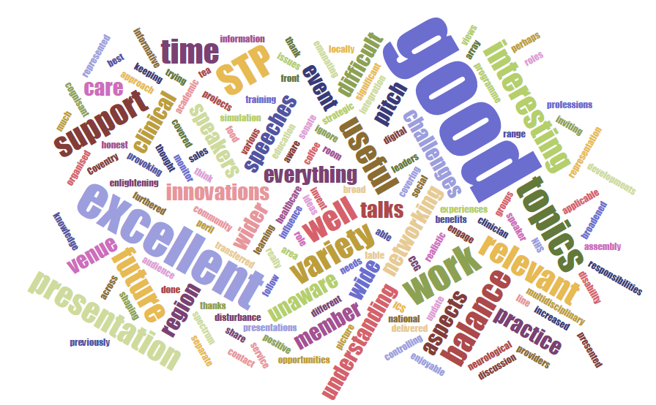
Word cloud pulled from survey comments:



Appendix 1: Agenda

Clinical Senate Assembly Event

Developing Integrated Health and Care Services and Systems:
Learning from the West Midlands and More Widely

28th November 2018 09.00 to 13.00 hours

Coventry University Technology Park, Puma Way, Coventry, CV1 2TT

Agenda

'West Midlands Clinical Senate Assembly Event' has been approved by the Federation of the Royal Colleges of Physicians of the United Kingdom for 3 category 1 (external) CPD credit(s).

Timings | Item(s) | Presented by
9:00 | Arrival and Refreshments
9:30 | Welcome, Introduction | Professor Adrian Williams  Professor of Neurology  Chair Neurosciences NNAG/CRG & WMids Senate
9:40 | Clinical Leaders Shaping STP and ICS | Dr Helen Hibbs  Chief Officer Wolverhampton CCG and Black Country STP SRO
09:55 | Integrated Primary Care Teams working together in partnership with internal and external services to provide patient-centred care.  The role of GP’s and Community Nursing | Dr. Will Taylor  Clinical Director, Integration - Birmingham and Solihull CCG  GP Partner - Lordswood Surgery, a member of “Our Health Partnership”
10:10 | How Local Authorities are supporting and working with Integrated Care Services. | Peter Fahy  Local Authority  Director of Adult Services  Coventry City Council
10.25 | Coventry University Simulation | Dr Natasha Taylor  Principal Lecturer and Lead for Simulation  Faculty of Health and Life Sciences  Coventry University

10:40 | Panel Q&A
11:00 | Break & Networking
11:30 | West Midlands Academic Health Science Network  Benefits to integrating care that have come out of the 100,000 Genome Project and the RAIDPlus testbed | Dr Peter Lewis  Consultant Psychiatrist  Associate Director for Innovation BSMHFT;  MH Clinical lead West Midlands Academic Health Science Network  Sean James  Genomics Ambassador  West Midlands Academic Health Science Network
11:50 | An overview of the work of the West Midlands Clinical Senate | Professor Adrian Williams  Professor of Neurology  Chair Neurosciences NNAG/CRG & WMids Senate
12:00 | Local Exemplar  Stage 2 Clinical Review - Shropshire Future Fit | Debbie Vogler  Associate Director  NHS Future Fit Programme
12.15 | Innovation in Care Homes | Anthony Billingham  The Carlton Care Group
12:30 | Panel Q&A
12:50 | Summary & Close | Professor Adrian Williams  Professor of Neurology  Chair Neurosciences NNAG/CRG & WMids Senate
13:00 | LUNCH & Networking | All

Electronic copies of the presentations will be circulated after the event

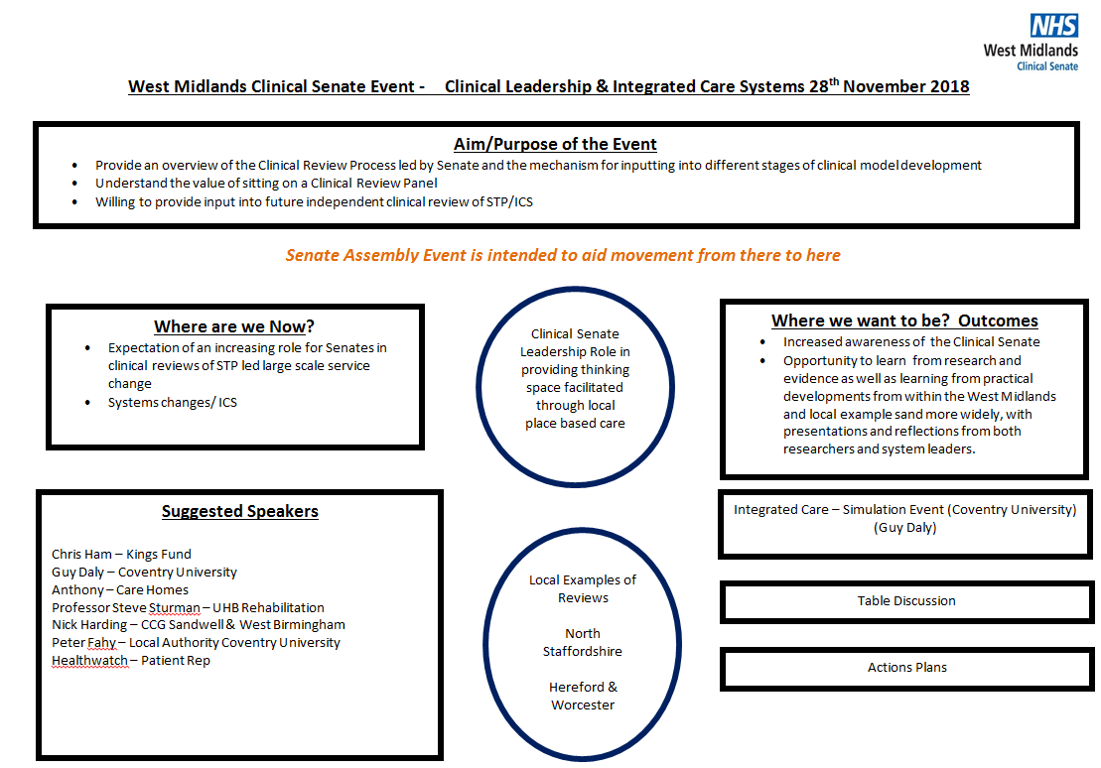

7.2 Appendix 2: Storyboard

Appendix 3: Save the Date Flyer

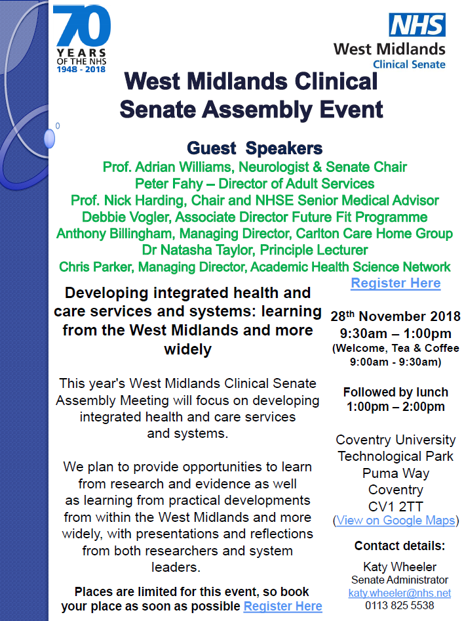

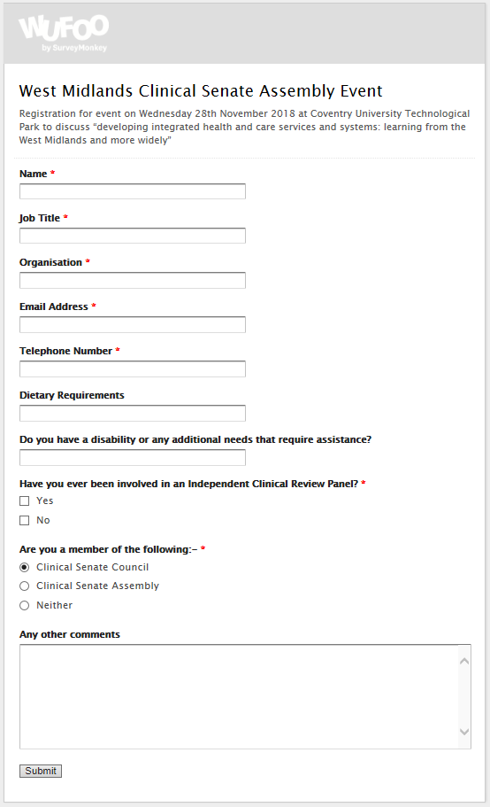

Appendix 4: Online Registration Form

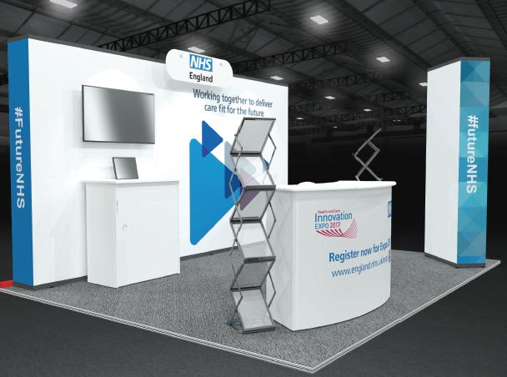
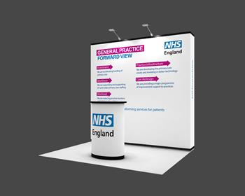
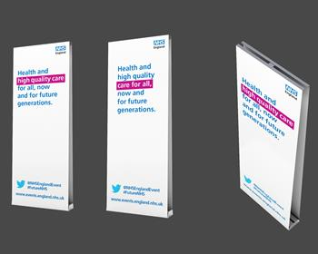

Appendix 5: Event Banners
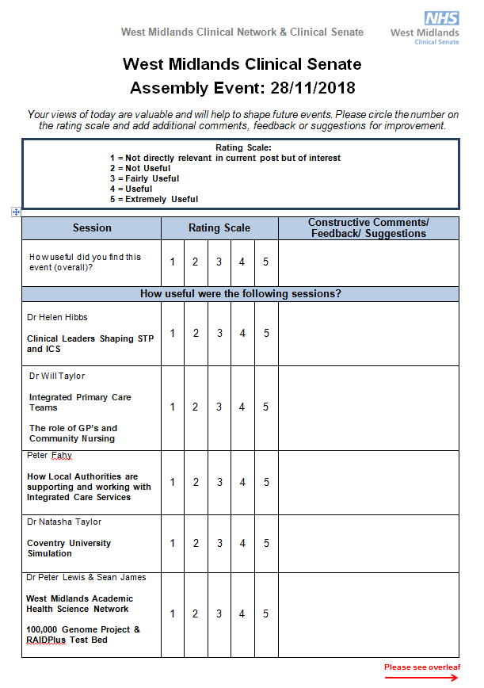

Appendix 6: Survey
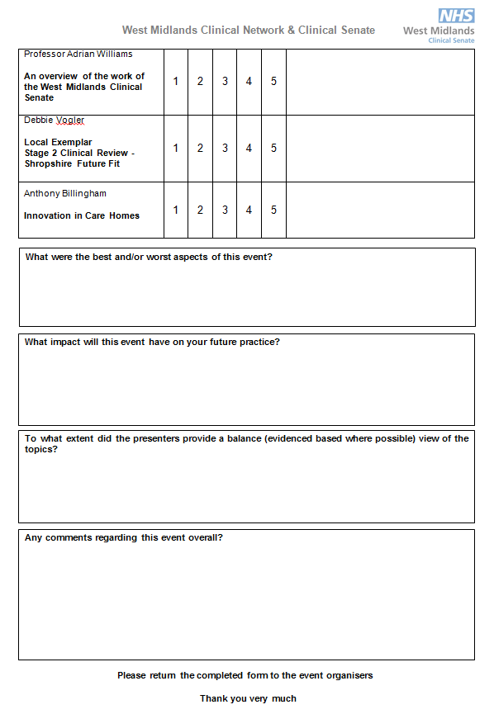

Appendix 7: Survey Comments

How useful did you find this event (overall)?
As a non-academic/clinician I was able to follow all of the presentations
Interesting topics and innovations
Dr Helen Hibbs
Very relevant to the region
Dr Will Taylor
Good to hear from front line
Peter Fahy
We ignore the issues emanating from the social care at our peril. Good presentation.
Dr Natasha Taylor
Interesting approach being delivered by Coventry
Dr Peter Lewis & Sean James
A little over my head, but none the less interesting and useful
Prof Adrian Williams
If it wasn't there you would have to invent something else! Good
Debbie Vogler
Honest, realistic presentation
Anthony Billingham
Excellent
Useful update, but a little too much 'sales pitch'.
What were the best and/or worst aspects of this event?
Best - everything on time - with a monitor controlling speeches
Wide variety of topics covered. Both positive experiences and challenges for integration
Having the national picture of ICS and STPs
Good topics - especially the use of digital innovations. Has made me think about future projects applicable to my service
Difficult to hear everything due to disturbance within the room
As a speaker, being unaware of the audience made it difficult to pitch my presentation
Good time keeping. Good variety of speakers across the range of professions represented
Clinical leaders and shaping of STP. Simulation work is education and learning
All relevant
A good variety of speeches
Excellent multidisciplinary representation
Networking
What impact will this event have on your future practice?
Now more aware of the various groups to contact in the future
Makes one think about different aspects of healthcare
Support me in my role in the clinical senate
Has been thought provoking. All talks broadened my understanding of challenges within the NHS
Trying to be more cognisant of wider strategic developments within my region that I was previously unaware of
Furthered my understanding of the work of CCGs/STPs locally and aspects which could be transferred to my area of work
Engage with STP - neurological disability and community care
Will share wider
Will take back some ideas into practice
Increased knowledge to influence practice
To what extent did the presenters provide a balance (evidence based where possible) view of the topics?
Excellent speakers covering wide array of relevant topics. Thanks.
Good balance
Good balance of views from across the spectrum of providers
Very much so
Significant and broad
Good balance
Any comments regarding the event overall?
Good event. Well presented. Good tea/coffee and food
Very enlightening event
More information and support on: assembly member, roles and responsibilities, support, benefits of being a member, future training needs
Very useful and enjoyable. Excellent venue. Thank you for inviting me.
Excellent programme
Really informative. Excellent networking opportunities
Perhaps too many separate talks, would be good to have more time for table work/discussion
Well done!
Good venue. Well organised

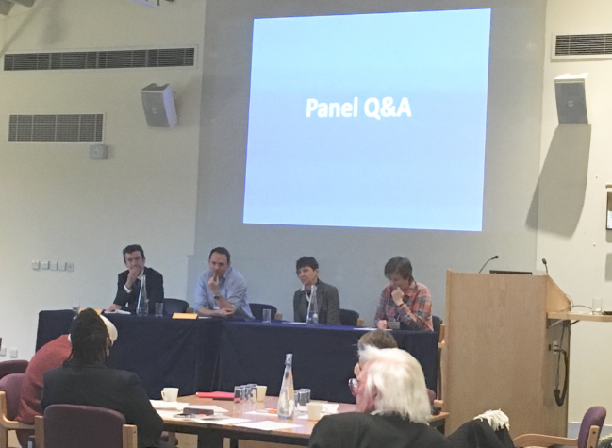
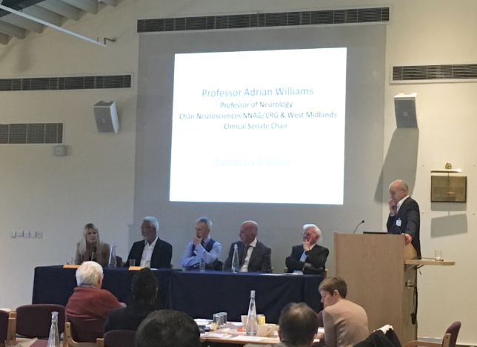
Appendix 8: Photos

