

Post Event Pack

East Midlands Clinical Senate
Assembly Event

Held on Monday 25th November 2019
College Court Conference Centre, Knighton Road, Leicester



5th December 2019

Dear Colleague
Thank you for attending our recent Clinical Senate Assembly Event. Our theme this year provided members with an opportunity to hear about digital and innovation and good practice within the NHS, and particularly examples from across our region.
We were also fortunate to hear from two sponsoring organisations who offered their perspectives on the Clinical Senate’s clinical review process. Understanding these views is incredibly important to us, as Clinical Senates support commissioners to put outcomes and quality at the heart of commissioning, and are a source of independent, strategic advice and guidance to all local health care systems, to assist them to make the best decisions about healthcare for the populations they represent.
We heard from a broad range of speakers on Health Technology Assessment for Medical Device Technology, a live demonstration of the Connected Notts Proactive Intervention and the potential for developing Artificial Intelligence and its prospective use in breast screening. We were also very privileged to hear a patient perspective, as gaining feedback and insights from patients and service users is extremely important to help drive improvements in patient care. We also heard about the aims and vision of the Lincoln Medical School and their plans to create a workforce from the local community.
We hope that you found it a valuable experience, and enclosed in this post-event pack is:

- The agenda from the day with each individual presentation hyperlinked
- Biographies of our presenters
- Excerpts of feedback from the day
- The list of delegates who attended

Thank you for contributing so positively to the day and with thanks to all of our speakers for joining us and for making it such a success. We hope that you find the enclosed information useful.

Yours sincerely
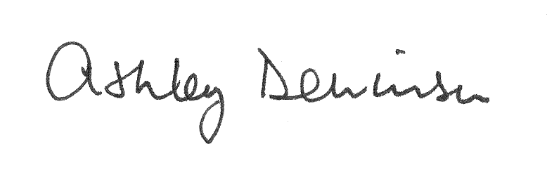

Professor Ashley Dennison
Chair
East Midlands Clinical Senate
1. Objectives
Our event was an opportunity to:
• Hear about innovation
• Network with colleagues and other Clinical Senate members
• Learn about good practice within the NHS

2. Agenda for the day
Times | Agenda Item | Presenter(s)
10:05am–10:15am | An update on the work of the Clinical Senate since we last met | Emma Orrock  Head of Clinical Senate
10:15am– 11:00am | A CCG’s perspective on the Clinical Senate’s clinical review process  National Rehabilitation Centre | Hazel Buchanan  Associate Director of Special Projects & EPRR  Nottingham and Nottinghamshire CCGs
11:20am– 11:50pm | Digital Services, Patient Perspective | Gary Taylor  Patient Leader, MyHealth Access  Board of Trustees, Primary Sclerosing Cholangitis (PSC) Support  University Hospitals Birmingham
11:50am– 12:20pm | Local Health Technology Assessment for Medical Device Technology and the relevance for STPs/ICSs | Professor Dan Clark  Centre for Healthcare Equipment & Technology Adoption Director and Head of Clinical Engineering  University of Nottingham
1:15pm– 1:45pm | Vision and ethos of the Medical School – a local perspective | Professor Alistair Warren  Vice-Dean Early Years and BMedSci (Lincoln)  University of Nottingham
1:45pm– 2:15pm | Connected Notts Proactive Intervention (live demo – slides not available) | Dr Mike O'Neil  GP/Nottingham West CCG
2:35pm– 3:05pm | Artificial Intelligence and practical evidence of its use and application from EMRAD | Simon Harris  EMRAD Senior Project Manager
3:05pm– 3:50pm | An Acute Trust’s perspective on the Clinical Senate’s clinical review process  University Hospitals of Leicester NHS Trust - Acute Reconfiguration | Justin Hammond  Head of Reconfiguration PMO University Hospitals of Leicester

3. Our Speakers

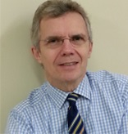
Professor Ashley Dennison – Chair
Ashley is Consultant Hepatobiliary and Pancreatic Surgeon at University Hospitals of Leicester NHS Trust, Professor of Hepatobiliary and Pancreatic Surgery, University of Leicester and the East Midlands Clinical Senate Chair.
Ashley graduated with MB, ChB from Sheffield University in 1977, obtained his FRCS in 1982 and his MD (Sheffield) in 1985. He was a Wellcome Research Fellow in Oxford from 1983-85, and from 1990-92 worked in Switzerland with Professor Blumgart, Paris with Professor Bismuth and Hannover with Professor Pichlmayer. Since 1994 he has been a consultant hepatobiliary and pancreatic surgeon at the University Hospitals of Leicester NHS Trust. He is the chief investigator and responsible for all research supervision and collaboration with external centres (national and international). He is also the lead clinician responsible for “sense checking” initiatives for service improvement and delivery. His main clinical and research interests relate to the metabolism and anti-cancer properties of intravenous lipid emulsions, the treatment of colorectal metastases and pancreatic adenocarcinoma and islet cell autotransplantation following total pancreatectomy for chronic pancreatitis. He has investigated ablative techniques for the treatment of colorectal metastases and the anti-inflammatory and anti-cancer effect of infusions of lipid emulsions containing omega-3 fatty acids. He has the largest European experience of pancreatectomy followed by islet cell auto-transplantation for chronic pancreatitis and is at present investigating the potential clinical applications of pancreatic ductal cells (intermediate cells). His interest in lipids has recently resulted in trials in acute pancreatitis, sepsis in the intensive care setting, colorectal liver metastases and pancreatic cancer.


Hazel Buchanan
Hazel is currently the Associate Director of Special Projects and Emergency Planning for the Nottingham and Nottinghamshire CCGs; an enjoyable and varied role that includes driving forward and embedding prevention, working with the health and social care system on innovation and transformation as well as ensuring the CCGs fulfil their statutory responsibilities in research and take an evidence-based approach across the CCGs. The role also includes meeting the CCGs responsibilities and working with the system in relation to health protection, business continuity and emergency planning. This role follows on from positions across a wide range of disciplines in the NHS over the past ten years including service improvement and commissioning, partnership working across the system, corporate governance and medicines management in primary care. Before joining the NHS, Hazel was employed in the financial services sector with responsibilities covering service improvement, business process re-engineering, project and programme management. Hazel’s passion for working in the health sector began in Canada with a variety of roles across a large teaching hospital. Hazel is a graduate in sociology and public policy with a Masters in Social Policy and a Masters in Business Administration.
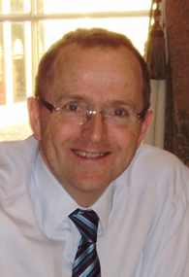
Professor Dan Clark
Dan leads the Clinical Engineering service in Nottingham, one of the largest in Europe and provides the full scope of equipment services including: device evaluation, commissioning, service and maintenance, decommissioning and disposal. This service has specialist teams in renal technical support, anaesthetics and ventilators and general medical and also provides a comprehensive equipment library service, a medical devices training unit and a medical devices safety team. Dan also leads an innovation and research unit that designs and produces novel medical devices plus a healthcare technology evaluation and adoption service (CHEATA – the Centre for Healthcare Equipment And Technology Adoption). He has considerable experience of evaluating new technologies and introducing them into the healthcare setting.
Dan has an honorary chair in the Faculty of Engineering at the University of Nottingham where he supports a range of healthcare-related engineering research groups. He manages the Trust’s Medical Devices Group and sits on a number of trust-wide risk committees. He is the Co-director of the Centre for Healthcare Technologies, a collaborative venture between Nottingham University and Nottingham University Hospitals NHS Trust specialising in the acceleration of curiosity driven science into adopted medical technology. He is a member of NICE’s Medical Technology Advisory Committee, a member and Treasurer of the IFMBE (International Federation and Medical and Biomedical Engineering) Health Technology Assessment Division Board and a collaborating member of the IFMBE Clinical Engineering Division. Dan is also the Vice Present – International of IPEM (the Institute of Physics and Engineering in Medicine).

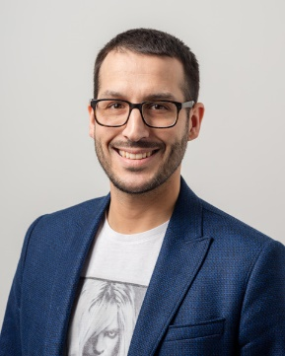
Gary Taylor
Gary is Deputy Managing Director & Group Digital Director for one of the largest independent media and digital agencies in the UK, working with global brands and household names such as Nestle, Purina, Furniture Village and Admiral Insurance.
With an excellent knowledge of digital strategy and strong commercial awareness he was appointed to the Board of Trustees to bring guidance, advice and strategic direction to PSC Support across the ever-changing digital landscape.
Diagnosed with PSC and an AIH overlap in 2008, Gary underwent a liver transplant in January 2017 after just 9 weeks on the waiting list.
'Having experienced the condition from diagnosis through transplant, I wanted to share my experience of PSC with other patients to provide a level of transparency and reality; particularly in the younger age group and those with children. The work that Martine and the wider PSC Support team continuously undertake has been invaluable in helping to improve the lives of people with primary sclerosing cholangitis (PSC) through support, education, advocacy and research.'
Gary is an avid Porsche fan and also collects retro video games. He is the co-founder of Ruck.co.uk, the UK’s leading Rugby Union website, which reaches millions of rugby fans across the world each month. He lives with his wife and two children in the West Midlands.
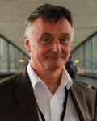
Professor Alistair Warren
Alistair has wide experience in the basic sciences that underpin medicine. As well as teaching, examining and researching in Biomedical Sciences he has led many curriculum developments in the area. He joins the University of Nottingham as Professor of Anatomical Sciences and Vice Dean, Early Years & BMedSci course at the Lincoln Medical School.
After completing his BSc (hons) in Biological Sciences, Alistair undertook a PhD and post-doctoral fellowship in Developmental Neurobiology. He became Lecturer and Senior Lecturer in Anatomy and Cell Biology, then Professor in Biomedical Science at the University of Sheffield. His laboratory research focused on quantitative morphometric analyses, at light and electron microscopic levels, and he has worked on a range of topics including male and female infertility. He has supervised many postgraduate students at PhD, MD and MSc levels.
At Sheffield, Alistair held a number of leadership positions including Faculty Director of Learning and Teaching in Science, member of the Faculty Executive Board, and Chair of the University Quality and Scrutiny Committee, amongst others. He led Phase 1 (then the first two years) of the MBChB course and set-up a successful MSc in Science Communication. He taught medical, dental and science students and is a Fellow of the Anatomical Society. He was voted 'Best personal tutor' across the university and won the 'Student Voice Advocate' award.

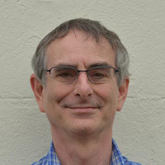
Dr Mike O’Neil
Mike is a GP in Nottingham and clinical architect for the GPRCC (GP Repository for Clinical Care) data warehouse and eHealthScope interface. His work is in the surfacing care gaps and proactive interventions for population health management. He previously designed Version 3 Read Codes (Clinical Terms) and worked at Imperial Cancer Research Fund on the design of large-scale decision-support systems.
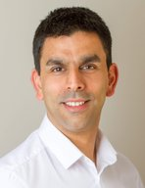
Simon Harris
Simon has 17 years of experience in project and change management, using technology enabled transformation to support patient care. He currently leads on the transformational pillar of the EMRAD strategy which includes the Artificial Intelligence in breast screening project.

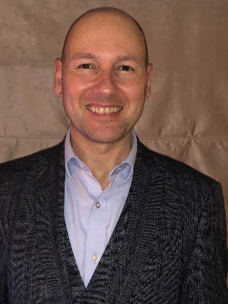
Justin Hammond
Justin is the Head of UHL Reconfiguration PMO at University Hospitals of Leicester. He has been in the role just under two years having had a career of over 25 years in the public, private and voluntary sectors where he has led on a number of complex change programmes. The early part of Justin’s career development was in the voluntary sector, where he learnt true ‘value for money’ as every penny counts. Whilst the work was very rewarding, the constant funding reviews and contract negotiations were draining, so after six years Justin moved jobs in to Leicester City Social Care, where he could directly affect the views of commissioners from within. His roles were varied and interesting with a clear focus on developing projects and schemes that would drive improvements and change traditional working practices. As a qualified project and programme manager his skills are going to be put to the test as he supports the UHL team in delivering the biggest reconfiguration programme the trust has ever embarked on.

4. Who attended
A total of 39 people attended and the full attendee list (Appendix A) is attached.

5. Results from the Evaluation Feedback Forms
A total of 17 feedback forms were completed on the day and the responses received are detailed below.
5.1 Presentations
Feedback received on the day was very positive with 90% of respondents rating the presentations as either good or excellent and this was supported by the qualitative comments received.
“Excellent review of health technology assessment process”
“Fascinating use of data crunching”
“Excellent presentation and insight into patient perspective”
5.2 Highlights of the day
The whole day was very well received with respondents appreciating the breadth of topics covered. Attendees were also interested in the feedback received on our clincial review process.
“Most interesting to hear about these various areas”
“All useful information. Good to hear feedback from reviews carried out by EMCS. Thankyou”
“Using digital to support/improve experience of patients with a specific condition”
“Patient perspective. Artificial intelligence, real progress!”
5.3 Overall rating of the day
100% of respondents rated the day as either good or excellent.

5.4 Venue and facilities
100% of respondents rated the venue and facilities as either good or excellent and this was reflected in the qualitative comments received.
‘Fantastic facility’
‘Great facilities and venue’

6. CPD Points
East Midlands Clinical Senate Assembly Event has been approved by the Federation of the Royal Colleges of Physicians of the United Kingdom for 6 category 1 (external) CPD credit(s).

7. Word cloud


APPENDIX a – lIST OF ATTENDEES
Molla Imaduddin | Ahmed | Locum Consultant Paediatrician (Respiratory) | University Hospitals of Leicester NHS Trust
Ben | Anderson | Deputy Director for Healthcare Public Health | Public Health England East Midlands
Bernadette | Armstrong | Extended Scope Physiotherapist | Northamptonshire Healthcare NHS Foundation Trust
Julie | Attfield | Executive Director Nursing, and Clinical Senate Vice-Chair | Nottinghamshire Healthcare NHS Trust
Suzanne | Avington | Physiotherapist - Team Leader Community Rehabilitation | Nottinghamshire Healthcare NHS Trust
Zoe | Boyes | Network Senior Quality Improvement Manager – Mental Health | East Midlands Clinical Network
Simon | Browes | Programme Director | NEMS Health Partners/Nottinghamshire Alliance of Training Hubs
Hazel | Buchanan | Associate Director of Special Projects & EPRR | Nottingham and Nottinghamshire CCG
Dan | Clarke | Centre for Healthcare Equipment & Technology Adoption Director and Head of Clinical Engineering | University of Nottingham
Matt | Day | Consultant in Healthcare Public Health | Public Health England
Ashley | Dennison | Consultant Hepatobiliary and Pancreatic Surgeon, Professor of Hepatobiliary and Pancreatic Surgery, and Clinical Senate Chair | University Hospitals of Leicester NHS Trust
John | Dick | Patient representative | East Midlands Clinical Senate
Susan | Edge | Patient representative | East Midlands Clinical Senate
Richard | Elliott | Consultant Anaesthetist | University Hospitals of Derby and Burton
David | Eveson | Consultant Physician and Head of Service Stroke Medicine | University Hospitals of Leicester NHS Trust
Elizabeth | Gonzalez Malaga | Specialty Trainee Registrar in Special Care Dentistry | Northamptonshire Healthcare NHS Foundation Trust
Rebecca | Hall | GP Partner | Charnwood Community Medical Group
Justin | Hammond | Head of UHL Reconfiguration PMO | University Hospitals of Leicester NHS Trust
Mike | Hannay | Managing Director, Medical Technologies Innovation Facility (MTIF) | Nottingham Trent University
Simon | Harris | EMRAD Senior Project Manager | EMRAD
Lara | Harrison | Administrator | East Midlands Clinical Senate
Jamilla | Hussain | Project Manager | West Midlands Clinical Senate
Gavin | McHaffie | Consultant Nephrologist | Nottingham University Hospitals NHS Trust
Paul | Midgley | Patient representative | East Midlands Clinical Senate
Chris | Miller | Consultant in Geriatric Medicine and General Internal Medicine | Leicester Royal Infirmary
Kirit | Mistry | Chair | South Asian Health Action Charity
Mike | O'Neil | GP | Rushcliffe CCG
Emma | Orrock | Head of Clinical Senate | East Midlands Clinical Senate
Ben | Pearson | Executive Medical Director | Derbyshire Community Health Services
Remi | Popoola | Senior Physiotherapist | Danetre Hospital, Daventry
Hugh | Porter | GP and Chair | NHS Nottingham City CCG
Brian | Rowlands | Emeritus Professor of Surgery | University of Nottingham
Jane | Scullion | Consultant Respiratory Nurse | University Hospitals of Leicester NHS Trust
Bozena | Smith | Neuro services manager/occupational therapist | DMRC Stanford Hall
Keith | Spurr | Patient representative | East Midlands Clinical Senate
Gary | Taylor | Patient Leader, MyHealth Access and Board of Trustees, PSC Support | University Hospitals Birmingham
Davis | Thomas | Clinical Director | Northampton General Hospital
Alistair | Warren | Vice-Dean Early Years and BMedSci (Lincoln) | University of Nottingham
Jo | Watson | Head of Clinical Productivity | NHS England and NHS Improvement – Midlands & East

