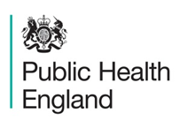

East Midlands Clinical Senate and Public Health England

‘Physical Activity and Exercise Medicine’

Physical Activity as Treatment

Post Event Pack

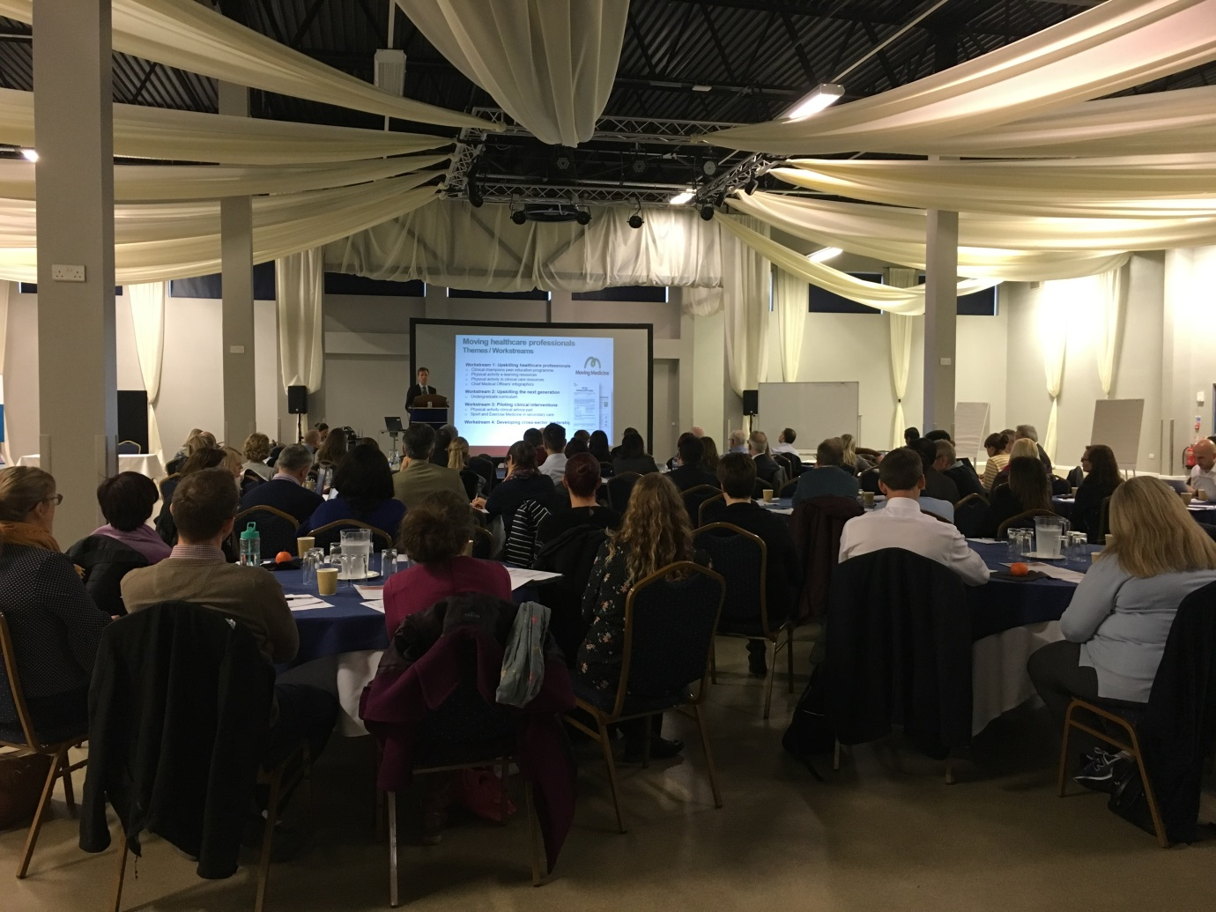

28th November 2018

Contents

Joint Letter from East Midlands Clinical Senate Chair and Public Health England East Midlands Director 3
1. Background 5
2. Aims and objectives 5
3. Agenda for the day 6
4. Our speakers 7
5. Who attended 7
6. Results from the feedback forms 7
6.1 Overall rating of the day 7
6.2 Learning points 8
7. Conclusions 9
8. Next steps 9
9. Useful websites and resources 9
10. Contact information 9
Appendix A – Speaker biographies 10
Appendix B – List of delegates 14
Appendix C – Clinical Champion programme 17
Appendix D – Beat the Street programme 18

Joint Letter from East Midlands Clinical Senate Chair and Public Health England East Midlands Director

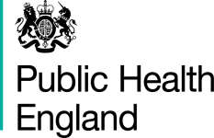

7th December, 2018

Dear colleague,

Thank you for attending our recent event on Physical Activity as Treatment, hosted by the East Midlands Clinical Senate and Public Health England.

The clinical senate holds an annual assembly event for its members for these reasons:

- It provides an opportunity to act as a vehicle for health and care professionals and patient representatives to debate ideas, build consensus and make recommendations /give advice on issues that support development and transformation of health and care services
- It is a way of sharing and promoting changes and innovations - providing a space to explore implementation, impact and learning
- Networking

This year, the clinical senate council agreed that our theme for the day would be physical activity and exercise medicine, building on the previous proactive work undertaken by the clinical senate by considering how physical activity could be prescribed as a treatment across a range of conditions.

The feedback we have received has been incredibly positive and both clinical senate members and other colleagues attending the event appreciated the opportunity to network, and to increase their knowledge and awareness of the resources available and current practice across the region.

The agenda covered a broad range of areas throughout the day. Dr Mike Brannon provided the national overview on the Moving Healthcare Professionals Programme. He relayed a strong message around patients listening to professional medical advice, and the value of, and the potential for, an exercise “prescription” was particularly compelling. We also heard about the moving medicine initiative, the clinical champion programme for physical activity, and gained insight into areas where physical activity is already “prescribed” as a form of treatment and the potential for building prehabilitation into surgical pathways.

We hope that you found it a valuable experience, and enclosed in this post-event pack is:

- The agenda from the day with each individual presentation hyperlinked
- Bios for our presenters
- List of delegates who attended including role and organisation
- Excerpts of feedback from the day
- Information about Beat the Street programme
- Information about the Clinical Champion programme

The clinical senate council will be considering next steps at its upcoming meetings and the work undertaken to date by Andy Fox, Lucy Gavens and Elizabeth Gonzalez Malaga on the mapping and the clinical pathways pilot. We are planning to present our case studies in a format which is accessible to commissioners and other organisations, and to describe how and why physical activity as treatment might be commissioned system wide and across a range of conditions.

Clinical senates are a source of independent, strategic advice and guidance to commissioners, STPs, and other stakeholders, to assist them to make the best decisions about healthcare for the populations they represent.

Public Health England is an executive agency of the Department of Health and Social Care and exists to protect and improve the nation’s health and wellbeing and reduce inequalities. PHE East Midlands is committed to working with partners across the East Midlands to deliver these aims and has worked with the clinical senate to progress a number of clinically relevant prevention programmes.

Thank you for contributing positively to the day. We hope that you find the enclosed information useful.

Yours sincerely,

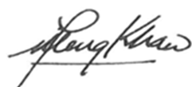
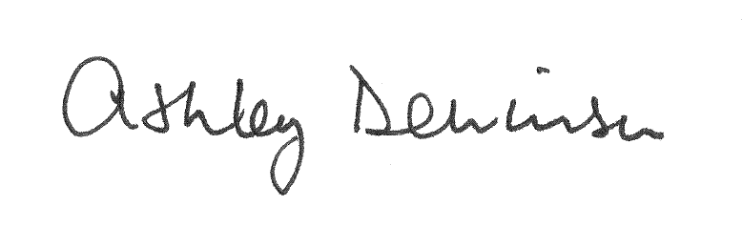

Professor Ashley Dennison Dr Fu Meng Khaw
Chair Director
East Midlands Clinical Senate Public Health England East Midlands

1. Background

A new physical activity resource for health professionals was launched in October 2018. The Moving Medicine tool produced by the Faculty of Sport and Exercise Medicine (FSEM) in partnership with Public Health England (PHE) and Sport England with support from National Lottery funding, will help healthcare professionals advise patients on how physical activity can help to manage their conditions, prevent disease and aid recovery.

Currently one in four of the population in England does less than 30 minutes of moderate intensity physical activity a week and are classified as inactive.

Physical inactivity is in the top ten greatest causes of ill health nationally, with negative impacts on health, wellbeing, social and economic outcomes for individuals and communities.

Evidence shows that one in four patients would be more active if advised by a GP or nurse, yet nearly three quarters of GPs do not speak about the benefits of physical activity to patients due to either lack of knowledge, skills or confidence.

The tool focuses on helping to address the most common long term health conditions affecting the population, such as cancer, depression, musculoskeletal pain and type 2 diabetes.

2. Aims and objectives

The event aimed to enable attendees to develop their understanding of physical activity as treatment through:

- An update on the Moving Healthcare Professionals Programme (MHPP)
- Presentation of the Moving Medicine and NICE evidence resources on physical activity prescription for key physical and mental health conditions
- Presentation of local work mapping NHS commissioned and provided physical activity services across the East Midlands
- Collectively identifying the opportunities, gaps and challenges in embedding ‘Physical Activity as Treatment’ into practice

3. Agenda for the day
Times | Agenda Item | Presenter(s)
10:00am – 10:05am | Welcome and Introductions | Professor Ashley Dennison – East Midlands Clinical Senate Chair
10:05am – 10:15am | Clinical Senate Update | Emma Orrock – Head of East Midlands Clinical Senate
10:15am – 10:25am | Introduction to Physical Activity as Treatment | Ben Anderson – Deputy Director, Healthcare Public Health
National Overview

10:25am – 10:40am | Physical activity into healthcare – Moving Healthcare Professionals Programme (MHPP) | Dr Mike Brannan – National Lead for Physical Activity, Public Health England
10:40am – 10.55am | Moving Medicine | Dr Jill Neale – Specialty Registrar in Sport and Exercise Medicine, Faculty of Sport and Exercise Medicine
10:55am – 11:15am | REFRESHMENTS
11:15am – 11:30am | Physical Activity as Treatment within NICE pathways | Deborah O’Callaghan – Associate Director,  NICE Field Team, Midlands and East
11:30am – 11:45am | Q and A with the Panel | All
11:45am – 12:15pm | Table based discussion – How can the national evidence base shape what we do locally?  - Opportunities to apply the evidence  - Understanding barriers to application | Facilitator: Andy Fox – Speciality Registrar, Public Health England
12:15pm – 12:30pm | Feedback from the table discussions | All
12:30pm – 1:30pm | LUNCH, Networking and Display Stands
Local Perspectives

1:30pm – 1:45pm | Clinical Champions for Physical Activity | Dr Jean Wong – GP Clinical Champion for Public Health England, RCGP Sport and Exercise Medicine Rep, GPwSI Sport and Exercise Medicine
1:45pm – 2:00pm | Supporting developments in local services – Learning from the National Centre for Sport and Exercise Medicine | Dr Kristen Clements – Senior Translational Scientist and NCSEM Consortium Manager, National Centre for Sport and Exercise Medicine, Loughborough University
Local Experiences

2:00pm – 2:20pm | Physical activity and surgical pathways | Dr Andrew Packham – Consultant Anaesthetist, University Hospitals of Leicester NHS Trust
2:20pm – 2:40pm | Clinical Senate “Physical Activity as Treatment” Work Programme  - Mapping Physical Activity as Treatment  - Clinical Pathways Pilot (Cardiology/Mental Health) | Andy Fox – Speciality Registrar, Public Health England  Elizabeth Gonzalez Malaga – Specialist Registrar in Special Care Dentistry, Northamptonshire Healthcare NHS Foundation Trust and East Midlands Clinical Senate Fellow
2:40pm – 2:50pm | Q and A with the Panel | All
2:50pm – 3:10pm | REFRESHMENTS
3:10pm – 3:15pm | Beat the Street Initiative | Dr William Bird MBE – CEO, Intelligent Health
3:15pm – 3:40pm | Table based discussion – Informing the clinical senate work programme  - Physical Activity in your specialty?  - Good practice and gaps in local pathways | Facilitator: Andy Fox – Speciality Registrar, Public Health England
3:40pm – 3:55pm | Feedback from the table discussions | All
3:55pm – 4:00pm | Closing Remarks | Professor Ashley Dennison – East Midlands Clinical Senate Chair
4:00pm | CLOSE

4. Our speakers

We were fortunate to have a selection of national and local speakers from the East Midlands Clinical Senate, Public Health England, the Faculty of Sport and Exercise Medicine, NICE, National Centre for Sport and Exercise Medicine at Loughborough University and University Hospitals of Leicester NHS Trust. Speaker biographies are attached – please see Appendix A.

5. Who attended

A total of 81 participants attended from across the East Midlands. There was representation from East Midlands Clinical Senate Council and Assembly Members, Public Health England, Acute and Mental Health Provider Trusts, Clinical Commissioning Groups, Universities, Local Authorities and County Councils, County Sports Partnership, NHS England, East Midlands Clinical Networks, Leicester, Leicestershire and Rutland Alliance Core/Planned Care and patient representatives. Full attendee list is attached – please see Appendix B.

6. Results from the feedback forms

A total of 29 feedback forms were completed on the day and the responses received are detailed below. Additional feedback received on the day was very positive with attendees stating that the opportunity to network was extremely useful and the event had significantly increased their knowledge and awareness in this area. 100% of respondents stated that the event met the objectives of the day.

6.1 Overall rating of the day

The majority of respondents (97%) stated that the overall day was either excellent, very good or good:

This was supported by qualitative comments received:

‘Topics covered were inspiring about the importance of physical activity and its contribution to the wellbeing of our patients’

‘Very interesting and inspiring day. Useful information about resources available - moving medicine etc. Got me thinking about how we can implement this locally working with CCG and developing our integrated lifestyle service/exercise referral programme’

‘Broad selection of speakers and attendees. Good time management. Well facilitated breakout sessions’

‘Good presentations. Well facilitated group sessions. Productive networking’

‘Lots of useful, new information’

‘The event exceeded expectations’

6.2 Learning points

Qualitative feedback on the key learning points that respondents would take away and share with their organisation focussed on how physical activity as a treatment could be incorporated into exisiting patient pathways, the potential for collaboration and the importance of collecting data to measure physical activity as part of the patient pathway:

‘Potential for physical activity, social prescribing as part of acute pathways. Will endeavour to expand social prescribing for physical activity to wider population’

‘We can make a small start to make a difference’

‘The reassurance to emphasise the importance of physical activity in treating mental illness’

‘Integrating exercise/physical health into local areas alongside all services/local organisations’

‘Resources that are available. Think more about measuring physical activity’

‘Data and resources to share with management, other clinicians, patients, statutory and third sector agencies to encourage a focus on enhancing levels of activity in patients’

‘Ways of incorporating Physical Activity into business cases and service specs. Where to find evidence to support the above. Data and coding is King’
‘I think the moving medicine website is exceptional. I have already started looking to integrate this into my practices - it needs better communication’

7. Conclusions

Both the number and cross representation of delegates attending the event was excellent and indicated considerable interest from attendees in developing their knowledge and awareness in this area.

The overall feedback indicated that the audience found the conference not only interesting and thought provoking but it also provided information, help, support and access to practical information in terms of evidence, resources and materials. There was also evidence that the event provided reassurance for attendees to emphasise the importance of physical activity as part of the patient pathway. It was also clear that attendees were starting to develop ideas on how they could expand existing pathways to incorporate physical activity as a treatment.

8. Next steps

The clinical senate council will be considering next steps at its upcoming meetings and the work undertaken to date by Andy Fox, Lucy Gavens and Elizabeth Gonzalez Malaga on the mapping and the clinical pathways pilot. We are planning to present our case studies in a format which is accessible to commissioners and other organisations, and to describe how and why physical activity as treatment might be commissioned system wide and across a range of conditions.

9. Useful websites and resources

http://emsenate.nhs.uk/
https://movingmedicine.ac.uk/
https://www.nice.org.uk/
http://www.publichealth.hscni.net/publications/physical-activity-infographics
http://www.ncsem-em.org.uk/
https://www.southtees.nhs.uk/services/prepwell-project/
https://www.poetts.co.uk/home

10. Contact information

East Midlands Clinical Senate – england.eastmidlandsclinicalsenate@nhs.net | 0113 825 5039

Appendix A – Speaker biographies

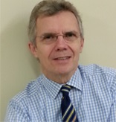
ASHLEY DENNISON – CHAIR

Ashley is Consultant Hepatobiliary and Pancreatic Surgeon at University Hospitals of Leicester NHS Trust, Professor of Hepatobiliary and Pancreatic Surgery, University of Leicester and the East Midlands Clinical Senate Chair.

Ashley graduated with MB, ChB from Sheffield University in 1977, obtained his FRCS in 1982 and his MD (Sheffield) in 1985. He was a Wellcome Research Fellow in Oxford from 1983-85, and from 1990-92 worked in Switzerland with Professor Blumgart, Paris with Professor Bismuth and Hannover with Professor Pichlmayer. Since 1994 he has been a consultant hepatobiliary and pancreatic surgeon at the University Hospitals of Leicester NHS Trust. He is the chief investigator and responsible for all research supervision and collaboration with external centres (national and international). He is also the lead clinician responsible for “sense checking” initiatives for service improvement and delivery. His main clinical and research interests relate to the metabolism and anti-cancer properties of intravenous lipid emulsions, the treatment of colorectal metastases and pancreatic adenocarcinoma and islet cell autotransplantation following total pancreatectomy for chronic pancreatitis. He has investigated ablative techniques for the treatment of colorectal metastases and the anti-inflammatory and anti-cancer effect of infusions of lipid emulsions containing omega-3 fatty acids. He has the largest European experience of pancreatectomy followed by islet cell auto-transplantation for chronic pancreatitis and is at present investigating the potential clinical applications of pancreatic ductal cells (intermediate cells). His interest in lipids has recently resulted in trials in acute pancreatitis, sepsis in the intensive care setting, colorectal liver metastases and pancreatic cancer.

BEN ANDERSON
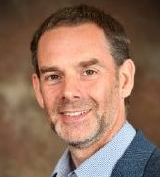
Ben is PHE’s Deputy Director for Healthcare Public Health in the East Midlands, responsible for a team that supports the NHS and local authorities on all aspects of healthcare public health including specific support to NHS England on specialised commissioning, dental public health, health and justice and screening and immunisation services. Ben also leads on Knowledge and Intelligence within the PHE Centre and is the Executive sponsor of the Centre’s Deep Dive programme which has produced reports on Health Inequalities, Alcohol, Cancer, Early Years (0-5), CVD, TB and Health and Justice since its inception.

Prior to joining PHE in 2014 Ben trained in Public Health in Yorkshire and Humber, including working with the DH’s Health Inequalities National Support Team, and worked as a Public Health Consultant in the NHS and Local Government in both Yorkshire and Humber and the East Midlands. He continues to be passionate about tackling health inequalities and the delivery of local solutions through collaboration and system leadership. In his current role, he works closely with all of the East Midlands Partner Organisations and over the past 3 years he has led a joint programme of work with the East Midlands Clinical Senate on Prevention in response to the NHS Five Year Forward View. This work has supported the development of a holistic view of prevention in the East Midlands and a set of diagnostic tools for providers and commissioners to assess their progress against the national ambition for a “radical upgrade in prevention and public health”. Ben is a Fellow of both the Faculty of Public Health and the Higher Education Academy and contributes to Public Health Training as the Training Programme Director for Quality within the East Midlands School of Public Health. Ben is co-chair of the East Midlands Healthcare Public Health Community of Improvement and CVD Prevention Steering Groups and Chair of the Advisory Group for the Sheffield NIHR School for Public Health.

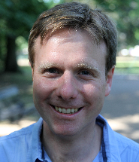
MIKE BRANNAN

Mike is the National Lead for Physical Activity at Public Health England and a registered public health consultant. He was an author of the national physical activity framework, Everybody Active Every Day, and leads the national physical activity team. Mike has worked in the public, private, academic and voluntary sectors and has over a decade of experience as a public health professional at national, regional and local levels. He has held leadership roles on health inequalities, transport, sustainability, housing, employment, health and work and physical activity. Prior to public health, Mike had an eclectic background as a biochemist and a public relations consultant.

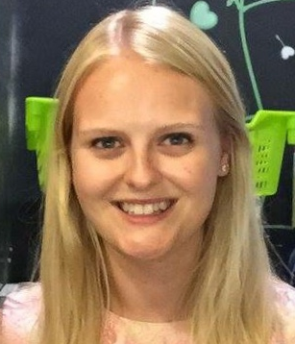
JILL NEALE

Jill is a specialty registrar in sports and exercise medicine in the East Midlands. She has previously undertaken academic training in Leicester and is particularly interested in the use of physical activity in chronic disease and health promotion, having completed her MRes dissertation on the use of exercise in Renal Transplant Recipients.
She is currently undertaking a Health Education England Management and Leadership Fellowship and is focusing on improving awareness and utilisation of Exercise Referral Services from secondary care. She has been directly involved in the development of the Falls and Frailty aspect of the Moving Medicine clinician-facing resources.

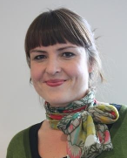
DEBORAH O’CALLAGHAN

Deborah O’Callaghan is the Associate Director of the NICE Field Team in the Midlands and East. She is also the Sector Lead for Public Health. Working across provider and commissioning organisations, her role is to support health and social care organisations to use NICE guidance and Quality Standards to achieve high quality care and improvements in health and wellbeing. Deborah is committed to collaborating with partner organisations including other national bodies to ensure a cohesive package of support is available to organisations across the region.

Deborah has worked at NICE for 10 years, prior to which she held a variety of strategy, redesign and quality improvement roles within the NHS and social care sector. More recent posts include Associate Director of Strategic Development in a London PCT and Director of a London Cardiac Network.

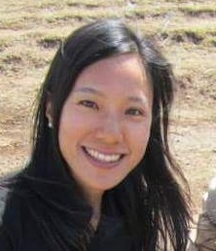
JEAN WONG
Dr Jean Wong is a GP with a special interest in Sports and Exercise Medicine. She completed her medical training in Leicester and an MSc in Sports and Exercise Medicine at Nottingham University, obtaining a merit. She is a GP Principal in Loughborough and a Specialty Doctor in Sports and Exercise Medicine at Loughborough University. She is a GP Clinical Champion of Physical Activity in the Midlands for Public Health England.

Dr Wong has a keen interest in education and is actively involved in teaching trainee doctors and medical students. In addition, she is involved in osteoarthritis research at the Rheumatology department in Nottingham City Hospital. She sits on the steering committee of the Primary Care Rheumatology Society and is the Sports and Exercise Medicine Representative for the Royal College of General Practitioners.

KRISTEN CLEMENTS
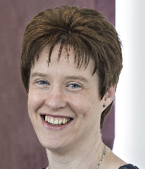
Kristen has a PhD in musculoskeletal biology and has worked both in the higher education sector and pharmaceutical industry. Kris' current role is to work alongside academic and clinical staff in the National Centre for Sport and Exercise Medicine (NCSEM) East Midlands to facilitate the translation of existing sports science, clinical and public health research to inform the development of new and existing services to benefit patient health. In addition, to mentor and direct the work of a team of translational scientists and to support the development and delivery of CPD and e-learning solutions. She is also the NCSEM consortium manager. This role involves supporting the development of the local partnerships and strengthening the ties between members, as well as ensuring the NCSEM East Midlands is a major contributor to the NCSEM as a whole.

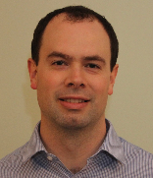
ANDREW PACKHAM

Dr Andrew Packham is a Consultant Anaesthetist at the University Hospitals of Leicester NHS Trust. He completed his medical and speciality training in the East Midlands, taking up a consultant post in 2012. Alongside theatre work, he is the medical procurement lead for theatres and intensive care and clinical lead for the perioperative cardiopulmonary exercise testing service.

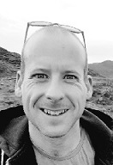
ANDREW FOX
Andy Fox is a Specialty Registrar in Public Health working with Public Health England East Midlands. He has been working with the East Midlands Clinical Senate to examine how to map the use of exercise as treatment across the East Midlands. Amongst his other work he has recently led an innovative project to develop local intelligence on the impact of preventable cancer across the region.

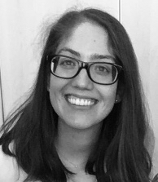
ELIZABETH GONZALEZ MALAGA
Elizabeth graduated in Dentistry at University Rey Juan Carlos (Madrid, Spain) in 2009. Soon after, she moved to the UK where she gained a broad experience in general dental practice, Oral and Maxillofacial Surgery, Orthodontics and Special Care Dentistry. She has completed The Diploma of Membership of the Faculty of Dental Surgery (MFDS) of The Royal College of Surgeons of Edinburgh and a Masters in Special Care Dentistry at Eastman Dental Institute (UCL) awarded with Distinction and in The Dean’s List. Currently, she is doing her Specialty Training Registrar in Special Care Dentistry at Northamptonshire Healthcare Foundation Trust and a Clinical Fellow for East Midlands Clinical Senate.

Appendix B – List of delegates

First Name | Surname | Job Title | Organisation
Dr Bhavyang | Acharya | Consultant in Palliative Medicine | Northamptonshire Healthcare Foundation Trust - Cynthia Spencer Hospice
Lindsay | Adams | Marketing and Communications Manager | Loughborough University
Shade | Agboola | Consultant in Public Health | Nottingham City Council
Ben | Anderson | Deputy Director, Healthcare Public Health | Public Health England, East Midlands
Bernadette | Armstrong | Extended Scope Physiotherapist | Northamptonshire Healthcare Foundation Trust
Jo | Atkinson | Consultant in Public Health | Leicester City Council (Public Health)
Suzanne | Avington | Team Leader Community Therapy | Nottinghamshire Healthcare Foundation Trust
Romila | Bahl | Sports and Exercise Medicine Registrar - Public Health placement | Leicestershire County Public Health
Dr Rebecca | Barker | Consultant Anaesthetist | Sherwood Forest Hospitals
Mark | Batt | Consultant in Sport and Exercise Medicine | Nottingham University Hospitals NHS Trust
Lisa | Beard | Operations Manager | Burton Albion Community Trust
Dr William | Bird | Intelligent Health CEO | Intelligent Health
Zoe | Boyes | Senior Quality Improvement Manager | East Midlands Mental Health Clinical Network
Dr Mike | Brannan | National Lead for Physical Activity | Public Health England
Jackie | Browne | Sport & Physical Activity Manager | Northamptonshire Sport
Kerryn | Chamberlin | Director | Active Partners Trust – County Sports Partnership for Nottinghamshire and Derbyshire
Nicole | Chavaudra | Programme Director – Bassetlaw Accountable Care Partnership | Bassetlaw CCG
Dr Kristen | Clements | Senior Translation Scientist and NCSEM Consortium Manager | National Centre for Sports and Exercise Medicine
Ann | Crawford | Deputy Director Health, Wellbeing and Workforce Development | Public Health England, East Midlands
Sharon | Dale | Health Manager | Derby County Community Trust
Ashley | Dennison | Chair of East Midlands Clinical Senate | East Midlands Clinical Senate
John | Dick | Assembly Member - patient representative | East Midlands Clinical Senate Assembly
Aly | Evans | Clinical Senate Support Manager | East Midlands Clinical Senate
Andy | Fox | Speciality Registrar | Public Health England
Sue | Glendenning | Trust wide Gynaecology | United Lincolnshire Hospitals NHS Foundation Trust
Elizabeth | Gonzalez Malaga | Specialist Registrar in Special Care Dentistry and Clinical Fellow | Northamptonshire Healthcare NHS Foundation Trust/ East Midlands Clinical Senate
Claire | Greaves | Chief Scientist and Head of Medical Physics and Clinical Engineering | Nottingham University Hospitals NHS Trust
Dr Rebecca | Hall | Clinical Senate Fellow / GP Partner | East Midlands Clinical Senate
Lara | Harrison | Clinical Senate Administrator | East Midlands Clinical Senate
Maria | Hastings | Technology Product Manager | Independent Consultant
Christopher | Higgins | Deputy Director of Operations | Lincolnshire Partnership NHS Foundation Trust
Dr James | Hopkinson | Consultant in Sport and Exercise Medicine & Clinical Lead | Nottingham North & East Clinical Commissioning Group
Liz | Hudson | Healthier Lifestyles Manager | Corby Borough Council
Eyad | Issa | NIHR Clinical Lecturer and East Midlands Clinical Senate Fellow | University of Leicester
Dr Peter | Jones | Subject Leader for Sport, Exercise, Life Science and Psychology | University of Northampton
Richard | Keeton | Service Manager | Derbyshire County Council
Dr Fu-Meng | Khaw | Centre Director | Public Health England East Midlands
Sarah | Kimberley-Fisk | Specialist Occupational Therapist | Specialist Intervention Team, CAMHS
Dr Girish | Kunigiri | Clinical Director | East Midland Clinical Network for Mental Health
Iain | Little | Assistant Director of Public Health | Derbyshire County Council
Deborah | Manger | Deputy Medical Director | Northamptonshire Healthcare NHS Foundation Trust
Dr Mangesh | Marudkar | Consultant Psychiatrist for Older Adults | Leicestershire Partnership NHS Trust
Etain | McDermott | Public Health Programme Manager | Leicester City Council
Laura | Meadows | Therapy Speciality Lead for MSK and Women’s Health | University Hospitals of Leicester NHS Trust
Sean | Meehan | Health and Wellbeing Programme Lead | Public Health England
Dr Christopher | Miller | Consultant Geriatrician / Clinical Senate Fellow | University Hospitals of Leicester NHS Trust / East Midlands Clinical Senate
Asif | Munaf | ST3 Sport and Exercise Medicine | Nottingham University Hospitals
Patrick | Musto | Consultant Anaesthetist | University Hospitals of Leicester NHS Trust
Jasmine | Murphy | Consultant in Dental Public Health | PHE East Midlands
Jill | Neale | Sport and Exercise Medicine SpR | University Hospitals of Leicester NHS Trust
Deborah | O'Callaghan | Associate Director, NICE Field Team, Midlands and East | NICE
Emma | Orrock | Head of East Midlands Clinical Senate | East Midlands Clinical Senate
Dr Andrew | Packham | Consultant Anaesthetist/ Clinical Lead for Anaesthetic Cardiopulmonary Exercise Testing Service | University Hospitals of Leicester NHS Trust
Jenna | Parton | Public Health Practitioner | Northamptonshire County Council
Dr Ben | Pearson | Consultant Geriatrician | University Hospitals of Derby and Burton NHS Foundation Trust
Remi | Popoola | Clinical Senate Fellow/ Senior Physiotherapist | Danetre Hospital, Daventry
Anne | Pridgeon | Regional Lead for NHS England | Public Health England Midlands and East Regional Team
Emma | Putman | Occupational Therapist | CAMHS, Northamptonshire Healthcare Foundation Trust
Dr Aly | Rashid | Medical Director | NHS England - Midlands and East (Central Midlands)
Maureen | Raynor | Midwifery Lecturer | De Montfort University
Sally | Reece | Clinical Specialist (Mortality) | Lincolnshire Partnership NHS Foundation Trust
Lisa | Riddaway | Senior Strategy Commissioning Manager | NHS Nene CCG & Corby CCG
Brian | Rowlands | Emeritus Professor of Surgery | University of Nottingham
Dr Kerri | Sallis | GP, Clinical Lead and Associate Medical Director | Primary Integrated Community Services Ltd
Mike | Sandys | Director of Public Health | Leicestershire County Council
Nigel | Schofield | Consultant Clinical Neuropsychologist | University Hospitals of Derby and Burton NHS Foundation Trust
Dr Darin | Seiger | GP Chair | NHS Nene CCG
Dr Pumi | Senaratne | Sport and Exercise Medicine Registrar | Whyburn Medical Practice
Baljit | Singh | Consultant Colorectal Surgeon | University Hospitals Leicester
Harpreet | Sohal | Lifestyle Service Manager | Public Health, Leicester City Council
Rachel | Sokal | Consultant in Public Health | Independent
Laura | Spowage | Health and Wellbeing Programme Manager | Public Health England
Keith | Spurr | Assembly Member - patient representative | East Midlands Clinical Senate Council
Lynda | Stockwell | Head of Physical Healthcare | Lincolnshire Partnership NHS Foundation Trust
Clare | Walker | Network Senior Quality Improvement Manager – CVD and Diabetes East Midlands Clinical Networks | NHS England
Nathan | Ware | Consultant Anaesthetist | University Hospitals of Leicester NHS Trust
John | Widdowson | Health and Inclusion Manager | Burton Albion Community Trust
Luke | Wilkinson | Active Supporters Team Leader | Derby County Community Trust
Dr Jane | Williams | Consultant Paediatrician & CYP Clinical Lead (Midlands) | NHS England
Laura | Wivell | Senior Mental and Emotional Well-Being Practitioner - CAMHS Practitioner | Lincolnshire Partnership NHS Foundation Trust
Dr Jean | Wong | GP Physical Activity Champion | Public Health England

Appendix C – Clinical Champion programme

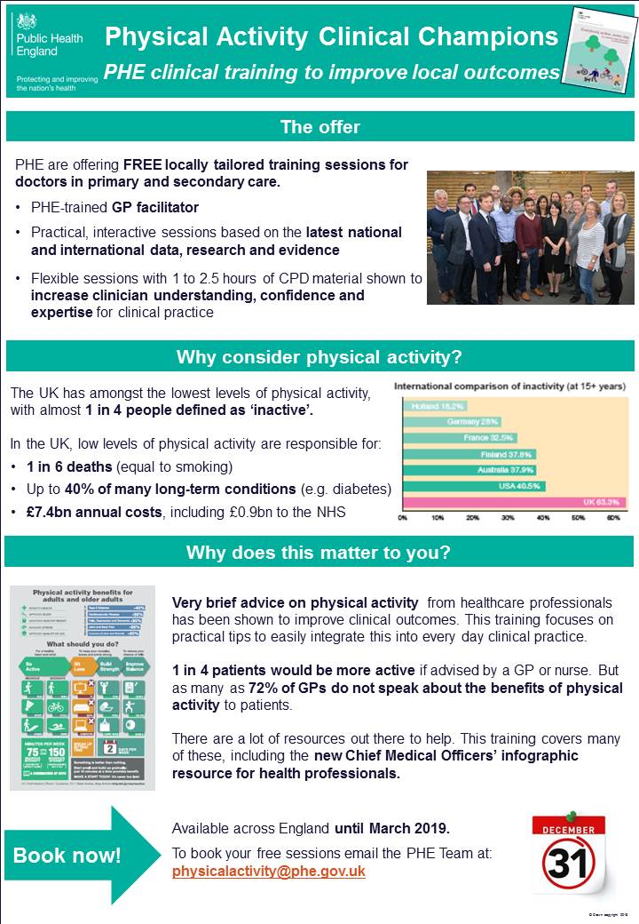

Appendix D – Beat the Street programme

https://www.gov.uk/government/news/new-physical-activity-resource-for-health-professionals

