Robotic-Assisted Surgery Review
A Summary Guide

Robotic-Assisted Surgery Review 1
Introduction 3
Methods 4
Systematic Review 4
Data Analysis of Geographical Variation 4
Findings 5
Hysterectomy 5
Cystectomy 6
Prostatectomy 7
Radical Nephrectomy 8
Partial Nephrectomy 9
Colonic Resection 9
Rectal Resection 11
Summary 12
Recommendations 13
Appendices 14
Appendix 1: Clinical terms and their definitions 14

Introduction
The use of robotic-assisted surgery has expanded rapidly in recent years and the general consensus among clinicians is that this trend will continue. Robots are now widely available and employed in an increasing number of surgical specialties and it is anticipated that their use will become established practice for a range of procedures in the foreseeable future. These developments have occurred despite a lack of joined-up commissioning of robotic-assisted surgery in England, where NHS England is the responsible commissioner for some procedures and ICBs are the responsible commissioner for others, or clear supporting clinical or health economic data. Formal commissioning policies setting out what should and should not be funded are in place for some areas, and for some indications, but for others there is a lack of guidance.
Having recognised this gap, the East and West Midlands Clinical Senate Councils agreed to support a review of robotic-assisted surgery in the region. This evidence review, undertaken jointly by Public Health Registrars at NHS England – Midlands and Clinical Fellows from the Senates, consists of 2 parts:
- A systematic review exploring the clinical effectiveness, safety, and cost-effectiveness of robotic-assisted surgery compared with laparoscopic and open techniques.
- An analysis of the geographical variation in robotic-assisted surgery use in the Midlands.
For both parts of this review, the following 6 surgical procedures were considered:
  - Hysterectomy
  - Cystectomy
  - Nephrectomy (radical and partial)
  - Prostatectomy
  - Colonic Resection
  - Rectal Resection

Methods

Systematic Review
The aim of the systematic review was to answer the following 3 research questions in relation to our 6 surgical indications of interest:
- What is the clinical effectiveness of robotic-assisted surgery in the following indications, in comparison to open and laparoscopic surgery?
- What is the safety profile of robotic-assisted surgery in the following indications, in comparison to open and laparoscopic surgery?
- What is the cost effectiveness of robotic-assisted surgery in the following indications, in comparison to open and laparoscopic surgery?
The clinical fellows and public health registrars produced a PICO (population, intervention, comparators and outcomes) document and a literature search was then undertaken by UKHSA library services, with the search restricted to reviews of procedures in adults published in English between 2010-2023. The returns were each screened against pre-agreed inclusion and exclusion criteria, with included results subsequently assessed for risk of bias using the Risk of Bias in Systematic Reviews (ROBIS) tool. For each manuscript, both steps were undertaken independently by 2 people, with any disagreements resolved through discussion and consensus. Finally, data extraction was undertaken individually.

Data Analysis of Geographical Variation
Data for the financial years April 2019 to March 2023 were extracted from the admitted patients secondary uses service (SUS) dataset for all patients resident in England. For each of the surgical indications of interest, procedures were filtered based on:
- Indication for procedure (cancer/not cancer)
- Surgical modality (robotic assisted/non-robotic)
- ICB (based on the lower super output area of the patient’s residence at the time of the procedure)
- Provider Trust (based on the provider code of trust associated with the recorded procedure)
Age standardised rates were calculated using the direct method for mid-2020 population estimates. Data for the age standardised rate of cancer incidence in 2018-2020 was extracted from the CancerData portal.

Findings

Hysterectomy

Literature Review
The final analysis was based on 18 systematic reviews, with 10 assessed as being at low risk of bias and 8 as high risk. The evidence demonstrates that robotic-assisted surgery may overall be worse than open techniques with regards to patient outcomes. Outcomes from robotic-assisted surgery are likely similar to laparoscopic techniques with the following key findings:
- Open Surgery – Patients undergoing robotic-assisted compared with open hysterectomy experience less estimated blood loss, lower blood transfusion rates, a shorter hospital stay, and a lower overall complication rate. However, patients undergoing robotic-assisted hysterectomy also experience a higher mortality and possibly a higher recurrence rate than those undergoing open hysterectomy. The evidence is mixed, (suggesting either improved or similar results for robotic-assisted techniques) for intra-operative and post-operative complications.
- Laparoscopic Surgery – The evidence demonstrates that patients undergoing robotic-assisted compared to laparoscopic hysterectomy report improved Quality of Life scores and lower postoperative pain. The evidence is again mixed however, (suggesting either improved or similar results with robotic-assisted techniques) for estimated blood loss, and post-operative complications.

Geographical Variation
Residents mainly go to their local trust for robotic surgery, with limited referral to other areas.
There is a poor correlation between the incidence of uterine cancer in an ICB and the rate of robot-assisted hysterectomy for uterine cancer (Figure 1). The age-standardised rate of robotic hysterectomy for uterine cancer ranges from 1.7 to 10.3 per 100,000 population.
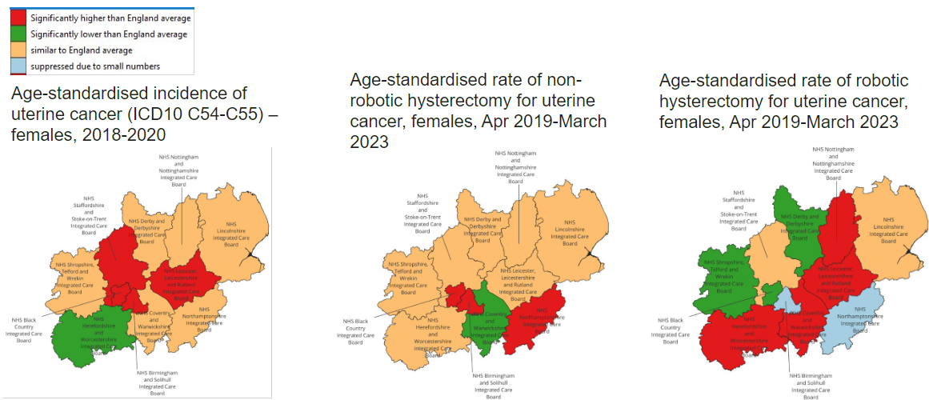
Figure 1: Uterine cancer maps

Cystectomy

Literature Review
The final analysis was based on 14 systematic reviews, with 4 assessed as being at low risk of bias and 10 as high risk. The evidence demonstrates that robotic-assisted surgery results in similar outcomes to both open and laparoscopic surgery, with the following key findings:
- Open Surgery - Patients undergoing robotic-assisted radical cystectomy experience significantly less blood loss and blood transfusion rates than those undergoing open radical cystectomy. There is no evidence that perioperative complication rates are lower for robotic assisted compared with open radical cystectomy with several papers finding no difference. The evidence demonstrates that there is no difference between the two techniques for mortality, quality of life, positive surgical margins, length of hospital stay, or readmission rates.
- Laparoscopic Surgery – The evidence is limited but one paper suggests that cancer recurrence rates may be lower for those undergoing robotic-assisted compared with laparoscopic radical cystectomy. No difference was found between the two techniques for blood loss, blood transfusion rates, mortality, quality of life, positive surgical margins, length of hospital stay, or readmission rates.

Geographical Variation
Residents mainly go to their local trust for robotic surgery, with limited referral to other areas.
There is a poor correlation between the incidence of urological cancer in an ICB and the rate of robot-assisted cystectomy for urological cancer (Figure 2). The age-standardised rate of robotic assisted cystectomy, nephrectomy, and prostatectomy for urological cancer ranges from 13.7 to 47.5 per 100,000 population. All but one of the ICBs in the Midlands have rates of robotic-assisted surgery for these indications which are lower than the average for England.
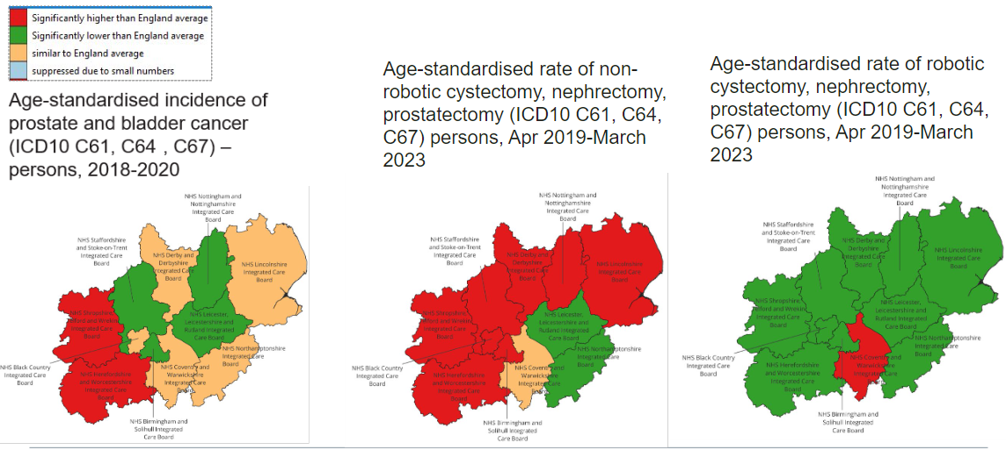
Figure 2: Urological cancer maps

Prostatectomy
The final analysis was based on 20 systematic reviews, with 9 assessed as being at low risk of bias and 11 as high risk. The evidence demonstrates that robotic-assisted surgery results in better outcomes than both open and laparoscopic surgery, with the following key findings:
- Open Surgery – Patients undergoing robotic-assisted prostatectomy experience less blood loss, lower rates of blood transfusion, shorter lengths of hospital stay, and better clinical outcomes in terms of impotence and sexual dysfunction, anastomotic leak, and injury to surrounding organs compared with open surgery. The evidence also demonstrates that robotic-assisted surgery is more cost-effective in the long term for larger centres. The evidence is equivocal but favours robotic-assisted surgery for complication rate, patient reported erectile dysfunction, and the rates of adverse events. Based on the available evidence, there does not appear to be a difference in the rates of patient reported urinary symptoms and continence between techniques.
- Laparoscopic Surgery – Patients undergoing robotic-assisted prostatectomy experience less blood loss, lower rates of blood transfusion, shorter lengths of hospital stay, and better clinical outcomes in terms of impotence and sexual dysfunction, anastomotic leak, and injury to surrounding organs compared with open surgery. The evidence also demonstrates that robotic-assisted surgery is more cost-effective in the long term for larger centres. The evidence is equivocal but again appears to favour robotic-assisted surgery for patient reported erectile dysfunction, urinary incontinence, and the rates of adverse events. Based on the available evidence, there is no difference in the rates of conversion to open surgery, or on patient reported urinary symptoms and continence between techniques.

Geographical Variation
Geographical variation across the Midlands for use of robotic-assisted prostatectomy was analysed in combination with cystectomy and nephrectomy. Findings were grouped and are presented in Figure 2 on page 7.

Radical Nephrectomy
The final analysis was based on 5 systematic reviews, with all 5 assessed as being at low risk of bias. The evidence indicates that robotic-assisted surgery results in better outcomes than open surgery and similar outcomes to laparoscopic surgery, with the following key findings:
- Open Surgery – The evidence demonstrates that warm ischaemia time is reduced with robotic-assisted compared to open radical nephrectomy. It also demonstrates that robotic-assisted surgery compares favourably with regards to blood transfusion rates, length of hospital stay, estimated blood loss, and perioperative complication rates. Evidence from a single paper with a small sample size demonstrated that lymph node dissection and sampling is higher for robotic-assisted open radical nephrectomy. There is no difference between the two techniques in respect of intra- or post-operative complication rates, cancer specific or overall survival and positive surgical margin.
- Laparoscopic Surgery – The evidence demonstrates that warm ischaemia time is better with robotic-assisted compared to laparoscopic radical nephrectomy. There is also a single paper with a small sample size that suggests that lymph node dissection is improved with robotic-assisted surgery. There is no difference between the two techniques for intra- or post-operative complication rates, cancer specific or overall survival, positive surgical margin, or the rate of conversion to open surgery.

Partial Nephrectomy
The final analysis was based on 10 systematic reviews, with 8 assessed as being at low risk of bias and 2 as high risk. The evidence demonstrates that robotic-assisted surgery may result in better outcomes than open surgery and confers no advantage in respect of outcomes to laparoscopic surgery, with the following key findings:
- Open Surgery – The evidence demonstrates that patients undergoing robotic-assisted surgery compared with open surgery experience reduced postoperative complication rates, lower readmission rates, lower blood transfusion rates, lower estimated blood loss, and a shorter hospital stay. There is no difference between the two techniques with regards to warm ischaemia times, intraoperative complication rates, cancer-specific survival, cancer-free survival, overall survival, positive surgical margins, or tumour recurrence rates.
- Laparoscopic Surgery – The evidence demonstrates that there is no difference between robotic-assisted and laparoscopic partial nephrectomy in terms of warm ischaemia time, intraoperative complication rate, cancer-specific survival, cancer-free survival, overall survival, or positive surgical margins.

Geographical Variation
Geographical variation across the Midlands for use of robotic-assisted nephrectomy was analysed in combination with cystectomy and prostatectomy. Findings were grouped and are presented in Figures 2 on page 7.

Colonic Resection
The final analysis was based on 7 systematic reviews, with 4 assessed as being at low risk of bias and 3 as high risk. There is insufficient evidence to allow a comparison of robotic-assisted colonic resection with open surgery, and available outcomes demonstrated that results are equivalent to laparoscopic surgery. The following key findings were identified:
- Open Surgery – There was only one study comparing the results of patients undergoing robotic-assisted colonic resection with open surgery. This study demonstrated reduced lengths of hospital stay for the robotic surgery cohort. In one study there was no difference in patient morbidity between the two techniques for colonic resection while another found no difference with regards to anastomotic leak rates following right hemi-colectomy. One study examined costs-effectiveness and concluded that robotic-assisted colectomy was superior to open surgery.
- Laparoscopic Surgery – The is no evidence suggesting that robotic-assisted colonic resection results in either lower or similar length of hospital stays, and lower or similar estimated blood loss compared with laparoscopic surgery. Results for rates of conversion to open surgery are similarly mixed demonstrating either reduced or equivalent rates for robotic-assisted hemi-colectomy. The available evidence shows that there is no difference between the two techniques in respect of mortality, morbidity, retrieved lymph nodes, complications, or disease-free survival. There was also no difference with regards to anastomotic leaks following right hemi-colectomy. One study considered the completeness of resection in right hemi-colectomies only and demonstrated no difference between robotic-assisted and laparoscopic techniques.

Geographical Variation
Residents mainly go to their local trust for robotic surgery, with limited referral to other areas.
There is a poor correlation between the incidence of colorectal cancer in an ICB and the rate of robotic-assisted colectomy for colorectal cancer (Figure 3). The age-standardised rate of robotic assisted colectomy for colorectal cancer ranges from 1.5 to 7.7 per 100,000. However, it is important to compare the disease and surgery incidences with caution in this instance as the disease incidence shown is for both colonic and rectal cancer, while surgical incidence only refers to colonic resection.
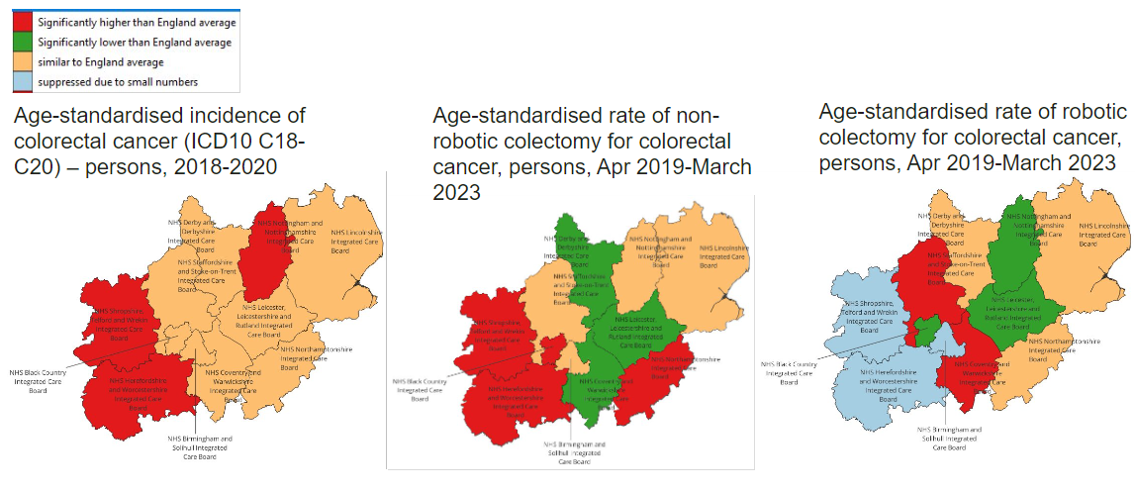
Figure 3: Colorectal cancer maps

Rectal Resection
The final analysis was based on 10 systematic reviews, with 6 assessed as being at low risk of bias, 2 as high risk, and 3 as being unclear. The evidence indicates that robotic-assisted surgery results in broadly similar outcomes to open and laparoscopic surgery, with the following key findings:
- Open Surgery - The evidence from a single study suggests that patients undergoing robotic-assisted rectal resection experience less blood loss and a shorter length of hospital stay compared with open surgery. The available literature demonstrates that there is no difference between the two techniques in terms of anastomotic leak rates, sexual dysfunction rates, or the rate of clear margins.
- Laparoscopic Surgery - The evidence demonstrates that robotic-assisted surgery rectal resection has a higher cost-utility than laparoscopic techniques. The available evidence for clinical parameters is mixed with results suggesting that robotic-assisted surgery is either better than or equivalent to laparoscopic techniques in terms of blood loss, the rate of conversion to open surgery, post-surgical urinary function, post-surgical quality of life scores, reintervention rates, and clear resection margins. There is no difference with regards to complication rates, morbidity, mortality, readmission, recurrence, distal/proximal resection margins, or R0 resection rates.

Summary
Our evidence indicates that robotic assisted surgery results in better outcomes than either open or laparoscopic techniques for patients undergoing a prostatectomy. For all other surgical procedures explored in our systematic review, robotic surgery was found to confer no benefit when compared with laparoscopic surgery (Table 1).
Table 1: Summary of outcomes from robotic assisted compared to open and laparoscopic surgery.
 | Robotic vs. Open | Robotic vs. Laparoscopic
Hysterectomy | Worse | No benefit
Cystectomy | No benefit | No benefit
Prostatectomy | Improvement | Improvement
Radical Nephrectomy | Improvement | No benefit
Partial Nephrectomy | Improvement | No benefit
Colonic Resection | (Insufficient evidence) | No benefit
Rectal Resection | No benefit | No benefit

Our search predominantly identified evidence relating to clinical effectiveness and patient related outcomes. Additional considerations when reviewing the use of robotic-assisted surgery are theatre time and costs, including for consumables and servicing of equipment. Where patient outcomes are demonstrated to be equivalent for different surgical techniques, these become particularly important factors to ensure the efficient use of public resources.
We also found that residents mainly go to their local Trust for robotic-assisted surgery. With providers having varying capacity for undertaking robotic-assisted surgery and using it for different indications which is expected to introduce inequalities in access.

Recommendations
- Based on the available data, the evidence supports the use of robotic-assisted surgery rather than open surgery or laparoscopic surgery for prostatectomy. We recommend surgical centres prioritise the use of robotic devices for those indications that have the strongest evidence base.
- A significantly greater body of evidence will be required to determine when robotic-assisted surgery is most effective and cost-effective and when there are potential benefits compared with laparoscopic and open techniques in respect of the surgical indication and patient demographics. We therefore recommend that commissioners require prospective data collection to expand the evidence base, as a mandatory requirement for funding of robotic assisted surgery procedures.
- We recommend that for indications where there is presently no or limited evidence to suggest that robotic assisted surgery has better outcomes than open surgery or laparoscopic surgery that funding should be restricted to patients who are entered into multi-centre clinical trials.
- Care pathways should be developed across the Midlands that bridge systems, to support equitable access for patients to robotic-assisted surgery regardless of geography. Our findings show that patient access is currently principally influenced by the availability of robots to their local provider, leading to unwarranted variation across the region.
- Formal commissioning policies should be developed in relation to each established or potential indication for the use of robotic assisted surgery. These should state whether robotic assisted surgery should be routinely funded or not and where this procedure is to be routinely funded the eligibility criteria should be clearly established.

Appendices

Appendix 1: Clinical terms and their definitions
Clinical Term | Definition
Anastomotic Leak | This is a defect in an anastomosis leading to a communication between the intra and extra luminal compartments.
Clear Resection Margin (Circumferential, and distal or proximal) | This is where the margin of specimen resected is clear of cancer on histopathological analysis.
Estimated Glomerular Filtration Rate (eGFR) Change | This is the change of the eGFR (a mathematically derived formula based on a patient’s serum creatinine, age, sex, and race), a key indicator of renal function.
Positive Surgical Margins | When cancer is present at the resected specimen margin.
R0 Rate | The R classification denotes the absence or presence of residual tumour after treatment. R0 corresponds to no residual tumour.
Venous Thromboembolism | This is a condition that occurs when a blood clot forms in a vein.
Warm Ischaemia Time | The time a tissue / organ / body part remains at body temperature after its blood supply has been reduced or cut off but before it is cooled or reconnected to a blood supply. This is important surgically as a shorter warm ischaemia time correlates with improved function.

