
Supporting a Greener NHS
A thematic analysis and survey of the Green Surgery landscape in the Midlands, UK.

Authors:
Trisha Khanani, Angela Holden, Tareq Al Saoudi, John Isherwood

Acknowledgements:
East Midlands and West Midlands Clinical Senates.
Emma Orrock, Head of Clinical Senates
Helena Clements, East Midlands Senate Assembly member
Liz Marder, East Midlands Senate Council member
Mark Cheetham, West Midlands Senate Council member

Introduction
There is a collective movement of social and political awareness with regards to global climate change. This has become an increasing local, national and international topic of concern. Every aspect of our daily activities are being scrutinised and the question of how we can move to more sustainable practice is being asked at every level. The 2009 Lancet Climate Change Commission stated that climate change was “the biggest global threat of the century” (1, 2). The concern of rising global temperatures secondary to the accumulation of green house gasses and carbon dioxide and the consequential effect on global climate is a particular aspect of concern. This has been summarised and condensed into the measurable metric termed “carbon footprint”, to which all activities have been measured by, this ensures consistency when reporting and comparing either usage or improvements made in achieving environmental impacts.

The healthcare sector has come under increasing scrutiny as it is estimated to be responsible for approximately 4.6% of the UK’s total carbon footprint and approximately 25% of the public sector’s footprint (2, 3, 4). On 1 July 2022, the NHS became the first health care system to embed net zero into legislation, through the Health and Care Act 2022. The Delivering a Net Zero NHS report is now issued as statutory guidance. This report is an ambitious account of NHS analytics and modelling underpinning the latest NHS carbon footprint, trajectories to net zero and the interventions required to achieve this ambition (5).

There has been an increasing focus on surgery and operating theatres because of their high utilisation of disposable resources, production of non-recyclable waste and production of harmful volatile anaesthetic agents. Operating theatres have had a seismic creep of expensive disposable equipment that has been unregulated with regards to consideration of the sustainability and green policies. The NHS, supported by several agencies including the UK Health Alliance on Climate Change, the Centre for Sustainable health care and the Health Foundation amongst others, has pledged to meet a “net zero” carbon target by 2040 in scope 1 and by 2045 in scope 2, through its Greener NHS programme (2, 6). There are now sustainability leads and standard operating procedures that are integral to each trust and integrated care board with a view to achieving this. Operating departments and in particular surgeons and anaesthetists have a crucial part to play in this objective.

There are numerous initiatives and documents some of which are summarised below:

Green Surgery: A Global Perspective (7)

A report from the UK Health Alliance on Climate Change (UKHACC). This report has wide ranging recommendations to achieving a Net zero carbon footprint.
- Aim: To reduce the environmental impact of surgical care while maintaining high-quality patient outcomes.
- Key Insights:
  - Interventions across care pathways, energy-efficient operating theatres, and sustainable anaesthesia practices are emphasized.
  - Prevention of surgical disorders is crucial for reducing carbon emissions.
  - Applying circular economy principles to surgical products helps reduce their environmental impact.

Green Surgery Challenge (8)
- Aim: Promoting low-carbon alternative products and processes in surgery.
- Actions:
  - Reusable instruments, maintenance, repair, and recycling.
  - Raising awareness and changing culture among the surgical community.
  - Partnering with other allied healthcare professionals and supporting services.

The Midlands Clinical Senates (East Midlands and West Midlands) have undertaken this project to identify key barriers to implementing sustainable practices in the surgical environment. The Senates’ Leadership Fellows have reviewed and evaluated the NHS Green Plans published by all 11 Integrated Care Systems (ICSs) in the Midlands. A comprehensive literature search and thematic literature analysis based on core areas for development was also undertaken to develop a framework for a stakeholder survey. The Senates then surveyed key stakeholders within NHS Trusts in the Midlands to identify barriers to implementing change.

This document summarises the project under three key sections:
- Review of ICS Green Plans
- Thematic Literature Analysis
- Stakeholder Survey

- Review of ICS Green Plans

NHS England first published the national strategy “Delivering a net zero National Health Service” in 2020 (6). All NHS Trusts were required to develop their own Green Plan, as set out by the 2021/2022 NHS Standard Contact (9). In order to support organisations to produce a meaningful Green Plan, NHS England produced guidance on “How to produce a Green Plan: A three year strategy to net zero” (10).
Every NHS trust and ICS were required to finalise their Green Plans by January 2022, followed by each ICS then publishing a system-wide Green plan 2 months later.

  - Key areas of focus
The Green Plan guidance denotes that the following areas of focus should be included as chapters in a Green Plan, with specific, tangible examples provided to demonstrate how the domain will be addressed.
- ‘Workforce and leadership’: Defining the organisation’s operational approach to sustainability, including workforce initiatives, training and committees.
- ‘Sustainable models of care’: How key principles will be rooted in service delivery and using innovative pathways to reduce emissions.
- ‘Digital transformation’: The use of technology to deliver care and services more efficiently and in a more sustainable way.
- ‘Travel and transport’: Reducing carbon emissions through ‘greener’ transport – including public transport, fleet vehicles and the transport of goods.
- ‘Estates and facilities’: Improving efficiency and reducing carbon emissions directly relating to infrastructure – for example modernising buildings, heating systems and reducing waste.
- ‘Medicines’: Reviewing prescribing practices and ways in which emissions relating to medicines can be reduced – this section also includes the ‘Early Interventions’ in the NHS Standard Contract relating to anaesthetic gases and inhalers.
- ‘Supply chain and procurement’: This domain accounts for the largest contributor for carbon emissions in the NHS, with the supply chain contributing to 62% of all emissions.
- ‘Food and nutrition’: How catering can be adjusted to reduce emissions, including sourcing local, less-processed food.
- ‘Adaptation’: Ways in which the organisation may adapt to reduce the impact of climate change, including extreme heat or flooding.

  - Early interventions as per NHS Standard Contract
The following interventions were included in the NHS Standard Contract and were considered early, mandatory interventions - the minimal foundations for Trusts and ICSs which should have been implemented before the publication of Green Plans.
- Board-level lead: Each ICS should have a designated, board level lead for sustainability and the implementation of the ICS Green Plan.
- Renewable energy: 100% of energy purchased should be renewable from April 2021.
- Desflurane use: Anaesthetic gases used during surgery represent a sizable proportion of carbon emissions, in particular desflurane. Through transforming anaesthetic practice, desflurane use should be reduced to less than 10% of volatile anaesthetic gases use in each Trust.
- Lower carbon inhalers: Metered dose inhalers contain propellants which contribute significantly to NHS carbon emissions. The ICS should make plans to encourage the prescription of alternative, low carbon inhalers.
- Ultra-Low and Zero emission vehicles: All new vehicles purchased or leased must be either ultra-low or zero emission vehicles.
- Travel plan: Each ICS should establish a travel plan, finding lower carbon alternatives for both patient and staff transport and encouraging active travel.
- Outpatient activity: 25% of all outpatient activity should take place remotely (for example, by telephone consultation).

  - Methods
Between June and September 2023, Green Plans were reviewed from 11 Integrated Care Systems across the East Midlands and West Midlands. The content of each plan was reviewed to determine whether each of the key areas of focus were included and if so, whether specific examples were included. Each individual review was reviewed by two independent reviewers to ensure consistency.

  - Findings
The findings of the ICS Green Plans are shown in a heat map (Figure 1).

Figure 1: ICS Green Plans – Heat Map
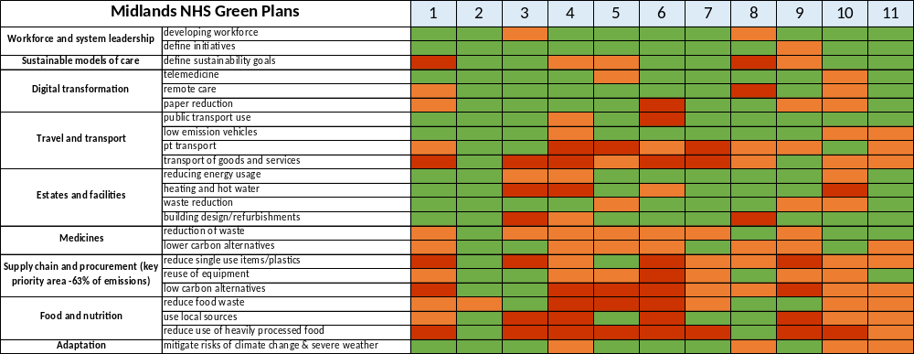
Specific plans or examples demonstrating how the ICS will achieve

Domain mentioned, no specific plans or examples provided
Domain not mentioned within ICS Green Plan

Integrated Care Systems have been anonymised (numbers 1 – 11). Each Green Plan was assessed for inclusion of the areas of focus outlined in the Green Plan guidance, along with the mandatory early interventions.
The key for the heat map is as follows:
- Green: The plan mentions the domain and provides evidence of specific examples of how the domain will be achieved. These examples may already have been implemented, or there is a clear plan of how these plans will be achieved.
- Amber: The plan mentions the domain but does not provide evidence of specific examples locally.
- Red: The plan does not mention the domain at all.
As demonstrated by the heat map, there was significant variation across the ICS green plans. Some plans were comprehensive, including multiple specific examples demonstrating significant commitment to the greener NHS with appropriate resource and time allocated to the writing of the report. However, some plans were more basic, without many specific examples or clear plans as to how the needs of each domain would be met – in general, these Green Plans were shorter in length and less comprehensive.
Across the board, ICS plans demonstrated consistent commitment to the delivery of remote care, particularly for outpatient attendances – though, this was perhaps reflective of change already implemented as a direct consequence of the Coronavirus pandemic which prevented clinical teams delivering face-to-face outpatient care.
There were particular examples of excellence, with one ICS exploring funding for a wind farm in order to produce their own source of renewable energy. Other examples included a partnership with Vanguard, a medical device manufacturer in Europe which re-manufactures surgical energy devices.

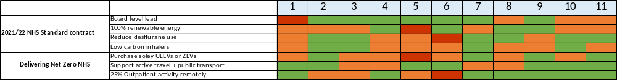
Figure 2: ICS Green Plan review – Early Interventions as per NHS Standard Contract

Specific plans or examples demonstrating how the ICS will achieve
Domain mentioned, no specific plans or examples provided

Domain not mentioned within ICS Green Plan

Figure 2 shows the inclusion of specific examples relating to the early interventions recommended by the NHS Standard Contract, which should have been implemented by mid 2022 (notably a year prior to our reviews of the NHS green plans). Our review demonstrated that these had not been consistently represented across the board.
Despite accounting for 62% of all emissions, specific interventions and examples relating to procurement and the supply chain were limited. With such a significant contribution to the carbon footprint of the NHS, one could expect this area to have featured more consistently across Green Plans – raising the question as to why tangible examples were so limited and whether there were any barriers at play.

  - Conclusions
All NHS Trusts and ICSs were required to develop Green Plans in accordance with NHS England guidance. Our review of the Green Plans across the Midlands demonstrated significant variation in the quality of plans and the presentation of specific, tangible interventions in order to achieve the required targets and outcomes. Whilst some ICS plans were completed to an extremely high level, with plenty of specific interventions and shining a light on excellence, many failed to demonstrate significant, tangible progress to the NHS’s goals of achieving Net Zero. None of the Green Plans gave specific examples across every domain, suggesting further work is needed, particularly with exploring barriers to implementing carbon reducing interventions.

- Thematic Literature Analysis

  - Aims
The primary objective of this thematic literature analysis was to identify the key barriers to the implementation of change and the promotion of sustainability within the surgical environment.

Understanding these barriers is crucial for devising effective strategies to overcome them and accelerate the adoption of sustainable practices in operating theatres. By undertaking a comprehensive examination of the literature and employing thematic analysis, this study aims to identify, categorise and explore the various challenges that impede the widespread adoption of sustainable practices in Surgery.
  - Methods
Following multiple meetings and discussions with experts in the field of Sustainability, it was deemed crucial to search the literature and explore the barriers to sustainability in the surgical environment. Three key areas were identified:
- Reusable surgical gowns
- Re-sterilisation of surgical energy devices
- Waste management and recycling practices within surgical theatres
For each of the three key areas listed, a computerised search was conducted using the Ovid MEDLINE and Embase databases, facilitated by an experienced librarian affiliated with the University Hospitals of Leicester NHS Trust. The search identified articles published until May 2023. The search strategies can be found in Appendices 1, 2 and 3.
Following the retrieval of articles, abstracts were screened by three Leadership Fellows to identify the prevalent barriers associated with the implementation of change and the advancement of sustainability in the surgical environment.
  - Results

Following the literature search, a total of 25 abstracts pertinent to reusable surgical gowns were identified. Additionally, 28 abstracts were retrieved for the re-sterilisation of surgical energy devices, while 29 abstracts were obtained pertaining to waste management and recycling practices within surgical theatres.

    - Reusable Surgical Gowns

Key themes and barriers to the implementation of reusable surgical gowns emerged across three areas (Figure 3).

Figure 3: Thematic literature analysis for “Reusable Surgical Gowns”.

There were frequently issues surrounding the efficacy of reusable surgical gowns as a sterile barrier, including concerns relating to infection control, safety profile, impermeability and quality maintenance. The perception that reusable surgical gowns could potentially increase the risk of surgical site infections was a significant barrier.

Findings from cost studies yielded mixed results, indicating uncertainty regarding the economic viability of implementing reusable gowns. Amongst stakeholders, there were concerns regarding the upfront and long-term costs associated with transitioning to reusable gowns, which may pose financial challenges to healthcare facilities.

There were also user-related concerns regarding the comfort and wearability of reusable gowns, particularly over prolonged periods, with emphasis on factors such as breathability and overall comfort for healthcare professionals during surgical procedures.

    - Re-sterilisation of Surgical Energy Devices

Key themes and barriers to the use of re-sterilised surgical energy devices emerged across three areas (Figure 4).

Figure 4: Thematic literature analysis for “Re-Sterilisation of Surgical Energy Devices”.

The thematic analysis of the literature highlighted two key barriers to the re-sterilisation of surgical energy devices. The most significant and prevalent concern was that damage inflicted to the instruments during the re-sterilisation process could impair function such as vascular seal integrity, tissue release and cutting blade functions. The implications to the safety profile of the devices was a key theme highlighted from the analysis.

The literature also identified that infection control concerns were a barrier as remnant material had been identified on re-sterilised devices and there were concerns of inadequate cleaning of energy devices prior to the re-sterilisation process.

    - Waste Management and Recycling within Surgical Theatres

Key themes and barriers to waste management and recycling within surgical theatres emerged across four areas (Figure 5).

Figure 5: Thematic literature analysis for “Waste Management and Recycling within Surgical Theatres”.

During the thematic literature analysis on recycling and waste management in surgical theatres, several key barriers emerged. Predominantly, a prevalent theme was the insufficient education or knowledge among staff regarding waste segregation and recycling practices. Additionally, there was a recurring issue concerning the lack of support from hospital leadership and inadequate provision of appropriate bins in the surgical environment. A less common theme was the resistance to change exhibited by staff, coupled with the convenience factor, particularly during emergencies or high workload periods.

  - Conclusions
This thematic literature analysis underscores significant barriers to implementing sustainability in the surgical environment. Several themes were identified, spanning concerns about infection control, cost implications, instrument damage and safety, and inadequate waste management practices. To address these challenges, healthcare facilities must prioritise staff education, leadership commitment, and technological advancements. By investing in comprehensive training programmes, promoting organisational commitment to sustainability, and implementing rigorous quality control measures, healthcare facilities can overcome these barriers and advance sustainability initiatives in the surgical setting.

Stakeholder Survey
A framework for the “Supporting a Greener NHS Survey” was developed based on our extensive literature search and thematic analysis. The literature analysis comprised of three computerised searches of the Ovid MEDLINE and Embase databases for articles published up to May 2023. The search topics were: reusable surgical gowns, re-sterilisation of surgical energy devices, and waste management and recycling in operating theatres.
The key themes and barriers to implementation identified were:
- Infection control
- Cost
- Safety concerns
- Lack of education
- Lack of leadership and support

These barriers were used to form a framework for the survey. A pilot survey was drafted by five NHS Midlands Senates Leadership Fellows and distributed on Microsoft Forms for expert feedback and verification. Following feedback from the pilot survey, the survey was refined and proceeded to wider dissemination to key stakeholders and experts across the Midlands region, this included, but not limited to, sustainability leads, procurement leads, theatre managers, surgeons and surgical teams. 94 responses from 9 trusts were available for analysis. There was a good spread of responses from all these trusts. Not all questions were answered by each responder, however all answered questions were analysed. Responders included:
- 7 – Clinical lead / Procurement lead
- 6 – Chief Medical Officer / Medical Director
- 27 – Manager
- 24 – Surgeons
- 30 – Nurses, theatre practitioners, scrub nurses, allied theatre staff
Once collated the responses were anonymised. The survey questions are shown below.

Supporting a Greener NHS Questionnaire.

- What is your position within your Trust/Organisation?
- What is your profession?
- Please state the name of your employing Trust/Organisation
- Do you have a sustainability lead within your Trust/Organisation? (Yes, no, don’t know)
- If yes, what is their role within the Trust/Organisation? (Clinician, estates department lead, both, other)
- Does your Trust/Organisation have a sustainability plan that you are aware of? (Yes, no, don’t know)
- How do you engage your stakeholders with the sustainability plan? (Internal communication, social media, education events, not applicable, other)
- What is the priority focus in terms of sustainability? (Financial, recycling, reusable equipment, reducing carbon footprint, other)
- Do you use drapes within your Trust/Organisation? (Yes, no, both, don’t know)
- What do you think are the barriers to using reusable drapes? (Financial, surgeon/clinician, availability, infection, none, other)
- Do you use reusable gowns within your Trust/Organisation? (Yes, no, both, don’t know)
- What do you think are the barriers to using reusable gowns? (Financial, surgeon/clinician, availability, infection, none, other)
- Do you use reusable laparoscopic ports within your Trust/Organisation? (Yes, no, both, don’t know), (What type: Disposable, reusable, hybrid (reposable), mix, don’t know)
- If you use “a mix” what proportion are reusable? (0-25%, 25-50%, 52-75%, >75%, don’t know)
- If you use “a mix” what is your preference? (Disposable, reusable, reposable)
- What do you think are the barriers to using reusable ports? (Financial, surgeon/clinician, availability, infection, none, other)
- Do you use reusable laparoscopic graspers within your Trust/Organisation? (Yes, no, both, don’t know)
- If you use “a mix” what proportion are reusable? (0-25%, 25-50%, 52-75%, >75%, don’t know)
- If you use “a mix” what is your preference? (Disposable, reusable, reposable)
- What do you think are the barriers to using reusable laparoscopic graspers? (Financial, surgeon/clinician, availability, infection, none, other)
- Do you use reusable laparoscopic scissors within your Trust/Organisation? (Yes, no, both, don’t know)
- If you use “a mix” what proportion are reusable? 0-25%, 25-50%, 52-75%, >75%, don’t know)
- If you use “a mix” what is your preference? (Disposable, reusable, reposable)
- What do you think are the barriers to using reusable laparoscopic scissors? (Financial, surgeon/clinician, availability, infection, none, other)
- How are your energy devices managed? (Discarded, recycled, repackaged / remanufactured, a mix, don’t know, other)
- Are you aware that these devices can be professionally sterilised? (Yes/ no)
- What are your main barriers to improving sustainability in theatres? (Financial, infection control, attitudes/resistance to change- surgeons, Attitudes/resistance to change- staff, Attitudes/resistance to change- procurement, Lack of senior leadership, lack of awareness/education, reusability, other) – 5 point Likert scale (Definitely no, possibly no, don’t know, possibly yes, definitely yes)
- If other please state
- Please add any additional comments you would like to make.

  - Survey Results

Regarding the presence of a sustainability lead within Trusts/Organisations, 48 respondents confirmed the existence of such a role, indicating that over half of the entities surveyed have a designated individual responsible for sustainability efforts. Conversely, 34 respondents were uncertain ("Don't Know"), and 7 explicitly stated the absence of a sustainability lead, Figure 6A.

Further inquiry was made among the 48 respondents who acknowledged the presence of a sustainability lead within their organisation. They were asked to specify whether the role was focused on clinical, estate management, or encompassed both areas. According to the responses, 13 identified the presence of a clinical sustainability lead, 15 reported an estate department lead, and 6 indicated that their organisation had leads in both areas. Remarkably, 12 respondents were unsure about the specific focus of the sustainability lead in their organisation, Figure 6B.

Figure 6: Availability, background and focus areas of sustainability leadership in trusts/organisations. (A) Availability of sustainability in the different trusts and organisations. (B) Background and focus of the sustainability lead in trusts/organisations.
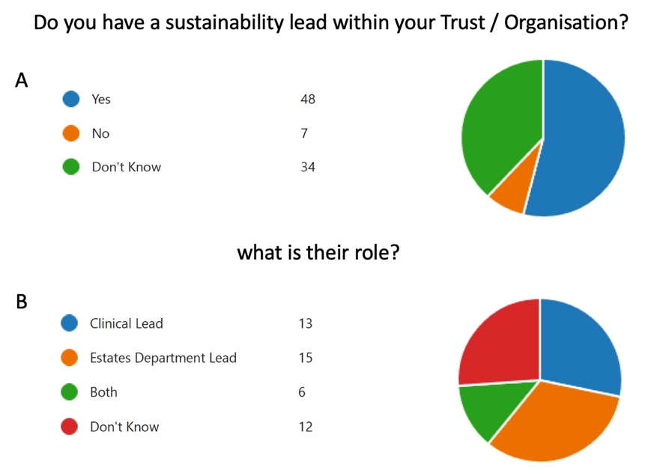

When participants were asked about the existence of a sustainability plan within their trust or organisation, 43 affirmed its presence, while 6 denied having any such plan. Additionally, 38 participants were unsure about the existence of a sustainability plan in their trust or organisation, Figure 7A. The responders to this question were predominantly clinical staff and split between surgeons and theatre staff. The methods of engagement and communication about the sustainability plan varied significantly among the trusts. A majority of 49 respondents identified internal communication as the primary method of engagement, highlighting its importance in disseminating information on sustainability initiatives. On the other hand, 11 participants pointed to social media as their method of communication, suggesting a broader, public-facing approach. Furthermore, 14 respondents mentioned educational events as a platform for engagement about sustainability plans, indicating the use of more interactive and informative sessions. Interestingly, 5 participants noted that their trusts utilise other unspecified methods for communicating about their sustainability plan. Notably, a significant number of 31 respondents indicated that the methods of communication about the sustainability plan were not applicable to them, Figure 7B.

Figure 7: (A) The awareness of participants of their organisation’s sustainability plan. (B) Ways of engagement of stakeholders with their sustainability plan.
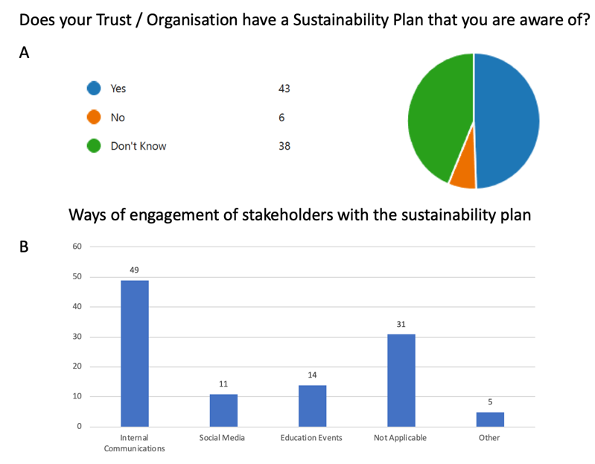
Regarding the participants' priorities concerning sustainability plans, a substantial majority of 62 individuals identified reducing their carbon footprint as their primary goal. Closely following, 52 participants highlighted recycling as their main focus. Additionally, financial savings and the use of reusable equipment were cited by 42 and 44 participants respectively, as their primary concerns, Figure 8.
Figure 8: Participants’ priority of the sustainability plans.
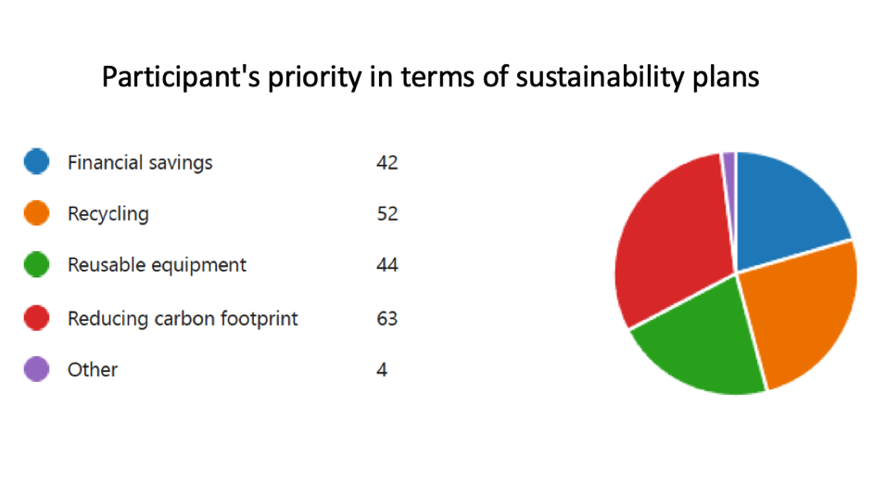
In this survey, participants discussed the practices of their trusts regarding the use of reusable drapes. The majority, with 40 respondents, indicated that their trusts do not employ reusable drapes. Meanwhile, 26 participants reported a combined use of reusable and disposable drapes within their trusts. A smaller contingent of 15 respondents mentioned the exclusive use of reusable drapes in their operations, while 7 were unsure about the type of drapes their trusts utilise, Figure 9A.

When it came to the barriers preventing the use of reusable drapes, surgeon preference emerged as the primary obstacle, cited by 33 participants. Infection control concerns followed closely, acknowledged by 26 respondents as a significant barrier. Financial reasons and availability issues were equally regarded as barriers by 23 participants each. Interestingly, 10 respondents did not identify any barriers to using reusable drapes. However, 11 participants pointed out the existence of other unspecified barriers to the adoption of reusable drapes, Figure 9B.
Figure 9: (A) The usage of reusable drapes among trusts as reported by the participants. (B) Barriers to the usage of reusable drapes from the participant’s point of view.
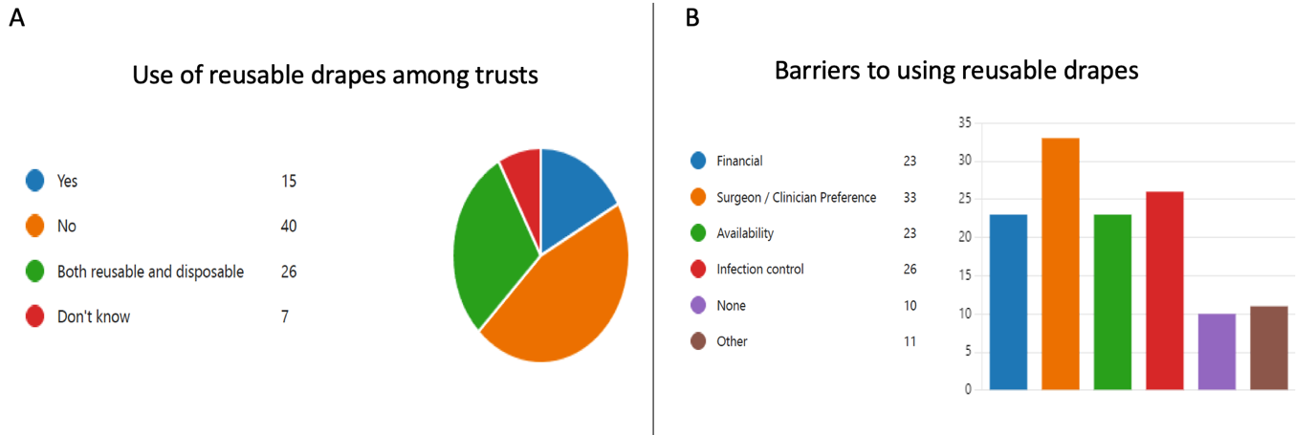
In the context of reusable gowns within trusts, the survey responses revealed diverse practices and perceptions. A majority of 31 participants reported that their trusts do not utilise reusable gowns. Conversely, 27 respondents indicated a hybrid approach, employing both reusable and disposable gowns. A smaller group, consisting of 23 participants, shared that their trusts exclusively use reusable gowns. Meanwhile, 8 participants were uncertain about the type of gowns in use within their trusts, Figure 10A.

When exploring the barriers to adopting reusable gowns, surgeon preference and availability were identified as the primary barriers, each noted by 29 participants. Financial constraints and concerns related to infection control were equally regarded as significant barriers by 22 participants. However, a noteworthy 18 respondents perceived no barriers to using reusable gowns. In contrast, 9 participants pointed to other, unspecified barriers, Figure 10B.

Figure 10: (A) The usage of reusable gowns among trusts as reported by the participants. (B) Barriers to the usage of reusable gowns from the participant’s point of view.
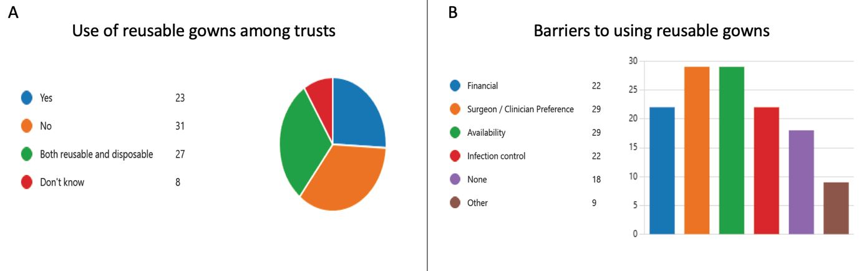

When inquiring about the utilisation of reusable laparoscopic ports within their trusts, participants offered a variety of responses. A significant portion, 39 respondents, indicated that their trusts exclusively use disposable ports. Meanwhile, 16 participants noted the use of both reusable and disposable ports. Notably, the exclusive use of reusable ports, as well as the use of hybrid (reposable) ports, was reported by only one participant each, Figure 11A.

The survey also sought to identify barriers to the adoption of reusable laparoscopic ports. Surgeon preference emerged as the predominant obstacle, with 38 participants identifying it as the main barrier. Infection control concerns were the next most cited barrier, with 26 respondents pointing to it as a reason for not adopting reusable ports. Financial considerations and issues with availability were equally noted by 24 participants as barriers. On the other hand, 11 participants reported no barriers to using reusable laparoscopic ports. However, 12 participants identified other unspecified barriers, Figure 11B.

Figure 11: (A) The usage of reusable laparoscopic ports among trusts as reported by the participants. (B) Barriers to the usage of reusable laparoscopic ports from the participant’s point of view.
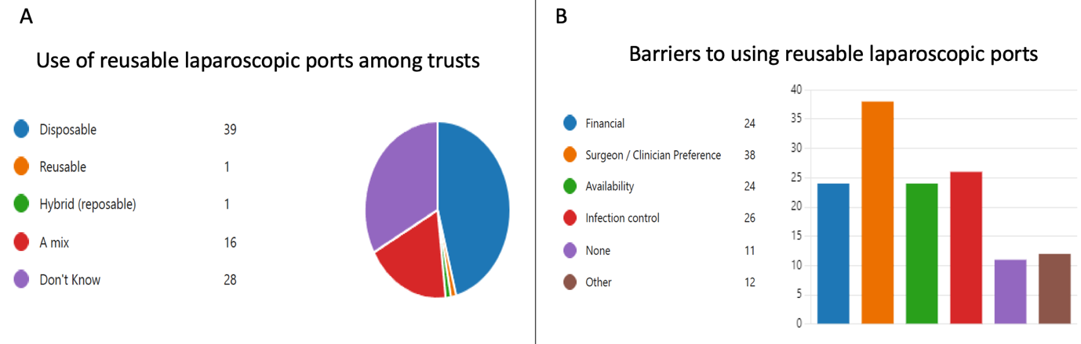
When it comes to the use of reusable laparoscopic graspers within their trusts, the survey participants presented a varied picture. Notably, the largest group, consisting of 29 participants, admitted to not knowing which type of laparoscopic graspers their trust utilizes. Meanwhile, 23 respondents each reported the use of either exclusively reusable graspers or a combination of disposable and reusable graspers in their trust. A smaller number, only 8 participants, indicated that their trust relies solely on disposable laparoscopic graspers. Interestingly, none of the respondents noted the use of hybrid (reposable) graspers, and only 2 mentioned the use of other types of graspers, Figure 12A.

In exploring the barriers to adopting reusable laparoscopic graspers, surgeons' preference was identified as the most significant hurdle, with 33 participants viewing it as the primary obstacle. Availability was noted as a barrier by 20 participants. Financial considerations and concerns related to infection control were cited by 15 and 11 participants, respectively. Despite these challenges, 19 respondents reported no barriers to the use of reusable laparoscopic graspers. Conversely, 12 participants highlighted other, unspecified barriers, Figure 12B.

Figure 12: (A) The usage of reusable laparoscopic graspers among trusts as reported by the participants. (B) Barriers to the usage of reusable laparoscopic graspers from the participant’s point of view.
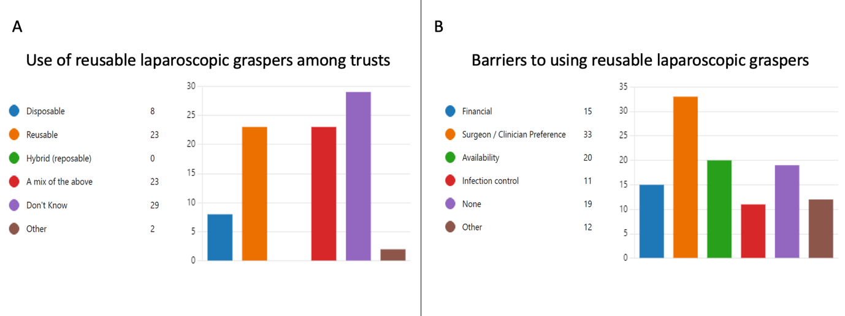

In the discussion about the use of laparoscopic scissors within their trusts, a notable number of participants, 31, indicated uncertainty regarding the type of laparoscopic scissors utilised. A considerable segment, 27 respondents, reported the exclusive use of disposable laparoscopic scissors in their practices. Meanwhile, the adoption of reusable laparoscopic scissors was confirmed by 9 participants, and a hybrid version was mentioned by 3 respondents. Additionally, 15 participants acknowledged using a combination of disposable, reusable, and hybrid laparoscopic scissors, Figure 13A.

When probing into the barriers hindering the wider adoption of reusable laparoscopic scissors, surgeon preference emerged as the predominant barrier, with 29 participants identifying it as a significant factor. The issue of availability was the next most cited barrier, raised by 21 participants, highlighting logistical challenges in procuring reusable options. Financial considerations and infection control concerns were also noted as barriers by 18 and 13 respondents respectively. Fifteen respondents perceived no barriers to the use of reusable laparoscopic scissors. On the other hand, 14 participants mentioned facing other, unspecified barriers, Figure 13B.

Figure 13: (A) The usage of reusable laparoscopic scissors among trusts as reported by the participants. (B) Barriers to the usage of reusable laparoscopic scissors from the participant’s point of view.
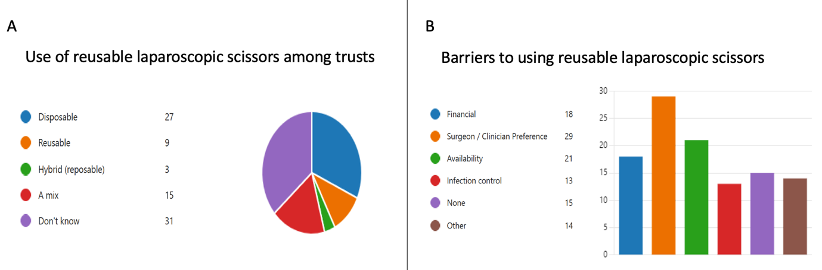

When it comes to the recyclability of the surgical energy devices used within their trusts, a significant portion of participants, 48, revealed they were unaware that such devices could be recycled, Figure 14A. As for the local management of these energy devices within their trusts, 35 participants admitted uncertainty about the specific handling processes, while 25 disclosed that these devices are typically discarded after use. In contrast, only a small fraction of respondents, 3 and 1 respectively, reported that energy devices in their trusts are recycled or remanufactured, indicating rare instances of sustainable management practices. Furthermore, 15 participants noted that the management of these devices involves a combination of the methods mentioned above. A minority of 4 respondents stated that their institutions employ other methods for managing these devices, Figure 14B.

Figure 14: (A) Awareness of potential recyclability of surgical energy devices among participants (B) Ways of management of the used surgical energy devices in their trust/organisation.
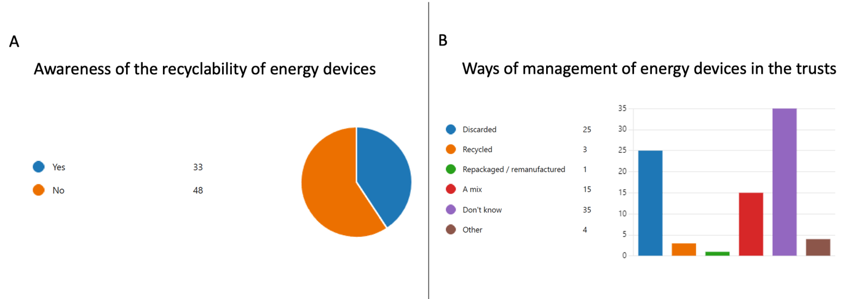
Participants in the survey were asked about their perspectives on the principal barriers to enhancing sustainability in operating theatres. The primary barriers, as identified by the respondents, were the attitudes of surgeons and their resistance to change, coupled with a lack of awareness and education on sustainability practices.
Following closely, financial constraints were recognized as another substantial barrier. Beyond these leading issues, participants also pointed out a range of other factors contributing to the challenge. These included concerns related to infection control, the attitudes and resistance to change among theatre staff and procurement departments, the absence of senior leadership driving sustainability initiatives, and issues surrounding the reusability of medical tools and devices, Figure 15.

At the conclusion of the survey, participants were provided with a free-text section to express their opinions on sustainability in theatres. Their responses encompassed the following themes:
- Awareness and Education: A recurring theme is the need for heightened awareness and education among all staff members. “Product awareness” and “Improving sustainability will need to be a collaborative approach”. The responsibility of a sustainability manager/lead is highlighted, emphasising the need for comprehensive strategies that encompass more than just clinical or estate involvement.
- Communication Gaps: Remarks about “poor communication, decisions made by people who are unaware of the requirements of the job”.
- Support and Commitment: There are reports of a lack of support from Estates when attempts are made to introduce recycling, indicating a need for stronger institutional commitment to sustainability initiatives.
- Waste Management: Multiple participants are concerned about the large amounts of ‘clean’ waste, such as disposable packaging, and the need for better waste stream disposal practices to reduce incineration costs and landfill damage.
- Single-use Items: The excessive use of single-use items is cited, along with a call for a review of reusable instrumentation, which has fallen out of practice but is seen as a necessity by staff who are concerned about waste.
- Resistance and Preferences: Influencing consultants and dealing with entrenched clinical preferences are identified as major issues, as sustainability and cost savings often take a backseat to individual choice.
- Institutional Processes and Education: Regular sustainability meetings and coordination with procurement are discussed. The challenge of shifting from single use to reusable items is framed as an educational challenge, with concerns about reprocessing and maintaining standards of care.
- Procurement Challenges: Participants note that procurement departments sometimes choose less expensive products that are not user-friendly or sustainable, resulting in a false economy.
- Supplier Issues: Even successful transitions to sustainable practices, such as moving to reusable theatre gowns, encounter issues such as supplier reliability, which can undermine sustainability efforts.
- Recycling Practicalities: Practical barriers to recycling, like improper segregation of waste (e.g., paper into tiger bags), are mentioned, along with uncertainty about the effectiveness of waste segregation.
- Logistical Challenges: Responses such as “Sterilisation processes and the logistics involved,” “Maintenance,” and “off-site with limited capacity”.

Figure 15: Main barriers to enhancing sustainability in operating theatres as reported by the participants.
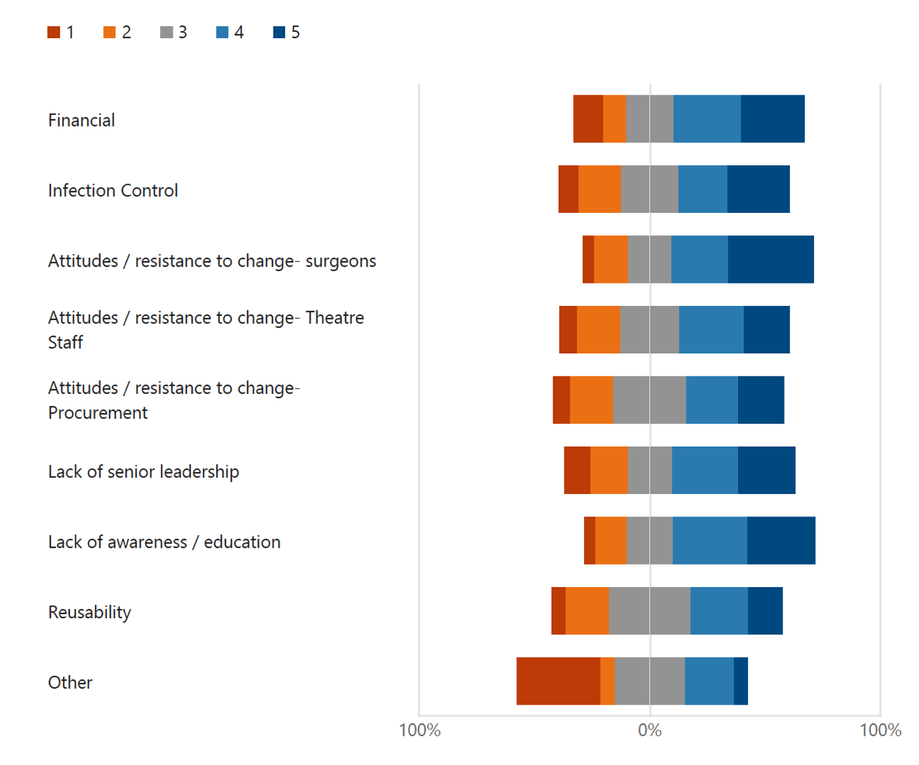

Conclusions and Recommendations
The literature analysis and survey of stakeholders in the Midlands identified several barriers to implementing sustainable changes. With national, regional and local organisational impetus coupled with clinical leadership commitment to sustainability, these barriers can be overcome with multi-disciplinary involvement. By investing in comprehensive training programmes and implementing rigorous quality control measures with input from infection prevention and control teams, clinical leaders and clinicians are best placed to help overcome these barriers and promote sustainability in the surgical environment.

References

- Costello A, Abbas M, Allen A, et al. Managing the health effects of climate change: Lancet and University College London Institute for Global Health Commission. Lancet 2009; 373: 1693–1733
- Sustainability in the Operating Theatre. A guide to good practice. Royal College of Surgeons of England. May 2022.
- NHS England. Greener NHS https://www.england.nhs.uk/greenernhs
- Naylor C, Appleby J. Sustainable Health and Social Care: Connecting environmental and financial performance. London: King’s Fund, 2012.
- https://www.england.nhs.uk/greenernhs/a-net-zero-nhs/
- NHS England. Delivering a net zero NHS. https://www.england.nhs.uk/greenernhs/ a-net-zero-nhs
- Brighton & Sussex Medical School, Centre for Sustainable Healthcare, and UK Health Alliance on Climate Change (2023). Green surgery: Reducing the environmental impact of surgical care. London: UKHACC. https://ukhealthalliance.org/sustainable-healthcare/green-surgery-report/
- https://sustainablehealthcare.org.uk/what-we-do/green-surgery-challenge
- NHS England, 2021. NHS Standard Contract 2021/22. Service Conditions (Full Length) Available from URL: 3-FL-SCs-2122-republished-may.pdf (england.nhs.uk)
- NHS England, 2021. “How to produce a Green Plan: a three-year strategy towards net zero”. Available from URL: How to produce a Green Plan: A three-year strategy towards net zero (england.nhs.uk)

Appendices

Appendix 1

Search Strategy for Reusable Surgical Gowns

Ovid MEDLINE® ALL <1946 to May 11, 2023>
1 Surgical Attire/ 104
2 ((surgical or surgery or theatre* or theater* or operating room) adj2 (gown* or dress or attire)).mp. [mp=title, book title, abstract, original title, name of substance word, subject heading word, floating sub-heading word, keyword heading word, organism supplementary concept word, protocol supplementary concept word, rare disease supplementary concept word, unique identifier, synonyms, population supplementary concept word, anatomy supplementary concept word] 384
3 1 or 2 384
4 (disposable* or single-use or “single use”).mp. [mp=title, book title, abstract, original title, name of substance word, subject heading word, floating sub-heading word, keyword heading word, organism supplementary concept word, protocol supplementary concept word, rare disease supplementary concept word, unique identifier, synonyms, population supplementary concept word, anatomy supplementary concept word] 22691
5 Disposable Equipment/ 5282
6 4 or 5 22691
7 (reusable or re-usable or multi-use or multiuse or “multi use”).mp. [mp=title, book title, abstract, original title, name of substance word, subject heading word, floating sub-heading word, keyword heading word, organism supplementary concept word, protocol supplementary concept word, rare disease supplementary concept word, unique identifier, synonyms, population supplementary concept word, anatomy supplementary concept word] 9560
8 Equipment Reuse/ 3183
9 7 or 8 12171
10 3 and 6 and 9 34
11 *”Protective Clothing”/ 3147
12 6 and 9 and 11 44
13 3 and 9 43
14 3 and 6 71

Embase <1974 to 2023 May 12>
1 surgical gown/ 874
2 surgical attire/ 220
3 ((surgical or surgery or theatre* or theater* or operating room) adj2 (gown* or dress or attire)).mp. 1305
4 1 or 2 or 3 1305
5 (disposable* or single-use or “single use”).mp. 32095
6 disposable equipment/ 10662
7 5 or 6 32095
8 (reusable or re-usable or multi-use or multiuse or “multi use”).mp. 12465
9 recycling/ 32857
10 8 or 9 44518
11 4 and 7 and 10 47

Appendix 2

Search Strategy for Re-sterilisation of Surgical Energy Devices

Ovid MEDLINE® ALL <1946 to May 18, 2023>
1 Energy device*.mp. 1301
2 Electrosurgery/ 4672
3 (harmonic* adj2 (scalpel* or shear*)).mp. [mp=title, book title, abstract, original title, name of substance word, subject heading word, floating sub-heading word, keyword heading word, organism supplementary concept word, protocol supplementary concept word, rare disease supplementary concept word, unique identifier, synonyms, population supplementary concept word, anatomy supplementary concept word] 1116
4 ligasure.mp. 831
5 thunderbeat.mp. 61
6 1 or 2 or 3 or 4 or 5 7669
7 Laparoscopy/ or Laparoscop*.mp. 169412
8 6 and 7 1170
9 (re-sterili?ation or resterili?ation).mp. [mp=title, book title, abstract, original title, name of substance word, subject heading word, floating sub-heading word, keyword heading word, organism supplementary concept word, protocol supplementary concept word, rare disease supplementary concept word, unique identifier, synonyms, population supplementary concept word, anatomy supplementary concept word] 141
10 exp Sterilization/ 33933
11 9 or 10 34003
12 6 and 8 and 11 3
13 6 and 11 18
14 Equipment Reuse/ or reusable.mp. 11401
15 6 and 14 40
16 reprocess*.mp. 4548
17 decontamination.mp. or Decontamination/ 16139
18 16 or 17 20441
19 6 and 18 10

Embase <1974 to 2023 May 19>
1 Energy device*.mp. 1636
2 Electrosurgery/ 6032
3 (harmonic* adj2 (scalpel* or shear*)).mp. [mp=title, abstract, heading word, drug trade name, original title, device manufacturer, drug manufacturer, device trade name, keyword heading word, floating subheading word, candidate term word] 2297
4 ligasure.mp. 2516
5 thunderbeat.mp. 272
6 1 or 2 or 3 or 4 or 5 12061
7 Laparoscopy/ or Laparoscop*.mp. 294095
8 6 and 7 3652
9 (re-sterili?ation or resterili?ation).mp. [mp=title, abstract, heading word, drug trade name, original title, device manufacturer, drug manufacturer, device trade name, keyword heading word, floating subheading word, candidate term word] 201
10 exp Sterilization/ 22082
11 9 or 10 22166
12 6 and 8 and 11 16
13 6 and 11 41
14 Equipment Reuse/ or reusable.mp. 43568
15 6 and 14 74
16 reprocess*.mp. 6914
17 decontamination.mp. or Decontamination/ 20440
18 16 or 17 27058
19 6 and 18 18

Appendix 3

Search Strategy for Waste Management and Recycling in Surgical Theatres

Ovid MEDLINE® ALL <1946 to May 17, 2023>
1 Operating Rooms/ 15790
2 (surgery or theater* or theatre* or operating room*).mp. [mp=title, book title, abstract, original title, name of substance word, subject heading word, floating sub-heading word, keyword heading word, organism supplementary concept word, protocol supplementary concept word, rare disease supplementary concept word, unique identifier, synonyms, population supplementary concept word, anatomy supplementary concept word] 3070105
3 1 or 2 3070105
4 Waste Management/ 9395
5 sustainability.mp. 42638
6 recycling.mp. or Recycling/ 47146
7 4 or 5 or 6 95389
8 3 and 7 1220
9 8 1220
10 limit 9 to yr=”2013 -Current” 955
11 state medicine/ 61807
12 limit 11 to yr=”2013 -Current” 16519
13 united kingdom.af. 920167
14 10 and 11 and 13 9
15 10 and 11 12
16 10 and 13 54
17 3 and 6 320
18 1 and 4 20
19 1 and 6 51

