Searching for Answers: Using Google Trends data to inform Long COVID Service Provision

Timothy Robbins^{1,2}, Kamlesh Patel^{1,3}

- Midlands Clinical Senates: East Midlands Clinical Senate, NHS England (Midlands), Birch House Ransom Wood Business Park Southwell Road West Rainworth Nottingham NG21 0HJ, United Kingdom and West Midlands Clinical Senate, NHS England (Midlands) 23 Stephenson Street Birmingham B2 4BJ, United Kingdom
- University Hospitals Coventry & Warwickshire NHS Trust, Clifford Bridge Road, Coventry, CV2 2DX, United Kingdom
- Queen Elizabeth Hospital, University Hospitals Birmingham NHS Foundation Trust, Mindelsohn Way, Edgbaston B15 2TH, United Kingdom

Conflicts of Interest:

Dr Tim Robbins has been appointed the Post COVID Lead for NHS England (Midlands).

No other conflicts of interest to declare

Funding:

This work was completed as part of the Midlands Clinical Senates Leadership Fellows Proactive Work

Abstract:

Background: Long COVID represents a new condition that has emerged following the COVID-19 pandemic, with uncertainty regarding who is most at risk, the pathophysiology of the disease, most effective treatments and mechanisms of action of those conditions. There is a need to rapidly build an evidence base to better support our understanding of this condition and how best to support people with it.

Method: Novel interrogation of publicly available Google Trends Data for information related to Long COVID or Post COVID syndrome. Google Trends determines the proportion of searches for user-specified terms among all searches performed using Google.

Results: Google Trends data allows a narrative, visual understanding of the searches performed by specified populations in relation to Post COVID or Long COVID syndromes. Important variations were noted between the use of the term “Post COVID” compared to “Long COVID”, variations across different UK regions and variations in searches internationally. The searches for Long COVID could be seen to coincide closely with variant peaks within the United Kingdom.

Discussion: Google Trends has been shown to be an important and useful resource for the broader understanding of a number of key areas within the pandemic including symptom onset and vaccine hesitancy. Here we present evidence that the platform has utility for understanding longer term impacts of the pandemic, including in relation to Long COVID.

Background

Persisting symptoms at 12 weeks following confirmed or suspected SARS-CoV-2 infection occur in an estimated 2 to 38% of the population (Sudre, 2021; Whittaker, 2021), although the incidence of significantly debilitating symptoms is likely to be much lower (Thompson, 2021). The term Long-COVID is widely used to describe the persistence of symptoms following initial infection with Post-COVID syndrome defined by NICE as the persistence of symptoms beyond 12 weeks (Shah, 2021).

The establishment of Long COVID support services as part of NHS England and Ireland’s 2020 5-point Long COVID services plan has required strategic planning to utilise primary and secondary care resources (Kondratiuk, 2021).

Google, which holds the majority market share as an internet search engine, employs its Trends tool to show the relative frequency of search terms in a sample of total searches over a period of time. Whilst relatively simplistic, analysis of such search data serves as a powerful tool to reflect population interest in real time, with the ability to detect the real-time global activity of diseases (Ginsbery, 2009).

Over 200 published manuscripts have used Google Trends data as part of their methodology, largely to explore the effects of the pandemic on aspects of health and social care (Walker, 2020; Rovetta, 2021). Relating directly to SARS-CoV-2 infection itself, Google Trends data has been used to determine whether population incidence of infection can be predicted by search terms. Further areas including vaccination programmes and side-effects have also been explored (Pullan, 2021).

However to date, Google Trends data have not been explored as a source of information with respect to Long-COVID. We explored how Google Trends can be used as a real time source of information in order to direct national strategy with regards to Long-COVID. Google Trends is likely to provide a good source of evidence relating to the COVID pandemic based on its large market share of all searches globally shown below in Figure 1.

Figure 1: Search Engine Market share (gs.stat.counter)

Methods

Google Trends determines the proportion of searches for user-specified terms among all searches performed using Google. This is used to generate a relative search volume (RSV), which represents the share of a particular term for a given location and time period, normalised by the highest share of that term over the time series. The highest share is set at 100 with other data points presented on a scale from 0 to 100, relative to the highest share.

We examined Long-COVID search terms from January 2020, to include the time of the first lockdown in the UK (March 2020) to July 2022.

An international comparison of Long-COVID searches in different countries was conducted. Additional search terms included “fatigue”, “brain fog”, “anosmia,” “shortness of breath,” “dyspnoea,” “post COVID” were collected for the UK population. Google Trends data were accessed in August 2022. Google Trends data was matched to data regarding infections and variants, in the United Kingdom, as reported by the Office for National Statistics.

This research uses publicly available, anonymised, aggregated, free to access data. Therefore, no research ethics approval was required.

Results

The clinical literature uses both the terms “Post COVID” and “Long COVID”, with post COIVD the more commonly defined term within service specifications (Parkin, 2021). The Google Trends data however clearly demonstrates that the term “post covid” was only initially the most publicly used search term during the early stages of the pandemic. The concept of “Long COVID” rose rapidly in October 2020 and has remained the predominant search term since (Figure 2).

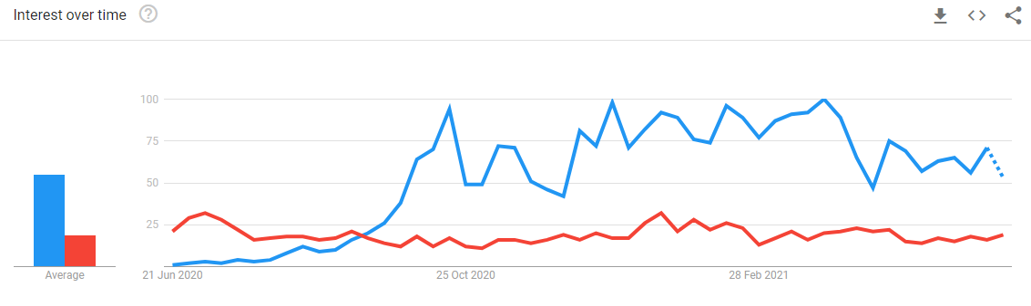
Figure 2: Post COVID vs Long COVID search terms over time

In addition to variation in language, the Google Trends data shows considerable variation in Geography. Searches for Long COVID are most common in England with a similar number of searches in Wales (96% of the England search numbers) and Scotland (95% of the search numbers). The use of Long COVID as a search term was however substantially less common in Northern Ireland where it was only searched 82% as frequently as England (Figure 3).
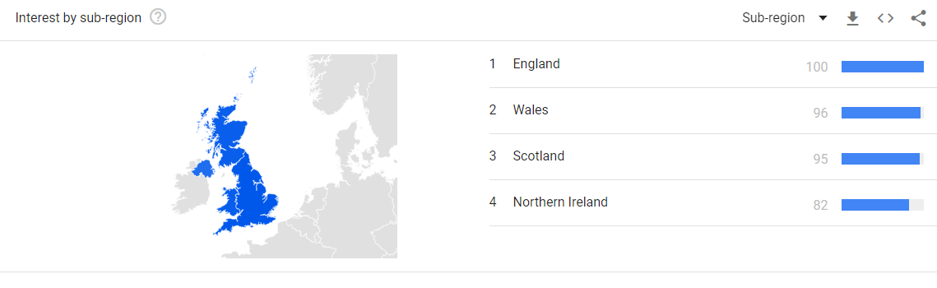
Figure 3: Variation in "Long COVID" search terms by region
Google Trends allows searching of “entities” which are concepts consistent across any language. “Long COVID” is offered by Google Trends as a “condition” entity, allowing a comparison internationally of the search term. Figure 4 below demonstrates that during the first study period (March 2020 to July 2022) the UK far exceeded all other countries in terms of Long COVID condition searches. Figure 5 represents an update to this paper highlighting the prevalence of these searches as of February 2023 demonstrates a very different picture with New Zealand, Germany and The Netherlands presented as the countries most commonly searching for Long COVID information.

Figure 4: International Search Terms by Long COVID Condition

When the presence of variants is compared to Long COVID searches, it is evident that spikes in the search for specific variants were accompanied also by a search for Long COVID as a long term complication (Figure 6).

Discussion

We present what we believe to be the first assessment of the utility of Google Trends on understanding data from Long COVID both in the UK and internationally. There is potentially useful learning around the preferred language of patients and service users. There is an increased focus on “language matters” in the NHS (Lloyd, 2018) and we may need to consider this dimension in the branding and roll-out of Long COVID services.

The appropriate descriptors and branding for services has wide implications for patients, organisations and services. The United Kingdom has been described as the “Long COVID capital” of the world (Glancy, 2021). Our data suggests that England in particular over Northern Ireland is a key area of focus when considering high levels of Long COVID searches. This is important as Long COVID is having a serious impact on the Labour market and the ability of the United Kingdom to respond to global economic challenges (Nafilyan, 2022). There may however be some reassurance for economists as more recently, there have been fewer searches for the United Kingdom relating to Long COVID in comparison to other countries internationally. It could be postulated that this may help the UK recover from particularly poor growth forecasts amongst developed nations.

It is uncertain whether there will be future waves or variants of COVID-19, however the data suggesting an association between new variants and increased searches for Long COVID is important. There are a missing cohort of people suffering from Long COVID who have not been seen or referred to specialist services (NICE, 2022; Shabnam, 2022). It may be that future targeted campaigns to find these missing patients might best be supported around the times of new variants arising and being prevalent within the population.

There are a number of limitations to the approaches and methods described here, most significantly is the narrative visual presentation. Statistical analysis of the Google Trends data is possible but there is uncertainty about the most appropriate methods towards achieving this in a robust scientific manner (Sato, 2021). Further work is needed in this area and may be best addressed through clinical, academic and industrial partnerships with digital service providers such as Google (Arora, 2019). Additional limitations relate to the availability of data, with data not accessible at a regional level nor at a useful “city based level”. We have further, due to statistical limitations not presented data linking other publicly available data sources (e.g. ONS data) to Google Trends data due to the challenges of statistical robustness and this may make for interesting future work. It is important to note though at no point was the combination of data sources in any way liable to expose patient level data and this must be avoided in any future research work.

In summary, Google Trends can be used as a useful tool for developing a broader understanding of the Long COVID syndrome. There is regional and international variation in frequency of searches relating to Long COVID, suggesting possible variation in incidence, awareness and acceptance alongside variation in the language used. Further research is undoubtedly needed, in particular to build better statistical approaches to analysing the data and potentially closer working relationships between UK Research and Public Health Authorities with digital service providers to increase the utility of these datasets within appropriate governance frameworks.

References:

Arora, V. S., McKee, M., & Stuckler, D. (2019). Google Trends: Opportunities and limitations in health and health policy research. Health Policy, 123(3), 338-341.

Ginsberg, J., Mohebbi, M. H., Patel, R. S., Brammer, L., Smolinski, M. S., & Brilliant, L. (2009). Detecting influenza epidemics using search engine query data. Nature, 457(7232), 1012-1014.

Glancy, J. (2021, June 12). Why is Britain now the capital of long Covid? News | the Sunday Times. https://www.thetimes.co.uk/article/why-is-britain-now-the-capital-of-long-covid-grjpvzfvw

Kondratiuk, A. L., Pillay, T. D., Kon, O. M., & Lalvani, A. (2021). A conceptual framework to accelerate the clinical impact of evolving research into long COVID. The Lancet Infectious Diseases, 21(6), 756-757.

Lloyd, C. E., Wilson, A., Holt, R. I. G., Whicher, C., Kar, P., Language Matters Group, ... & Wilmot, E. (2018). Language matters: a UK perspective. Diabetic Medicine, 35(12), 1635-1641.

Nafilyan, D. A. A. V. (2022, December 5). Self-reported long COVID and labour market outcomes, UK: 2022 - Office for National Statistics.

https://www.ons.gov.uk/peoplepopulationandcommunity/healthandsocialcare/conditionsanddiseases/bulletins/selfreportedlongcovidandlabourmarketoutcomesuk2022/selfreportedlongcovidandlabourmarketoutcomesuk2022

Parkin, A., Davison, J., Tarrant, R., Ross, D., Halpin, S., Simms, A., ... & Sivan, M. (2021). A multidisciplinary NHS COVID-19 service to manage post-COVID-19 syndrome in the community. Journal of primary care & community health, 12, 21501327211010994.

Pullan, S., & Dey, M. (2021). Vaccine hesitancy and anti-vaccination in the time of COVID-19: A Google Trends analysis. Vaccine, 39(14), 1877-1881.

Rovetta, A. (2021). Reliability of Google Trends: Analysis of the limits and potential of web infoveillance during COVID-19 pandemic and for future research. Frontiers in research metrics and analytics, 6, 670226

Sato, K., Mano, T., Iwata, A., & Toda, T. (2021). Need of care in interpreting Google Trends-based COVID-19 infodemiological study results: potential risk of false-positivity. BMC medical research methodology, 21(1), 1-10.

Search Engine Market Share Worldwide | Statcounter Global Stats. (n.d.). StatCounter Global Stats. https://gs.statcounter.com/search-engine-market-share

Shabnam, S., Razieh, C., Dambha-Miller, H., Yates, T., Gillies, C., Chudasama, Y. V., ... & Islam, N. (2022). Socioeconomic inequalities of Long COVID: findings from a population-based survey in the United Kingdom. medRxiv, 2022-10.

Shah, W., Hillman, T., Playford, E. D., & Hishmeh, L. (2021). Managing the long term effects of covid-19: summary of NICE, SIGN, and RCGP rapid guideline. bmj, 372.

Sudre, C. H., Murray, B., Varsavsky, T., Graham, M. S., Penfold, R. S., Bowyer, R. C., ... & Steves, C. J. (2021). Attributes and predictors of long COVID. Nature medicine, 27(4), 626-631.
Thompson, E. J., Williams, D. M., Walker, A. J., Mitchell, R. E., Niedzwiedz, C. L., Yang, T. C., ... & Steves, C. J. (2021). Risk factors for long COVID: analyses of 10 longitudinal studies and electronic health records in the UK. MedRxiv, 2021-06.

Walker, A., Hopkins, C., & Surda, P. (2020, July). Use of Google Trends to investigate loss‐of‐smell‒related searches during the COVID‐19 outbreak. In International forum of allergy & rhinology (Vol. 10, No. 7, pp. 839-847).

Whitaker, M., Elliott, J., Chadeau-Hyam, M., Riley, S., Darzi, A., Cooke, G., ... & Elliott, P. (2021). Persistent symptoms following SARS-CoV-2 infection in a random community sample of 508,707 people. Medrxiv, 2021-06.

