

LIFESTYLE MEDICINE: Exploring the evidence for social connectivity interventions to support children and young people’s mental health

Authors: Mr Joseph A Attard, Mr Sanjeev C Sharma and Dr Fiona Robertson

Acknowledgements: We would like to thank Emma Orrock, Chris Harris, Carly Mellors and all members of the Lifestyle Medicine Working Group for their guidance, support and constructive feedback throughout this project.

Introduction 4
Core Pillars of Lifestyle Medicine 4
Historical Origins 4
Children and Young People’s Mental Health 5
Lifestyle Medicine and Traditional Mental Health Care 5
Policy Context 6
Summary 6
Aims of the Review 6
Methods 8
Survey of Clinical Practice 8
Literature Review 8
Results 10
Survey 10
Participant Characteristics 10
Understanding of Lifestyle Medicine 11
Integration of Lifestyle Medicine into Practice 12
Interventions Currently in Use 12
Conditions Perceived to Benefit Most 13
Accessibility and Barriers to Implementation 14
Areas Requiring Greater Provision 15
Qualitative Insights 17
Summary of Findings 18
Literature Review Results 19
Study Characteristics 19
Overview of Findings 49
School-Based Interventions 49
Digital Interventions 50
Peer Support 51
Family and Community-Based Interventions 52
Discussion 54
Strengths and Limitations 55
Conceptual Framework 56
Key Considerations 57
References 58

Introduction
Lifestyle medicine is a holistic, evidence-based approach to health promotion that emphasises person-centred behaviour change across multiple domains of daily living. It recognises that factors such as diet, physical activity, sleep, stress and social support profoundly influence both physical and mental well-being. In practice, clinicians support education and behaviour-change coaching to address six interrelated pillars of healthy living: mental well-being, social relationships, nutrition, sleep, physical activity, and avoidance of harmful substances (1,2).

Core Pillars of Lifestyle Medicine
The six key domains of lifestyle medicine include:
- Mental well-being and stress management: Techniques such as mindfulness, relaxation, and counselling to build resilience and reduce anxiety (3).
- Social connection and healthy relationships: Strengthening family, peer and community ties to improve emotional support and reduce loneliness (1).
- Nutrition: Promoting whole, predominantly plant-based diets that support both physical and cognitive health (1,3).
- Physical activity: Encouraging regular exercise and active daily living, known to improve mood, cognition and self-esteem (1).
- Sleep hygiene: Supporting adequate restorative sleep, essential for emotional regulation, learning and behavioural control (1).
- Minimisation of harmful substances: Reducing or eliminating smoking, alcohol and other harmful substances that impair health (1).
Together these pillars span physical, mental and social dimensions of health, underpinning lifestyle medicine’s integrated model of care (1,2).

Historical Origins
Lifestyle medicine emerged in response to changing disease patterns and growing recognition of preventable chronic conditions. The term first appeared in medical literature in the late 1980s, first used as a symposium title in 1989 and in publications by 1990 (4). In the early 1990s, experts like Rippe described it as integrating lifestyle practices into clinical medicine to lower chronic disease risk and support mental health therapy (4). Over the last two decades the field has expanded rapidly: the American College of Lifestyle Medicine was established in 2003 and the British Society of Lifestyle Medicine (BSLM) in 2016 (1,2). These organisations and others have since formalised clinical training, research, and professional standards, reflecting a global shift toward prevention and person-centred, behaviourally informed care (2).

Children and Young People’s Mental Health
Children and young people (CYP) face an escalating mental health crisis. Globally, approximately 8% of children and 15% of adolescents have a diagnosed mental disorder, with around half of all lifetime mental illnesses beginning by age 18 (5,6). In the UK, national surveys estimate that 1 in 6 (≈17%) of 5-16 year-olds have a mental health problem (7). NHS England’s 2023 data further indicates that 20% of 8-16 year-olds and 23% of 17–19 year-olds likely meet diagnostic thresholds for a mental health disorder (8). Prevalence has increased sharply, by roughly 50% over the last three years, and yet despite early onset, around 70% of affected young people receive no timely intervention (5,6). This high and rising burden underscores the urgent need for preventive, whole-system strategies that extend beyond traditional clinical care.

Lifestyle Medicine and Traditional Mental Health Care
Conventional child and adolescent mental health services (CAHMS) often focus on diagnosis and symptom management through talking therapies and/or pharmacological treatment. Lifestyle medicine complements this by addressing upstream, modifiable determinants of mental health such as diet, sleep, social relationships, and physical activity, empowering young people to develop lifelong self-care skills (1,2). For example, community and school-based programmes that teach healthy eating, exercise and social skills aim to improve well-being and resilience, potentially reducing depression or anxiety before or alongside clinical manifestations and treatment.

Policy Context
International and national health policies increasingly advocate lifestyle and preventative approaches. The World Health Organization (WHO) recognises childhood and adolescence as critical windows for lifelong mental well-being, emphasising that half of mental health conditions begin by age 14–18. WHO and the UN Sustainable Development Goals call for multisectoral, youth-friendly initiatives promoting healthy lifestyles, social inclusion, and emotional development (5,9).
In the UK, NHS England and the National Institute for Health and Care Excellence (NICE), similarly prioritise early, community based mental health support. NHS England has rolled out hundreds of school-based Mental Health Support Teams to provide early help for mild-to-moderate issues (10). A recent NICE guideline (NG223) further recommends whole-school social and emotional well-being programmes to improve children’s social, emotional and psychological health (11).

Summary
Lifestyle medicine offers a broad, preventative model that integrates nutritional, physical, social and psychological interventions to promote resilience and long-term health (1,2). Its growing prominence reflects recognition that many modern health challenges, including those affecting CYP mental health, are rooted in modifiable behaviours and social environments. Aligning closely with current UK health policy, lifestyle medicine provides a framework for sustainable, person-centred care that empowers young people to build the habits, relationships, and resilience necessary for lifelong mental well-being (1,5,11).

Aims of the Review
This review aims to evaluate the current evidence base and clinical practice surrounding the application of lifestyle medicine interventions to support the mental health and well-being of children and young people (CYP). It seeks to identify examples of effective practice and mechanisms that contribute to improved outcomes, and to inform future service development through evidence-based recommendations and best-practice principles for consistent implementation across health and care pathways.
While lifestyle medicine encompasses six key domains, this review focuses specifically on social connectivity, interventions that strengthen supportive relationships and a sense of belonging through peer, family, school, community, or digital pathways. Interventions are prioritised where social connection is the active ingredient for mental health benefit, rather than those in which social contact is incidental or purely logistical.
To bridge evidence and real-world delivery, the project combined a UK-wide survey of CAMHS professionals, exploring current use, barriers, and priorities, with a systematic review of interventional studies on social-connectivity approaches for CYP mental health.

Methods

Survey of Clinical Practice
A cross-sectional survey was designed to explore the current use, perceived benefits, and implementation challenges of lifestyle medicine interventions in child and adolescent mental health services (CAMHS) across the United Kingdom. The survey was created using Microsoft Forms and was fully anonymous to encourage candid responses. The study was reviewed and approved by the project working group, who provided feedback on question structure and content to ensure face validity.
The final questionnaire (Appendix: Survey Questionnaire) consisted of both closed and open-ended questions, allowing for quantitative and qualitative data collection. It was divided into four sections: (1) demographic and professional characteristics (role, years of CAMHS experience, and region of practice); (2) current use of lifestyle medicine interventions; (3) accessibility of services and perceived barriers to implementation; and (4) views on effectiveness, future priorities, and recommendations. Closed questions included multiple-choice and Likert-scale items, while open-text fields allowed respondents to elaborate on examples of good practice and provide recommendations for service development.
The survey was initially distributed to CAMHS professionals working in the Midlands region of England, with recipients encouraged to share it with colleagues in other regions to broaden participation. Participation was voluntary, and no personally identifying information was collected.
The survey was live for six weeks from October 2024. A total of 46 complete responses were received. Quantitative data were exported from Microsoft Forms into Microsoft Excel for descriptive analysis, including calculation of response frequencies and percentages. Free-text responses were reviewed and thematically summarised to identify common views, priorities, and barriers reported by participants.

Literature Review
A survey-informed scoping review was conducted, in which responses from CAMHS professionals were used to identify priority areas within lifestyle medicine, leading to a focused review of the evidence for social connectivity interventions to support the mental health of children and young people.
Inclusion Criteria:
- Population: Children and young people < 18 years old
- Intervention: Social connectivity–focused interventions (peer‑led, group activities, digital social platforms)
- Comparator: Standard care, pharmacological treatment, or no intervention
- Outcomes: Changes in mental health outcomes, including symptoms of depression, anxiety, emotional well-being, and psychosocial functioning
- Study Design: Interventional (RCTs, cluster‑RCTs, non‑RCTs, mixed‑methods); excluded pilot-only and review articles
Exclusion Criteria:
- Participant age over 18 years
- Reported outcomes not related to mental health and wellbeing
- Observational studies
Search Strategy:
Medline, Embase, and APA PsycInfo were searched from database inception to 30th November 2024 using keywords and MeSH terms for “social connectivity,” “peer support,” “group intervention,” “children,” “adolescents,” “depression,” and “anxiety.” Results were screened for eligibility by reviewing the title and abstract. Three reviewers independently screened and extracted data on study design, setting, sample size, intervention characteristics, outcomes, follow‑up, and cultural context. Discrepancies were resolved through discussion and the final selection was agreed upon by all reviewers.
Data Extraction:
Information extracted from each study included: first author, year of publication, study design, country in which study was conducted, outcomes investigated, number of participants, participant age range, results, and study conclusions.

Results

Survey

Participant Characteristics
A total of 46 survey responses were received during the six-week period. Respondents represented a wide range of professional roles within child and adolescent mental health services (CAMHS). Four participants (8.7%) were consultant child and adolescent psychiatrists, seven (15.2%) were clinical psychologists, eight (17.4%) were specialist nurses, and two (4.3%) were general practitioners. Eleven respondents (23.9%) identified as allied health professionals, and the remaining 14 (30.4%) selected “other,” which included psychotherapists, counsellors, and other clinical or managerial roles.
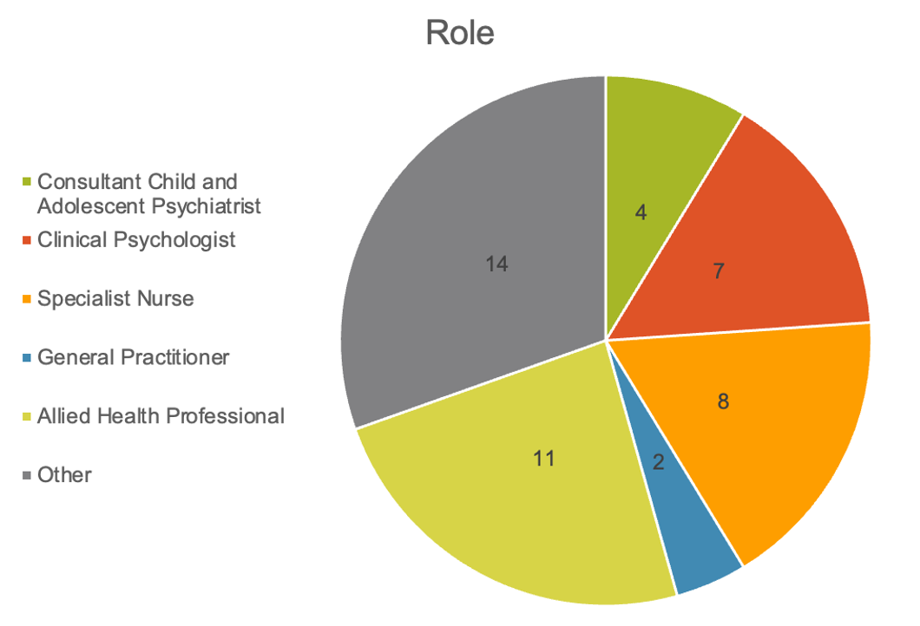
Geographical representation was broad. Three respondents (6.5%) worked in the East Midlands, 14 (30.4%) in the West Midlands, and 29 (63.0%) in other UK regions. Experience levels varied: 22 respondents (47.8%) reported 0–5 years of CAMHS practice, 11 (23.9%) had 6–10 years, eight (17.4%) had 11–19 years, and five (10.9%) reported over 20 years of experience.

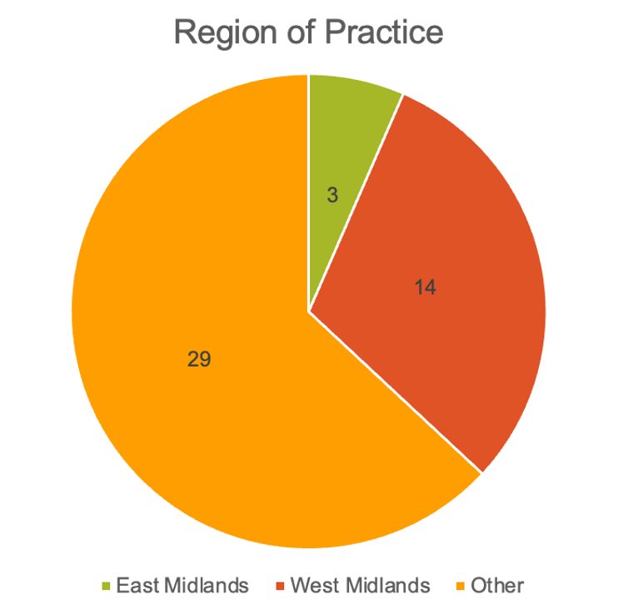
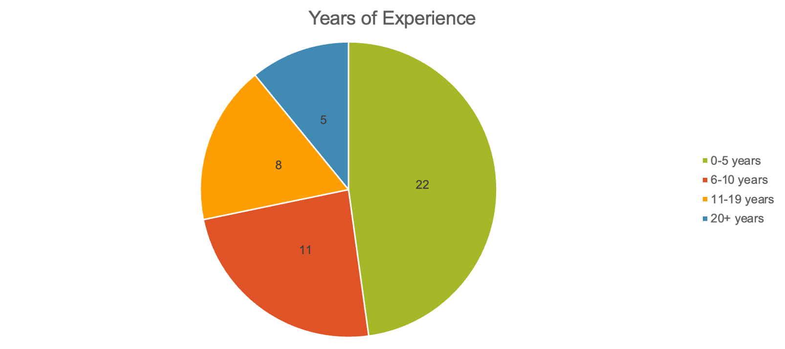

Understanding of Lifestyle Medicine
Respondents reported understanding of lifestyle medicine was moderate overall. Two respondents (4.3%) reported no understanding, eight (17.4%) rated their understanding as limited, 11 (23.9%) selected moderate, 21 (45.7%) reported good understanding, and four participants (8.7%) reported excellent understanding.
Formal training in lifestyle medicine was uncommon, with only seven respondents (15.2%) having received prior training. Interest in further training was high, with 34 participants (73.9%) expressing interest, 10 (21.7%) unsure, and only two (4.3%) not interested.
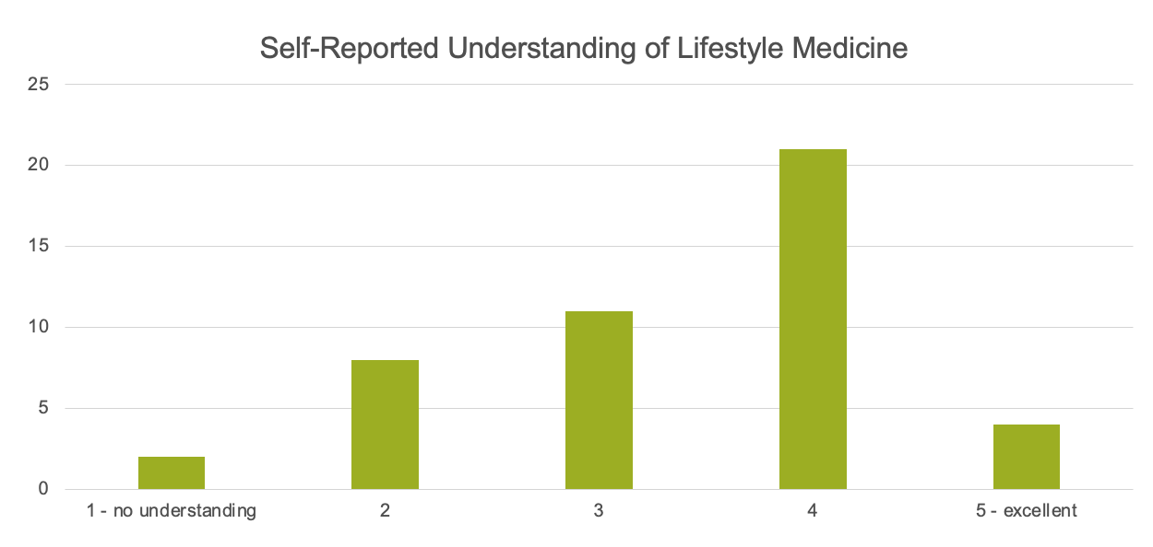
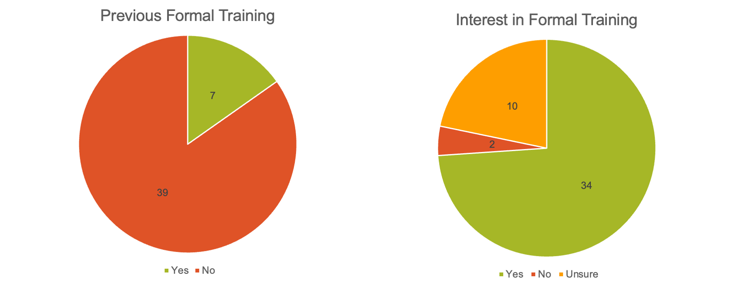

Integration of Lifestyle Medicine into Practice
The frequency of lifestyle medicine integration into practice varied. Six respondents (13.0%) reported not using it at all, six (13.0%) used it rarely, 16 (34.8%) used it sometimes, 15 (32.6%) often, and three (6.5%) reported very frequent use. These findings indicate that while over 70% of respondents incorporate lifestyle medicine at least occasionally, routine integration is not yet widespread.
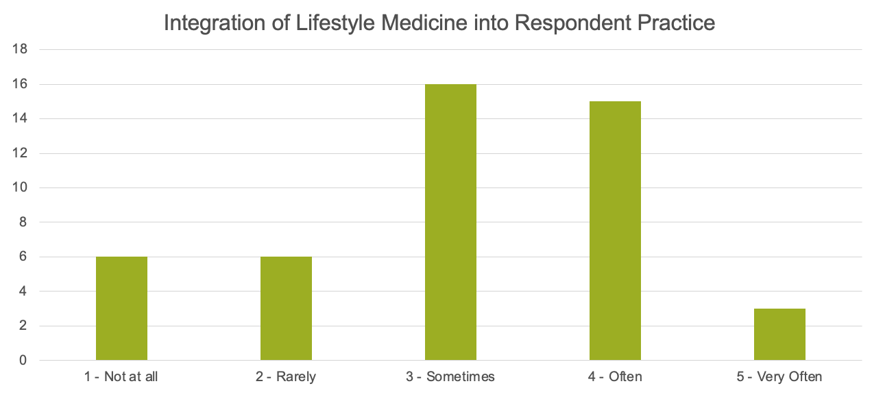

Interventions Currently in Use
The most frequently used intervention was sleep hygiene support, cited by 35 respondents (76.1%). Stress management and mindfulness strategies were reported by 27 respondents (58.7%), physical activity and exercise programmes by 25 (54.3%), and initiatives to enhance social connectivity by 24 (52.2%). Nutrition and dietary services were reported by 21 respondents (45.7%), and substance misuse programmes by 14 (30.4%). Three respondents (6.5%) reported using no lifestyle interventions, while seven (15.2%) described “other” approaches, including creative therapies, family support initiatives, and tailored behavioural programmes.
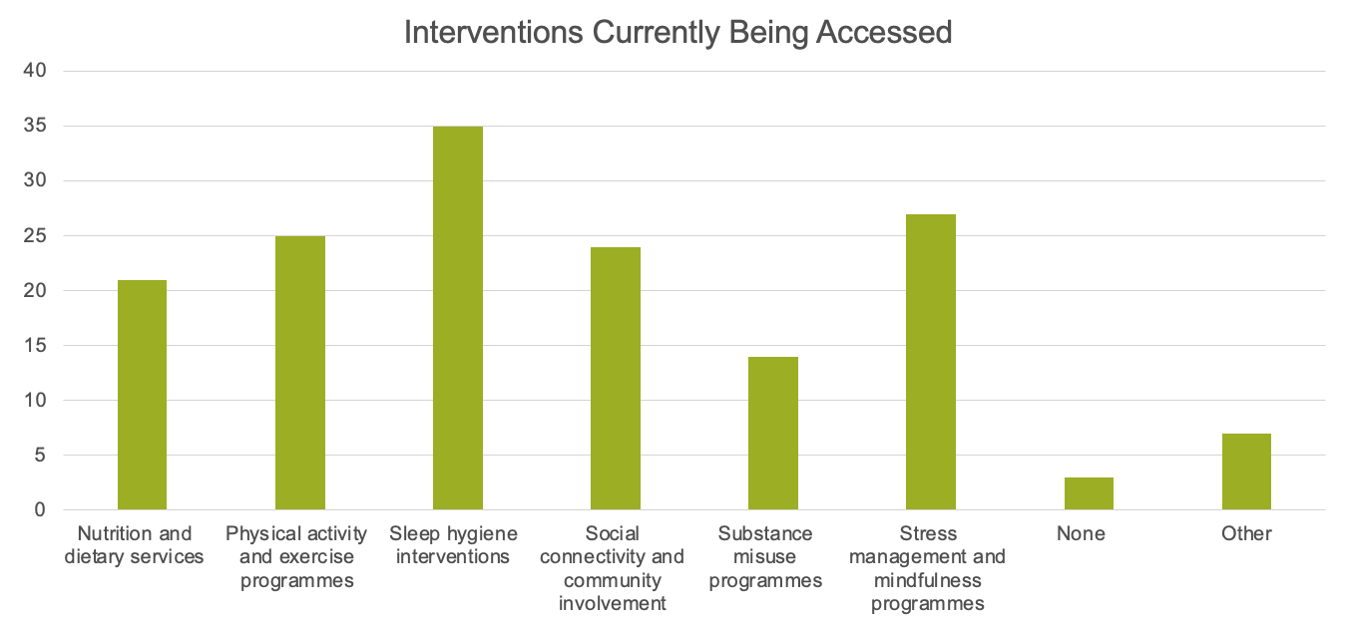

Conditions Perceived to Benefit Most
Lifestyle medicine was viewed as beneficial across a wide range of mental health conditions. Anxiety disorders were the most frequently cited (41 respondents, 89.1%), followed by mood disorders (39, 84.8%), conduct and behavioural conditions including ADHD (36, 78.3%), and sleep difficulties (35, 76.1%). Trauma-related conditions (33, 71.7%) and neurodevelopmental difficulties (31, 67.4%) were also highlighted as key areas of benefit.
Eating disorders (24, 52.2%), substance-related conditions (27, 58.7%), and obsessive-compulsive disorder (21, 45.7%) were recognised as suitable for lifestyle-based approaches. Fewer respondents endorsed psychotic disorders (16, 34.8%) or personality-related conditions (19, 41.3%).
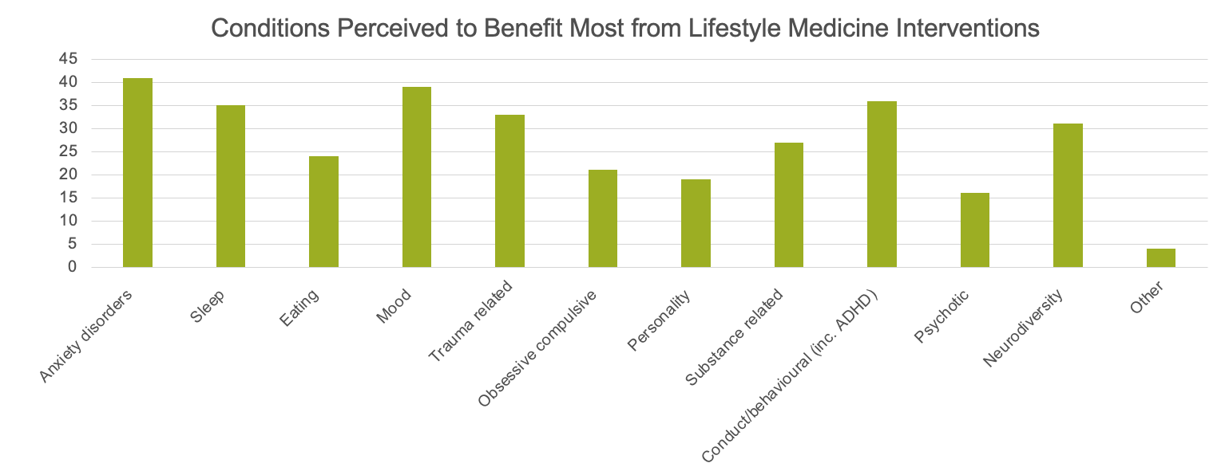

Accessibility and Barriers to Implementation
Respondents rated access to lifestyle medicine services as limited, with nutrition and dietary services identified as the least accessible. Over three-quarters of respondents rated these services as poor (37%) or fair (39.1%), with only 4.3% rating them as excellent. Physical activity and exercise programmes were also rated poorly by 65.2% of respondents.
In contrast, sleep hygiene interventions and stress management programmes were more widely available, with over 40% rating them as good (41.3% and 47.8%, respectively).
The most significant barrier to implementation was lack of funding, cited as a significant barrier by 65.2% of respondents. Limited staff training and expertise were also major obstacles, with 47.8% citing insufficient training and 34.8% reporting lack of expertise.
Over 90% of respondents experienced at least some difficulty delivering interventions within appointment times, with 32.6% reporting this as a significant barrier. Similarly, 32.6% highlighted a lack of patient engagement.
Limited collaboration with allied professionals was also a challenge, with 30.4% identifying it as a significant barrier and 60.9% reporting it as a moderate barrier. Socioeconomic challenges were another prominent factor, with 54.3% identifying them as a significant barrier, while cultural beliefs and practices were also noted by a smaller proportion of respondents.
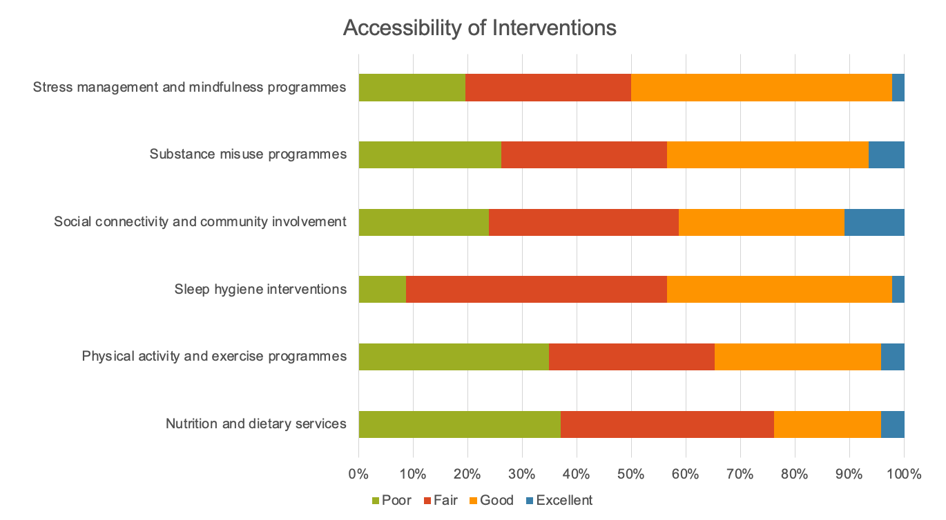
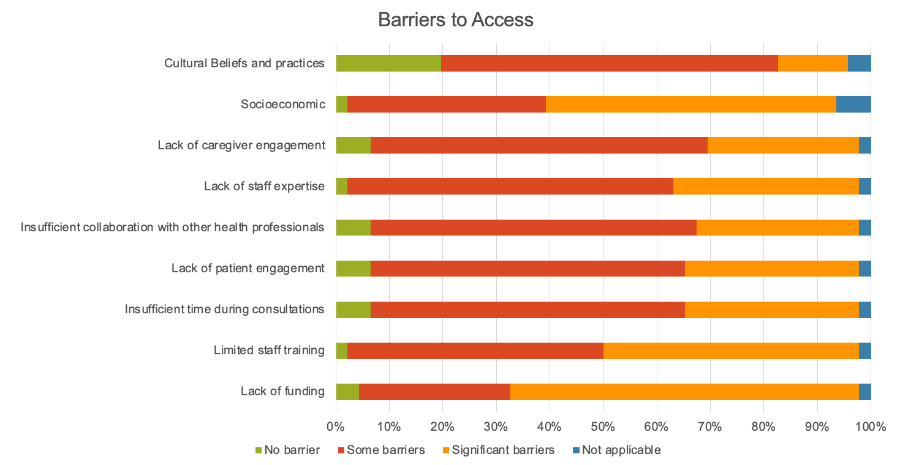

Areas Requiring Greater Provision
Respondents identified multiple areas of lifestyle medicine that require greater expansion. The most widely cited priority was social connectivity and community involvement, selected by 39 respondents (84.8%). Stress management and mindfulness programmes were the next most frequent priority (32 respondents, 69.6%), followed by nutrition and dietary services (31, 67.4%) and sleep hygiene interventions (27, 58.7%). Physical activity programmes were highlighted by 25 respondents (54.3%), while substance misuse interventions were prioritised by the fewest respondents (18, 39.1%). Four respondents (8.7%) identified additional interventions, such as creative therapies and family-based programmes, as areas requiring greater provision. These findings reflect a strong desire to see lifestyle approaches embedded earlier in the care pathway and more widely accessible to families and schools.
When asked to rank areas for future investment, respondents most frequently selected social connectivity and community involvement as their top priority, with 32.6% ranking it first. This was followed by physical activity and exercise programmes (23.9%), while nutrition and dietary services and sleep hygiene interventions were more commonly ranked in the middle categories. Substance misuse programmes were the least prioritised, with 67.4% ranking them last. These findings highlight a preference for interventions that foster social connections and community engagement, reflecting their perceived value in supporting young people’s mental health.
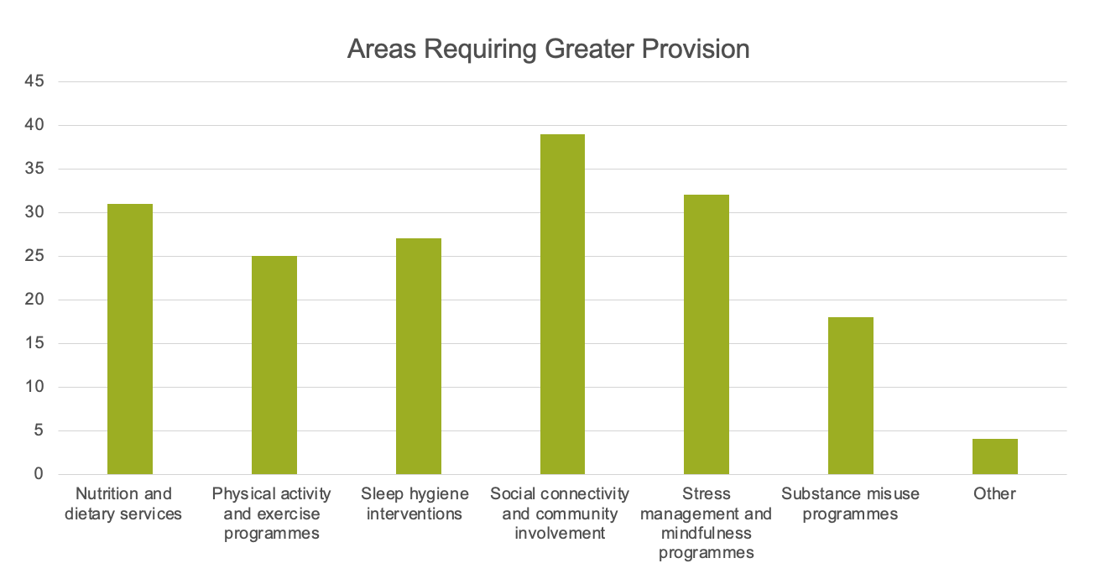
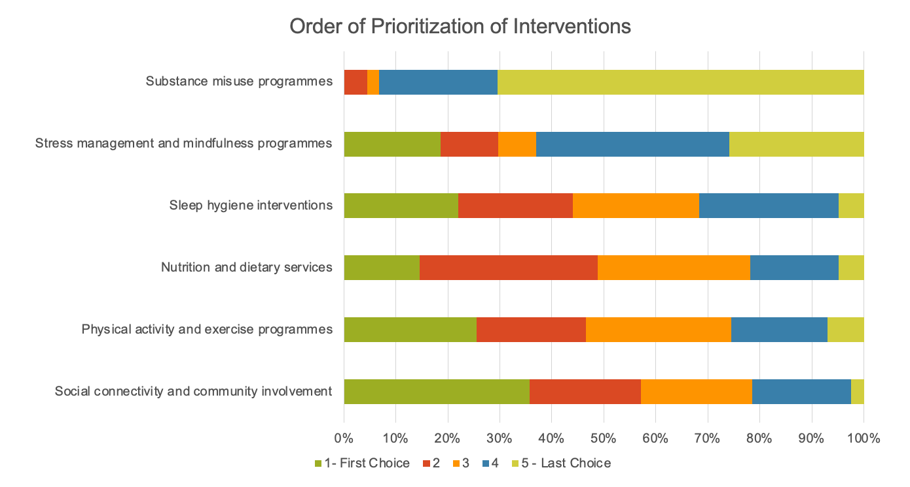

Qualitative Insights
Free-text responses highlighted a strong belief in the transformative potential of lifestyle medicine for children and young people (CYP). Clinicians emphasised the need for these interventions to be embedded as a core, mainstream element of CAMHS, offered early in the care pathway and even before diagnosis, particularly for neurodiverse conditions. Several respondents felt that introducing lifestyle interventions within education settings could help reduce the medicalisation of a wide range of conditions and promote sustainable wellbeing.
There was strong recognition of the preventive value of lifestyle medicine. Respondents described how these interventions could contribute to primary, secondary, and tertiary prevention, addressing both the management of existing conditions and the reduction of health inequalities driven by socioeconomic factors and wider determinants of health. Improved population education was seen as essential to changing expectations around treatment, particularly reducing reliance on medication as a first-line approach.
Many clinicians described already incorporating lifestyle interventions into their practice. Diet and sleep support were frequently identified as issues that young people actively sought help with, alongside opportunities for group work to foster social connection and self-efficacy. One respondent highlighted the benefits of offering these interventions to families on waiting lists, noting their potential to deliver immediate impact and reduce distress while young people await formal assessment.
Creative, age-appropriate approaches were also recommended, particularly for younger children. Respondents suggested arts and play-based community programmes as powerful tools for improving mental health and engagement.
Overall, there was a clear consensus that lifestyle medicine is both highly beneficial and cost-effective. One clinician described it as “a game changer” for helping young people establish sustainable, healthy lifestyles, underscoring the importance of making these interventions widely available and accessible to all families.

Summary of Findings
The survey results demonstrate strong professional support for lifestyle medicine, despite significant barriers to its implementation. Clinicians recognised its relevance across a wide range of mental health conditions, and nearly three-quarters of respondents expressed interest in expanding their expertise through further training.
These findings highlight the need for dedicated resources, structured training, and service development to support the integration of lifestyle medicine within CAMHS. Importantly, social connectivity interventions were identified as the top priority for future investment, guiding the focus of subsequent project planning.

Literature Review Results

Study Characteristics
Twenty-six studies were selected for inclusion in this review (Appendix: Search Strategy Results). These encompassed a mix of designs, 15 randomised controlled trials (RCT), seven of which were cluster RCTs, three mixed-methods studies, and eight non-randomised pretest-posttest studies, reflecting a field that leans toward experimental evaluation but still includes feasibility work. Samples ranged from 12 to 5,539 participants (median 189), with larger cohorts typical of school-based and digital programmes and smaller samples common in exploratory or qualitative work. Geographically, the evidence was internationally distributed (notably the United States of America, Australia, and Canada, alongside several European and Asian settings), supporting cross-cultural relevance while introducing variability in health systems and implementation contexts.
Fifteen of the 26 studies used randomised designs, providing stronger causal inference with common comparators of no intervention or standard business-as-usual programmes. Across studies, validated measures were routinely employed, such as the PHQ-9/PHQ-A, GAD-7, SCAS (GAD/SAD), SDQ (Emotional Symptoms), DQ5, the Warwick-Edinburgh Mental Well-Being Scale, and the CBCL, covering outcomes that included depressive and anxiety symptoms, internalising / externalising behaviours, psychological distress, mental well-being, help-seeking, coping, and post-traumatic stress disorder. Four thematic groups were identified: (1) school-based interventions, (2) digital interventions, (3) peer support, and (4) family and community-based interventions. The subsequent tables present a consolidated overview of study-specific findings, classified by thematic group.

Author (year) | Country | Study Design | Participants | Intervention Type | Control Group | Mental Health Outcomes | Measurement Tools
Zagni (2024) (16) | United States of America | Cluster RCT | 813 adolescents  6th - 9th grade | Technology - supported cooperative learning (via PeerLearning.net) | Business-as-usual teaching | Positive peer relations, Peer victimisation, Emotional problems (depression, anxiety) | Relatedness Scale, University of Illinois Bully Scale (Victimisation subscale), SDQ (Emotional problems subscale)
Andrews (2023) (17) | Australia | Cluster RCT | 2,539 students  Mean age 13.6 years in intervention group  Mean age 13.5 years in control group | Universal eHealth mental health programme (CBT-informed, 6 lessons) | Passive control (health education as usual) | No significant reduction in depression  No significant reduction in anxiety  No significant change in internalising symptoms  Mental-health knowledge increased (symptoms unchanged)  No moderation by friendship network characteristics | SDQ, PHQ-8, GAD-7, K6, 13-item MH knowledge quiz
Calear (2022) (18) | Australia | Cluster RCT | Years 7 - 10 | Sources of Strength peer-connectedness suicide prevention programme | Waitlist control | No significant effect on help-seeking intentions or behaviour at post-intervention, 6-month or 18-month follow-up. | GHSQ (intentions), AHSQ (behaviour)
Colomeischi (2022) (19) | Multiple European countries (Italy, Portugal, Croatia, Greece, Latvia, Romania) | Quasi - experimental pretest-posttest study with experimental and waitlist control groups | 1,163 children / adolescents  6 - 16 years | Promoting Mental Health at Schools (PROMEHS) program — 12 weekly one-hour lessons delivered by trained teachers | Waitlist control group (students did not receive PROMEHS until after post-test) | Improvements in social-emotional skills (self-awareness, self-management, social awareness, relationship skills, responsible decision-making)  Reductions in psychosocial difficulties (internalising and externalising problems) | Strengths and Difficulties Questionnaire (SDQ) — measures psychosocial strengths and difficulties  Social Skills Improvement System Social-Emotional Learning Brief Scales (SSIS-SEL) - measures SEL competencies based on the CASEL framework
Low (2022) (20) | United States of America | Cluster RCT | 1,890 students  7th grade | Cooperative Learning (peer-based instructional approach) | Business-as-usual teaching | Intervention schools showed significantly higher peer support and lower victimisation; direct positive effects on mental health via reduced victimisation / greater support. | Classroom Life Scale (peer support), Illinois Bully Scale (victimisation), SDQ Emotional Problems Subscale
Fang (2021) (21) | China | Quasi-experimental pretest-posttest follow-up design with a control group | 189 primary-school students  9 - 12 years | Growth Psychoeducation Intervention (GPI) — an eight-week culturally adapted group counselling program based on the Transtheoretical Model (TTM) to enhance covitality (gratitude, zest, optimism, persistence) among Chinese primary school students | Matched class groups with no intervention (same school, balanced demographics and pretest scores). | Increased covitality (gratitude, zest, optimism, persistence)  Improved school belonging  Reduced bullying victimisation  Sustained effects at 5-month follow-up | Social Emotional Health Survey–Primary (SEHS-P) — measures covitality and positive psychological traits  Delaware Bullying Victimization Scale (DBVS) — measures frequency and severity of bullying  Psychological Sense of School Membership Scale (PSSM) — measures school belonging and perceived rejection
Bokoch (2020) (22) | United States of America | Pretest-posttest non-equivalent control group design | 83 children  5 to 12 years old | Participants in the Mindfulness and Art Therapy Group Program (MATG-P), which involved eight weekly child therapy sessions, two conjoint parent-child meetings, and ongoing teacher meetings. | Nonequivalent control group (used in a pretest-posttest nonequivalent control group design) | Decreases in internalising symptoms, decreases in externalising symptoms, increases in attention, increases in peer relationship quality, increases in mindful parenting. | Parent and teacher ratings
Mishara (2020) (23) | Canada | Cluster RCT | 1,492 children (666 in intervention group; 826 in control group)  9 - 11 years | Passport: Skills for Life - school-based mental health promotion programme | Standard curriculum | Increased emotional awareness (sustained at 1 year)  Increased number of coping strategies (post-test and at 1-year follow-up)  Increase in positive academic behaviours (but not sustained at 1-year) | LEAS-C, Kidcope, CCQ, Draw & Write, Coping in hypothetical situations, SSRS
Singla (2020) (24) | India | RCT | 5,539 students  Secondary school students | SEHER - Whole-school intervention to improve school climate | Life-skills curriculum (Adolescence Education Program) only | Reduced depressive symptoms (via improved school climate)  Reduced bullying victimisation  Reduced violence perpetration  School climate mediated all effects | PHQ-9 (Depression), Bullying Victimisation Questionnaire, Custom 2-item violence scale, BBSCQ (School climate)
Pannebakker (2019) (25) | Netherlands | Cluster RCT | 38 schools  grades 7 to 9 | Skills for Life (S4L) - SEL curriculum based on CBT and Social Learning Theory | Standard curriculum | Improved self-efficacy after 20 months.  Reduced depressive symptoms after 20 months.  Reduced teacher-reported psychological problem behaviour after 20 months.  Stronger effects for students from lower educational levels (social gradient). | GSES (Self-efficacy), BDI (Depression), SDQ (Teacher and Student), RSE (Self-esteem), SIG-A (Social interaction)
Exner-Cortens (2019) (26) | Canada | RCT | 222 participants  14 - 18 years | Healthy Relationships Plus - Universal relationship promotion programme | Attention-control group (non-HRP activities matched in time and structure) | Improvement in past-month positive mental health; reductions in binge-drinking, marijuana use, bullying victimisation and perpetration (reported in follow-up) | MHC-SF (positive mental health), BEST (bullying), Youth Risk Behavioural Surveillance items (substance use)
Schwager (2019) (27) | Germany | Parallelised pre–post evaluation design with class-wise assignment | 1144 participants  Mean age 12 years | Implementation of Healthy Learning Together, consisting of:  Card set with 60 short exercises targeting: social integration, self-esteem, emotions, life competencies, concentration  Poster exhibition addressing themes such as friendship, anxiety, tolerance, and depression. | Wait-list control group, receiving education as usual (no intervention) | Primary outcomes:  Social integration, Class climate, Self-efficacy  Secondary outcomes: Mental wellbeing, Physical wellbeing  Findings: Significant positive effects (small) on class climate, and in high-adherence classes also social integration and self-efficacy.  No significant effects on mental or physical wellbeing. | All outcomes were measured with standardised questionnaires:  Social Integration Scale  Class Climate Scale – Linzer Questionnaire of School and Class Climate.  Generalised Self-Efficacy Scale  KINDL-R Mental Wellbeing subscale  KINDL-R Physical Wellbeing subscale
Table 1: School-Based Interventions

Author (year) | Country | Study Design | Participants | Intervention Type | Control Group | Mental Health Outcomes | Measurement Tools
Tuncgenc (2024) (28) | United Kingdom | RCT | 58 adolescents  11 - 16 years | Online group hip-hop dance | Waitlist control | Significant increase in social bonding (p < 0.0001) in intervention vs control. Significant improvement in wellbeing (p < 0.0001) in intervention vs control. Increases in bonding and wellbeing significantly predicted improved future orientation/hope for the future. | Social bonding scale, PERMA Profiler, Future Orientation scales
Lai et al (2023) (29) | Canada | pretest-posttest | 34 baseline parent interviews + 68 teacher reports (2015), and 47 parent interviews + 46 teacher reports (2018–2019) in the program cohort. | Children in Grades 1–2 | pretest-posttest | Teachers rated the program cohort children as having significantly lower emotional and behavioural problems.  Parents reported significantly higher social support and more positive community perceptions. | Teacher reports on emotional/behavioural functioning (tool not explicitly named in the paper abstract, but typically CBCL-Teacher Report Form or similar)  Parent interviews assessing perceived support and neighbourhood/community perceptions
Pavarini (2022) (30) | United Kingdom | RCT | 1,895 adolescents (intervention n = 948; control n = 947)  14 - 18 years | Online 5-day peer support training (Uplift) | Waitlist control | Improved peer emotional-support skills (significant).  Reduced depressive symptoms (significant).  Improved mental-health agency / self-efficacy (significant) | WEMWBS, SDQ-Emotional Subscale, GSES, Civic Engagement Scale, ASC-CD COVID Scale, Compassion Scales, IOS Scale
Birrell (2022) (31) | Australia | Cluster RCT | 166 students  Mean age 15.3 years | Peer-support digital intervention (classroom + mobile app) | Health education as usual | Greater reduction in depressive symptoms in intervention vs control.  Anxiety symptoms decreased in intervention group but not statistically significant.  No significant differences in psychological distress or help-seeking | GAD-7, PHQ-A, K6, mental health literacy scale, help-seeking questionnaires
O'Dea (2020) (32) | Australia | RCT | 193 adolescents  Mean age 14.82 years | Relationship-focused mobile app (WeClick) | Waitlist control | Greater reduction in depressive symptoms in intervention vs control (b = -1.86, 95% CI -3.73 to 0.02; Cohen d = -0.31)  Anxiety symptoms decreased in intervention group but not statistically significant  No significant differences in psychological distress or help-seeking | PHQ-A, DQ-5, SCAS-GAD, SCAS-SAD, SWEMWBS, GHSQ, SEQ-C, Shuster Social Support Scale, TBS
Table 2: Digital Interventions

Author (year) | Country | Study Design | Participants | Intervention Type | Control Group | Mental Health Outcomes Measured | Measurement Tools
Respati (2024) (33) | Indonesia (Kupang City, remote area) | Mixed-methods study  Embedded experimental model  Quantitative component:  Non-control group quasi-experimental pre-test/post-test design  Qualitative component:  Focus group discussions  Open-ended questionnaires  Content analysis | 45 senior high-school students | Carpe Diem Mental Health Board Game Intervention  Cooperative board game teaching:  Mental health literacy  Causes of depression  Coping and support-seeking  Peer support | Pre-post design | Quantitative outcomes (pre-post):  Significant improvements in:  Stigma & fear toward mental illness  Beliefs & perspectives about environmental causes of mental disorders  No significant changes in:  Perceptions of recovery and treatment  Attitudes toward interacting with people with mental illness  Beliefs about non-environmental causes  Perceived danger and unpredictability  Qualitative outcomes:  Themes showed:  Reduced stigma  Greater awareness of mental health problems  Increased peer support and engagement  Improved understanding of mental health concepts  Better social sensitivity and willingness to help peers | Quantitative tools:  Pre-validated questionnaires developed by the research team, measuring:  Stigma  Awareness  Perception  Knowledge  Attitudes toward mental illness  Health-seeking behaviour (peer, counsellor, professional help)  Likert-scale (5-point) items.  Analysed via Wilcoxon Signed-Rank Test.  Qualitative tools:  Focus Group Discussions (FGDs)  Open-ended questionnaires  Content analysis using Atlas.ti
Glaser (2023) (34) | Israel | Nonrandomised repeated-measures controlled trial (pre–post design) | Intervention group n = 103; Control group n = 77  Vocational secondary school youth (adolescents) | Friendship Online Intervention Program (FOIP): 8-month online mentoring and physical activity program for at-risk adolescents in vocational secondary schools. Conducted weekly (30 min), combining online physical activity and mentor–mentee “heart-to-heart” conversations. | Matched control group (no intervention) from same schools, similar demographics and grades. | ↑ Physical activity (57% increase in participants active ≥4 days/week), ↓ smoking, ↓ psychosomatic symptoms (large ES = 1.68), ↑ life satisfaction (ES = 0.68). No significant change in alcohol or cannabis use. | - HBSC Psychosomatic Symptoms Checklist  - Cantril Ladder for Life Satisfaction  - Self-reported questions on Physical Activity, Smoking, Alcohol, and Cannabis adapted from HBSC surveys.
Herrera (2023) (35) | United States of America | RCT | 764 youth  9 - 14 years | Community-based mentoring via Big Brothers Big Sisters | Waitlist control | Significant reductions in youth-reported depressive symptoms, parent-reported emotional symptoms, peer problems, conduct problems and total difficulties | Strengths and Difficulties Questionnaire (SDQ), Child and Youth Resilience Measure (CYRM)
Del Giudice (2022) (36) | Germany | RCT | 240 boys  6–12 years | Multimodal CBT (THAV) including child-focused, parent-focused (PMT), teacher- and peer-focused components | Educational group play (PLAY), 3–5 children per group | Significant improvement in social competence skills.  Significant reduction in conduct problems and oppositional behaviour.  Effects remained stable at 12-month follow-up. | SCL-DBD, FAVK, CBCL, SCL-ADHD (all parent-rated)
Panza (2022) (37) | United Kingdom | Mixed-methods feasibility and acceptability study (quantitative pre–post design with qualitative interviews) | 50 secondary-school students  16-18 years | Team Talk intervention: A one-hour team-based mental health literacy workshop for adolescent sport teams | pre-post design | - ↑ Social identity with team (p < .001)  - No significant change in self-efficacy to recognize or respond to mental health problems  - High acceptability and engagement  - Qualitative reports: enhanced openness, peer support, and team cohesion. | - Social Identity Questionnaire for Sport (SIQS) - 8 items (pre/post)  - Self-efficacy items (confidence in recognizing and responding to peers’ mental health problems; 0-100 scale)  - Acceptability Scale (adapted from AFFIRM Acceptability Scale)  - Qualitative interviews (athletes, parents, coaches) and researcher implementation logs.
Table 3 - Peer Support

Author (year) | Country | Study Design | Participants | Intervention Group | Control Group | Mental Health Outcomes | Measurement Tools
Bennett (2024) (38) | Canada | RCT | 207  2 - 4 years | Community comparison with self-referral to services | Community comparison with self-referral to services | Child behaviour problems, caregiver psychological distress, daily parenting stress | CBCL Externalising Problems Scale, Kessler-6, Parenting Daily Hassles Scale
Gagliano (2023) (39) | Italy | Pilot pre–post intervention study | 52 adolescents  Adolescents | 6-week educational filmmaking course involving writing, acting, filming, and editing short films under professional guidance. | Standard institutional activities | Improved social cognition (p = 0.049).  Improved communication (p = 0.009).  Improved motivation (p = 0.03).  Increased social awareness (p = 0.001).  Significant decreases in withdrawn/depressed (p = 0.007), social problems (p = 0.003), thought problems (p < 0.001), and rule-breaking behaviour (p = 0.03) | Rosenberg Self-Esteem Scale (RSE)  - Youth Self-Report Scale (YSR)  - Social Responsiveness Scale (SRS)  - Revised Conners’ Parent Rating Scale (CPRS-R)
Van Der Mheen (2020) (40) | Netherlands | One-group open trial  Pretest–posttest design (retrospective clinical data) | 28 children  4 - 8 years | Fun FRIENDS Program (Dutch version)  28 clinically anxious children aged 4-8  12 weekly 1.5-hour CBT-based group sessions  Focus on resilience, emotional regulation, coping skills, exposure, social skills  Delivered by two licensed psychologists; concurrent parent involvement | Pretest–posttest design | Significant improvements (pre-post):  ↓ Number of anxiety disorders (large effect)  ↓ Symptom interference with daily life  ↓ Emotional and behavioural problems  ↓ Internalising problems  ↓ Anxiety problems  Non-significant changes:  ↓Anxious/depressed symptoms (trend but not significant)  ↓Externalising problems (not significant) | Anxiety Disorders Interview Schedule for Children (ADIS-C)  Semi-structured parent interview  DSM-IV anxiety diagnoses  Parent and clinician interference ratings  Child Behaviour Checklist (CBCL)  CBCL 1.5–5 and CBCL/6–18  Measures internalising, externalising, total problems, anxious/depressed, anxiety problems  Parent-report (mothers only included in analyses)
Nelson (2020) (41) | Canada | Mixed-methods baseline–focal cohort comparison design | 4 baseline parent interviews + 68 teacher reports (2015), and 47 parent interviews + 46 teacher reports (2018–2019) in the program cohort.  Children in Grades 1–2 | Better Beginnings Waterloo (BBW) Program  Children in Grades JK–2 (ages 4–8) and their families  Delivered in two low-income, culturally diverse communities  Multi-component ecological prevention model including:  Child programs (reading, tutoring, running, music, sports, camps, nutrition, yoga)  Parent/family programs (parent groups, family days, English classes, school-readiness, trips)  Community programs (events, celebrations, cultural bridging activities)  Strong emphasis on resident participation and empowerment | Baseline comparison group:  Grade 1–2 children and their parents assessed before BBW implementation  Parent interviews (n=34) and teacher reports (n=68) | Child outcomes  Quantitative:  ↓Teacher-rated emotional & behavioural problems (significant at one school—Cedarbrae)  No significant effects: parent-rated emotional/behavioural problems, social skills, academic achievement  Qualitative:  ↓ Anxiety  ↓ Behavioural problems (e.g., tantrums, temper)  ↑ Social skills  ↑ Confidence and peer interactions  Some reports of improved academic engagement | Child measures  Social Skills Rating Scale (SSRS) – parent and teacher versions  Revised Ontario Child Health Study Scales – Emotional & behavioural problems  Teacher-rated academic achievement scale (reading, spelling, writing, mathematics)
Table 4 - Family & Community Support

Overview of Findings

School-Based Interventions
Evidence from Randomised Controlled Trials
School settings predominated as the delivery context, reflecting their capacity to reach large populations at scale (range 212 - 5,539; median 1,505 participants). Across diverse programmes, there was convergent evidence of improvements in protective factors such as peer support, resilience, coping skills, and mental-health literacy, often accompanied by reductions in bullying, victimisation, and broader emotional symptoms. However, the nature and durability of these effects varied considerably depending on intervention type. Cooperative and technology-enhanced learning models (16, 20) reliably fostered positive peer relations and reduced victimisation, underscoring the importance of social connectedness in mitigating risk. Yet, while these approaches occasionally produced gains in emotional functioning, their effects on depression and anxiety were inconsistent, suggesting that enhancing peer climate in the school setting alone may be insufficient to shift internalising symptoms.
Psychosocial and creative programmes, including drama-based initiatives and life-skills curricula (23), appeared better suited to strengthening coping, emotional awareness, and overall well-being. These gains, however, often reflected improved adaptive functioning rather than measurable reductions in psychiatric symptoms. Whole-school climate interventions, such as SEHER (24), demonstrated broader systemic effects by reducing bullying, violence, and negative peer dynamics, with some evidence of sustained benefit for depressive symptoms. This highlights the potential of structural changes in school environments to address multiple dimensions of youth mental health. In contrast, curriculum-based interventions grounded in CBT principles and delivered either digitally or in classrooms (17, 25) consistently enhanced mental health knowledge, self-efficacy, and social interaction, but their impact on depression, anxiety, and psychological distress was often modest, short-lived, or confined to subgroups. Peer-connectedness and relationship-focused programmes (18, 26) provided another distinct pathway, promoting help-seeking intentions, positive mental health, and reductions in bullying perpetration. These findings highlight the role of relational and community-based strategies in cultivating resilience and encouraging early intervention. These results suggest that while school-based interventions are powerful vehicles for strengthening resilience, social connectedness, and school climate, their capacity to deliver sustained improvements in depression and anxiety remains limited. Benefits often manifested in increased awareness, skill acquisition, or contextual improvements rather than consistent symptom reduction, emphasising the challenge of translating universal school-based programmes into enduring clinical impact.
Evidence from Non-Randomised Studies
Studies evaluated school-delivered programmes targeting classroom climate, social integration, stigma, and wellbeing. A large non-randomised evaluation of a whole-class tool combining exercises and a poster exhibition reported more positive changes in social integration, class climate, and self-efficacy than comparison groups, although no significant effects on mental or physical wellbeing were detected (27). Stigma-reduction / mental health literacy delivered through game-based learning demonstrated reductions in stigma and enhanced help-seeking / peer engagement in senior high school students (32).

Digital Interventions
Evidence from Randomised Controlled Trials
Digital interventions, typically smaller in scale than school-based programmes (range 58 - 193; median 133), showed promise for engagement and scalability, particularly in contexts where in-person delivery was constrained. Across studies, reported benefits included enhanced social bonding, well-being, hope, and future outlook, as illustrated by an online group hip-hop dance programme (28), which fostered positive experience and perceived performance. Online peer-support training (29) similarly improved well-being, resilience, and civic engagement, highlighting the potential of short, structured digital curricula to promote agency and community-mindedness, especially during the COVID-19 period when social connectedness was limited.
Peer support digital platforms delivered in hybrid classroom app formats (30) yielded modest reductions in depressive symptoms and supported help-seeking intentions and behaviours, though effects on anxiety and psychological distress were limited. Relationship-focused mobile applications such as WeClick (31) extended this digital engagement to domains of belongingness, social self-efficacy, and professional help-seeking intentions, but demonstrated mixed effects on depression, anxiety, and distress, with some outcomes showing no measurable change.
Collectively, digital tools demonstrated consistent value in enhancing social connection, empowerment, and help-seeking pathways, with particular strengths in engagement and accessibility. However, their impact on core clinical outcomes (depression, anxiety, and psychological distress) was variable, with benefits often confined to specific subgroups, secondary outcomes, or short-term gains. These findings underscore the promise of digital interventions as scalable and flexible supports, while also highlighting the ongoing challenge of achieving durable symptom-level improvements through digital delivery alone.
Evidence from Non-Randomised Studies
One feasibility pre-post virtual-reality group programme (twice weekly for four weeks) for youth with physical disabilities reported high enjoyment and perceived social connection, trends toward reduced depression (although not statistically significant), and reduced loneliness, with acceptable engagement and completion (29).

Peer Support
Evidence from Randomised Controlled Trials
Peer-focused models were common, with sample sizes ranging from 76 to 1,326 (median 701), and were typically designed to strengthen emotional, behavioural, and social adjustment through structured relationships. Community-based mentoring programmes such as Big Brothers Big Sisters (35) produced small but meaningful improvements in emotional and behavioural outcomes, as well as gains in prosocial behaviour and broader social-emotional development, when assessed at 18 months. These effects, while modest, highlight the value of sustained mentoring relationships for fostering resilience and developmental competencies over time.
By contrast, structured therapeutic approaches incorporating cognitive-behavioural elements demonstrated more robust symptom-level change. The THAV programme (36), a multimodal cognitive behavioural therapy (CBT) model combining child, parent, teacher, and peer-focused components, was associated with stable or improved outcomes for aggression, oppositional and conduct problems, and ADHD symptoms up to 10 months post-treatment compared with active play-based controls. Evidence of reductions in both internalising and externalising difficulties suggests that multimodal CBT frameworks may exert broader and more durable effects than non-specific peer activities.
Peer-focused interventions demonstrated a spectrum of impact: mentoring programmes promoted social-emotional growth and incremental behavioural improvements over longer follow-up periods, while CBT-based models achieved more immediate and clinically significant changes in disruptive behaviours and comorbid symptoms. This contrast underscores how the intensity, structure, and therapeutic orientation of peer-based models shape their capacity to deliver either developmental support or targeted symptom reduction.
Evidence from Non-Randomised Studies
Studies examined peer-mediated or explicitly social skill-building programmes. Community delivery of the PEERS® programme for adolescents with social challenges showed significant improvements in social skills and knowledge, alongside reductions in loneliness and caregiver-reported anxiety (37). A game-based learning intervention (“Carpe Diem”) produced statistically significant stigma reduction, improved mental health awareness, and qualitative evidence of stronger peer engagement (33). Additional school-based peer initiatives within this grouping generally emphasised belonging, prosocial skills, and help-seeking.

Family and Community-Based Interventions
Evidence from Randomised Controlled Trials
Family and community approaches were less frequently evaluated but offered complementary pathways to supporting youth mental health. The Family Check-Up programme (38), a brief motivational parenting intervention, was effective in reducing child behaviour problems, as measured on externalising symptom scales, but showed no corresponding benefits for caregiver psychological distress or daily parenting stress. These findings suggest that while parent-focused interventions can yield improvements in child outcomes, their impact on caregiver wellbeing may be more limited, perhaps requiring additional or longer-term support components.
Community-based interventions aimed at enhancing social participation and physical well-being demonstrated broader functional benefits. Importantly, benefits were consistent across diagnostic groups, underscoring the transdiagnostic potential of community participation approaches to promote recovery and inclusion. However, these gains were not paralleled by significant reductions in psychological distress, indicating that functional and vocational outcomes may respond more readily to such programmes than symptom-level measures.
Altogether, family and community interventions provided valuable complementary benefits: parenting programmes targeted child behaviour change, while community participation strategies enhanced functional and vocational trajectories. Yet, both approaches demonstrated limitations in alleviating caregiver or participant distress, highlighting the need to integrate symptom-focused components with broader family- and community-based supports.
Evidence from Non-Randomised Studies
Studies evaluated community-delivered group programmes spanning CBT-based groups, arts / identity-focused interventions, and filmmaking for youth with pre-existing mental health conditions. A six-week filmmaking course showed improved self-esteem (not statistically significant) and significant reductions on Social Responsiveness Scale parameters, supporting social functioning benefits in young people with psychiatric disorders (39). A 12-week CBT-based group reported reductions in the number of anxiety diagnoses on structured interview; broader anxious/depressed symptoms did not significantly change (40). Community arts programmes emphasising identity development reported improvements in identity formation, reduced social anxiety, and enhanced emotional expression qualitatively and on selected quantitative indices (41).

Discussion
This review highlights the considerable diversity of approaches to youth mental health promotion across intervention types, each offering distinct benefits but also important limitations. School-based programmes predominated in both scale and frequency of evaluation, reflecting their reach into large populations. These interventions consistently strengthened protective factors such as peer support, resilience, coping, and mental-health literacy, and reduced bullying, victimisation, and broader emotional symptoms. Approaches emphasising cooperative learning and social climate change proved particularly effective for improving peer dynamics, while psychosocial and creative programmes enhanced coping and emotional awareness. Yet, despite their breadth and scalability, school-based programmes yielded mixed effects on depression and anxiety, with improvements often confined to subgroups, attenuated over time, or restricted to increased awareness rather than symptom reduction.
Digital interventions offered a contrasting profile, typically smaller in sample size but notable for their accessibility, scalability, and capacity to maintain engagement during periods of social disruption, notably the COVID-19 pandemic. These interventions encouraged social bonding, agency, and help-seeking, with peer-support and relationship-focused platforms demonstrating modest reductions in depressive symptoms and improvements in connectedness. However, their impact on clinical outcomes such as anxiety and psychological distress was inconsistent. The emerging picture is that digital tools may serve as important adjuncts, well suited for enhancing social connection and resilience, but are not yet reliable substitutes for more intensive therapeutic programmes in reducing psychiatric symptoms.
Peer-focused models further underscored the role of relationships in shaping youth outcomes. Community-based mentoring, as in Big Brothers Big Sisters, promoted prosocial behaviour and incremental emotional and behavioural improvements over long follow-up, while multimodal CBT-based approaches such as THAV produced more immediate and sustained reductions in disruptive behaviours, aggression, and comorbid symptoms relative to active controls. This contrast suggests that while mentoring enhances developmental competencies through supportive relationships, structured therapeutic frameworks achieve stronger symptom-level effects by combining peer interaction with evidence-based clinical components.
Family and community-based approaches, though less frequently evaluated, provided complementary value. The Family Check-Up programme effectively reduced child behaviour problems but did not alleviate caregiver stress or distress, pointing to the challenge of addressing family wellbeing in parallel with child outcomes. Community-based participation programmes improved functioning, vocational status, and role performance across diagnostic groups, highlighting their potential for recovery-oriented and transdiagnostic support. Nonetheless, these gains were not accompanied by reductions in psychological distress, reinforcing the distinction between functional outcomes and symptom-level change.
Overall, these findings reveal a consistent pattern, that social connectivity interventions are most effective at strengthening protective factors, social connection, and functioning, but less reliable at producing durable improvements in clinically significant depression and anxiety disorders. Structural and school-wide approaches appear to shift environments in ways that reduce bullying and victimisation, while digital and peer-led initiatives excel at engagement, empowerment, and connectedness. Symptom-level change is more consistently achieved in targeted, structured programmes with therapeutic underpinnings, such as CBT-based interventions, rather than broad universal or community models. This highlights the importance of matching intervention type to intended outcome, developmental, functional, or clinical, and of integrating universal, scalable approaches with targeted therapeutic strategies to address the full spectrum of youth mental health needs.

Strengths and Limitations
Several methodological strengths were evident across the included studies. Many interventions were grounded in structured, theory-driven frameworks, such as cognitive-behavioural, social learning, or arts-based models, and an increasing proportion employed individual or cluster randomisation to enhance causal inference. The use of mixed-methods and qualitative approaches provided valuable insights into mechanisms of change, feasibility, and contextual factors influencing implementation. Moreover, the delivery of interventions across diverse settings, including schools, digital environments, and community or peer contexts, contributed to strong ecological validity and practical relevance.
Nonetheless, important limitations were also apparent. Sample sizes ranged widely, from small feasibility or case studies to large school-based trials, with many studies insufficiently powered to detect meaningful changes in mental health outcomes. Short intervention periods and limited follow-up restricted assessment of durability of effects. A substantial proportion of studies were non-randomised or lacked appropriate comparators, introducing risks of selection bias and confounding. Considerable heterogeneity in outcome measures, particularly in assessments of social connectedness, wellbeing, and psychological symptoms, reduced comparability across studies. Additionally, variable reporting of intervention fidelity and participant engagement constrained reproducibility. Consequently, although the literature indicates promising benefits of social connectivity interventions on psychosocial outcomes, methodological variability and the predominance of small-scale evaluations limit the strength of causal inferences.

Conceptual Framework
Viewed holistically, findings across intervention types can be understood within a tiered framework of impact. At the foundational tier, universal interventions, particularly school-based and digital programmes, most reliably strengthened protective factors such as peer support, coping, resilience, and mental-health literacy. These protective assets created a social and educational environment more conducive to wellbeing, even when direct symptom change was limited.
At the intermediate tier, interventions targeting functioning and connectedness, notably community participation programmes, mentoring models, and digital peer-support tools, enhanced social relationships, vocational outcomes, and adaptive behaviours. These approaches were especially valuable for fostering inclusion, engagement, and agency, and demonstrated transdiagnostic benefits across diverse youth populations.
At the clinical tier, symptom-focused interventions, particularly CBT-based and multimodal programmes delivered through school, peer, or family channels, were most likely to produce measurable reductions in depression, anxiety, behavioural problems, and comorbid symptoms. However, even within this tier, effects were sometimes modest, subgroup-specific, or time-limited, underscoring the need for sustained and integrated delivery.
This framework illustrates that different intervention types align with different levels of impact: universal programmes excel at building protective environments, relational and participatory models strengthen functioning and agency, and structured therapeutic approaches are needed to achieve symptom reduction. The integration of these tiers, rather than reliance on any single modality, appears essential for addressing the multifaceted nature of youth mental health.

Key Considerations
For policy and practice, the evidence supports prioritising school-based delivery platforms, especially CBT-informed, peer-led, and arts-based programmes in the middle-school years. Commissioners should develop digital and hybrid models that integrate web-based CBT and peer-support apps into classrooms, emphasising tools with demonstrated longitudinal benefits, and strengthen peer-support infrastructure via leadership and mentoring in secondary schools, including embedded digital peer tools to widen access. Given the current under-representation of family and community models, pilot funding for parental engagement and social-participation programmes is warranted, coupled with rigorous real-world evaluation. A tiered commissioning model (universal literacy and resilience; targeted small-group or app-based support; intensive wraparound services) and embedded outcome monitoring, emotional well-being, symptom change, social connectedness, and help-seeking, are practical next steps.
In conclusion, social connectivity interventions for children and young people consistently enhance social connectedness, literacy, and aspects of emotional well-being, with mixed but encouraging effects on depression and anxiety. The field benefits from a sizable body of randomised evidence and validated outcome measures, yet meaningful heterogeneity in interventions and endpoints constrains cumulative inference. Strategic commissioning in schools, thoughtful integration of digital and peer-led components, and expanded evaluation of family and community approaches, together with more standardised outcomes, offer the clearest pathway to maximising population impact.

References
1. British Society of Lifestyle Medicine. What is Lifestyle Medicine? [Internet]. BSLM; 2023 [cited 2025 Jul 28]. Available from: https://bslm.org.uk/what-is-lifestyle-medicine/
2. Egger GJ, Binns AF, Rossner SR. Lifestyle Medicine. 2nd ed. Sydney: McGraw-Hill; 2010.
3. Katz DL, Frates EP, Bonnet JP, Gupta SK, Vartiainen E, Carmichael D. Lifestyle as Medicine: The Case for a True Health Initiative. Am J Health Promot. 2018;32(6):1452–8.
4. Rippe JM. Lifestyle Medicine: The Health Care Solution for the 21st Century. Am J Lifestyle Med. 2014;8(5):287–91.
5. International Board of Lifestyle Medicine. About IBLM [Internet]. 2023 [cited 2025 Jul 28]. Available from: https://www.iblm.org/
6. NHS Digital. Mental Health of Children and Young People in England, 2023: Wave 4 follow-up to the 2017 survey [Internet]. 2023 [cited 2025 Jul 28]. Available from: https://digital.nhs.uk
7. NHS England. Mental Health Support Teams in Schools and Colleges [Internet]. 2023 [cited 2025 Jul 28]. Available from: https://www.england.nhs.uk/mental-health/cyp/trailblazers/
8. Office for National Statistics. Children’s mental health in Great Britain: 2022. [Internet]. ONS; 2023 [cited 2025 Jul 28]. Available from: https://www.ons.gov.uk/
9. Kessler RC, Berglund P, Demler O, Jin R, Merikangas KR, Walters EE. Lifetime Prevalence and Age-of-Onset Distributions of DSM-IV Disorders in the National Comorbidity Survey Replication. Arch Gen Psychiatry. 2005;62(6):593–602.
10. Department for Education. State of the Nation 2022: Children and Young People’s Wellbeing [Internet]. UK Government; 2022 [cited 2025 Jul 28]. Available from: https://www.gov.uk/
11. World Health Organization. Adolescent mental health: mapping actions of nongovernmental organizations and other international development organizations [Internet]. Geneva: WHO; 2021 [cited 2025 Jul 28]. Available from: https://www.who.int/
12. World Health Organization. Mental Health Action Plan 2013–2030 [Internet]. Geneva: WHO; 2021 [cited 2025 Jul 28]. Available from: https://www.who.int/publications/i/item/9789240031029
13. National Institute for Health and Care Excellence (NICE). Mental wellbeing: interventions to support children and young people [NG223]. London: NICE; 2022.
14. Sawyer SM, Azzopardi PS, Wickremarathne D, Patton GC. The Age of Adolescence. Lancet Child Adolesc Health. 2018;2(3):223–8.
15. Frates EP, Moore MA, Lopes MA, McMahon GT. Lifestyle Medicine Education. Am J Lifestyle Med. 2011;5(6):516–25.
16. Zagni B, Van Ryzin MJ. Technology-supported cooperative learning as a universal mental health intervention in middle and high school. Br J Educ Psychol. 2024 Sep;94(3):792-808. doi: 10.1111/bjep.12680. Epub 2024 Mar 13. PMID: 38479858; PMCID: PMC11305977.
17. Andrews JL, Birrell L, Chapman C, Teesson M, Newton N, Allsop S, McBride N, Hides L, Andrews G, Olsen N, Mewton L, Slade T. Evaluating the effectiveness of a universal eHealth school-based prevention programme for depression and anxiety, and the moderating role of friendship network characteristics. Psychol Med. 2023 Aug;53(11):5042-5051. doi: 10.1017/S0033291722002033. Epub 2022 Jul 15. PMID: 35838377.
18. Alison L. Calear, Sonia M. McCallum, Helen Christensen, Andrew J. Mackinnon, Alexandra Nicolopoulos, Jacqueline L. Brewer, Aliza Werner-Seidler, Alyssa R. Morse, Dominique Kazan, Louise M. Farrer, Laura Kampel, Philip J. Batterham, The Sources of Strength Australia project: A cluster randomised controlled trial of a peer-connectedness school-based program to promote help-seeking in adolescents, Journal of Affective Disorders, Volume 299, 2022, Pages 435-443, ISSN 0165-0327, https://doi.org/10.1016/j.jad.2021.12.043.
19. Colomeischi AA, Duca DS, Bujor L, Rusu PP, Grazzani I, Cavioni V. Impact of a School Mental Health Program on Children's and Adolescents' Socio-Emotional Skills and Psychosocial Difficulties. Children (Basel). 2022 Oct 30;9(11):1661. doi: 10.3390/children9111661. PMID: 36360389; PMCID: PMC9688343.
20. Low S, Van Ryzin MJ, Roseth CJ. Peer learning can modify the reciprocal relationship between peer support and victimization in middle school. J Adolesc. 2023 Apr;95(3):524-536. doi: 10.1002/jad.12133. Epub 2022 Dec 22. PMID: 36546511; PMCID: PMC10079556.
21. Fang M, Zhang L, Pan D, Xie J. Evaluating a Psychoeducation Program to Foster Chinese Primary School Students' Covitality. Int J Environ Res Public Health. 2021 Aug 18;18(16):8703. doi: 10.3390/ijerph18168703. PMID: 34444452; PMCID: PMC8392604.
22. Bokoch, R., & Hass-Cohen, N. (2020). Effectiveness of a School-Based Mindfulness and Art Therapy Group Program. Art Therapy, 38(3), 117–126. https://doi.org/10.1080/07421656.2020.1807876
23. Mishara BL, Dufour S. Randomized Control Study of the Implementation and Effects of a New Mental Health Promotion Program to Improve Coping Skills in 9 to 11 Year Old Children: Passport: Skills for Life. Front Psychol. 2020 Oct 29;11:573342. doi: 10.3389/fpsyg.2020.573342. PMID: 33192870; PMCID: PMC7658468.
24. Singla DR, Shinde S, Patton G, Patel V. The Mediating Effect of School Climate on Adolescent Mental Health: Findings From a Randomized Controlled Trial of a School-Wide Intervention. J Adolesc Health. 2021 Jul;69(1):90-99. doi: 10.1016/j.jadohealth.2020.09.030. Epub 2020 Oct 28. PMID: 33127241.
25. Pannebakker FD, van Genugten L, Diekstra RFW, Gravesteijn C, Fekkes M, Kuiper R, Kocken PL. A Social Gradient in the Effects of the Skills for Life Program on Self-Efficacy and Mental Wellbeing of Adolescent Students. J Sch Health. 2019 Jul;89(7):587-595. doi: 10.1111/josh.12779. Epub 2019 Apr 29. PMID: 31032979.
26. Exner-Cortens, D., Wolfe, D., Crooks, C. V., & Chiodo, D. (2019). A Preliminary Randomized Controlled Evaluation of a Universal Healthy Relationships Promotion Program for Youth. Canadian Journal of School Psychology, 35(1), 3-22. https://doi.org/10.1177/0829573518821508 (Original work published 2020)
27. Schwager S, Berger U, Glaeser A, Strauss B, Wick AK. Evaluation of "Healthy Learning. Together", an Easily Applicable Mental Health Promotion Tool for Students Aged 9 to 18 Years. Int J Environ Res Public Health. 2019 Feb 8;16(3):487. doi: 10.3390/ijerph16030487. PMID: 30744053; PMCID: PMC6388215.
28. Tunçgenç B, Greig EJ, Cohen E. Benefits of an online group dance program for adolescents' social bonding and wellbeing. J Adolesc. 2024 Dec;96(8):1917-1928. doi: 10.1002/jad.12391. Epub 2024 Aug 15. PMID: 39148201; PMCID: PMC11618708.
29. Lai B, Young R, Craig M, Chaviano K, Swanson-Kimani E, Wozow C, Davis D, Rimmer JH. Improving Social Isolation and Loneliness Among Adolescents With Physical Disabilities Through Group-Based Virtual Reality Gaming: Feasibility Pre-Post Trial Study. JMIR Form Res. 2023 Dec 6;7:e47630. doi: 10.2196/47630. PMID: 38055309; PMCID: PMC10733831.
30. Pavarini G, Reardon T, Hollowell A, Bennett V, Lawrance E; Peer Support Young People’s Advisory Group; Pinfold V, Singh I. Online peer support training to promote adolescents' emotional support skills, mental health and agency during COVID-19: Randomised controlled trial and qualitative evaluation. Eur Child Adolesc Psychiatry. 2023 Jun;32(6):1119-1130. doi: 10.1007/s00787-021-01933-0. Epub 2022 Feb 17. PMID: 35174419; PMCID: PMC8853257.
31. Birrell L, Debenham J, Furneaux-Bate A, Prior K, Spallek S, Thornton L, Chapman C, Newton N. Evaluating a Peer-Support Mobile App for Mental Health and Substance Use Among Adolescents Over 12 Months During the COVID-19 Pandemic: Randomized Controlled Trial. J Med Internet Res. 2023 Sep 27;25:e45216. doi: 10.2196/45216. PMID: 37756116; PMCID: PMC10538359.
32. O'Dea B, Han J, Batterham PJ, Achilles MR, Calear AL, Werner-Seidler A, Parker B, Shand F, Christensen H. A randomised controlled trial of a relationship-focussed mobile phone application for improving adolescents' mental health. J Child Psychol Psychiatry. 2020 Aug;61(8):899-913. doi: 10.1111/jcpp.13294. Epub 2020 Jul 19. PMID: 32683737; PMCID: PMC7496128.
33. Titik Respati, Yudi Feriandi, Rio Frederico, Eko Nugroho, Jerico Franciscus Pardosi, Adrienne Withall, Efficacy of a Mental Health Game-Board Intervention for Adolescents in Remote Areas: Reducing Stigma and Encouraging Peer Engagement, The Open Public Health Journal, Volume 17, 2024, ISSN 1874-9445, https://doi.org/10.2174/0118749445310785240603045859.
34. Glaser M, Green G, Barak S, Bord S, Levi S, Jakobovich R, Dunsky A, Zigdon A, Zwilling M, Tesler R. The effects of the Friendship Online Intervention Program on physical activity, substance abuse, psychosomatic symptoms, and well-being among at-risk youth. J Adolesc. 2024 Feb;96(2):251-265. doi: 10.1002/jad.12272. Epub 2023 Nov 20. PMID: 37985148.
35. Carla Herrera, David L. DuBois, Janet Heubach, Jean B. Grossman, Effects of the Big Brothers Big Sisters of America Community-Based Mentoring Program on social-emotional, behavioral, and academic outcomes of participating youth: A randomized controlled trial, Children and Youth Services Review, Volume 144, 2023, 106742, ISSN 0190-7409, https://doi.org/10.1016/j.childyouth.2022.106742.
36. Giudice TD, Lindenschmidt T, Hellmich M, Hautmann C, Döpfner M, Görtz-Dorten A. Stability of the effects of a social competence training program for children with oppositional defiant disorder/conduct disorder: a 10-month follow-up. Eur Child Adolesc Psychiatry. 2023 Sep;32(9):1599-1608. doi: 10.1007/s00787-021-01932-1. Epub 2022 Mar 13. PMID: 35279770; PMCID: PMC10460314.
37. Panza M, Redman G, Vierimaa M, Vella SA, Bopp M, Evans MB. Developing and evaluating a peer-based mental health literacy intervention with adolescent athletes. PLoS One. 2022 Dec 15;17(12):e0274761. doi: 10.1371/journal.pone.0274761. PMID: 36520806; PMCID: PMC9754252.
38. Bennett T, Georgiades K, Gonzalez A, Janus M, Lipman E, Pires P, Prime H, Duku E, Jambon M, McLennan JD, Gross J; Making the Race Fair Study Team. Targeted Child Mental Health Prevention and Parenting Support Within a Canadian Context: A Randomized Controlled Trial Evaluating the U.S.-Developed Family Check-Up®. Prev Sci. 2025 May;26(4):555-567. doi: 10.1007/s11121-024-01741-3. Epub 2024 Nov 22. Erratum in: Prev Sci. 2025 Jul;26(5):849. doi: 10.1007/s11121-024-01764-w. PMID: 39572487; PMCID: PMC12208979.
39. Gagliano A, Costanza C, Bazzoni M, Falcioni L, Rizzi M, Scaffidi Abbate C, Vetri L, Roccella M, Guglielmi M, Livio F, Ingrassia M, Benedetto L. Effectiveness of an Educational Filmmaking Project in Promoting the Psychological Well-Being of Adolescents with Emotive/Behavioural Problems. Healthcare (Basel). 2023 Jun 9;11(12):1695. doi: 10.3390/healthcare11121695. PMID: 37372813; PMCID: PMC10297831.
40. van der Mheen M, Legerstee JS, Dieleman GC, Hillegers MHJ, Utens EMWJ. Cognitive Behavioural Therapy for Anxiety Disorders in Young Children: A Dutch Open Trial of the Fun FRIENDS Program. Behaviour Change. 2020;37(1):1-12. doi:10.1017/bec.2019.16
41. Nelson G, Hasford J, Zatarain CL, Gilmer A, Worton SK, Eid M, Bangash S, Horne J. Waterloo Better Beginnings as a Transformative Prevention Project: Impacts on Children, Parents, and the Community. Int J Environ Res Public Health. 2020 May 15;17(10):3442. doi: 10.3390/ijerph17103442. PMID: 32429058; PMCID: PMC7277741.

Appendix

Survey Questionnaire
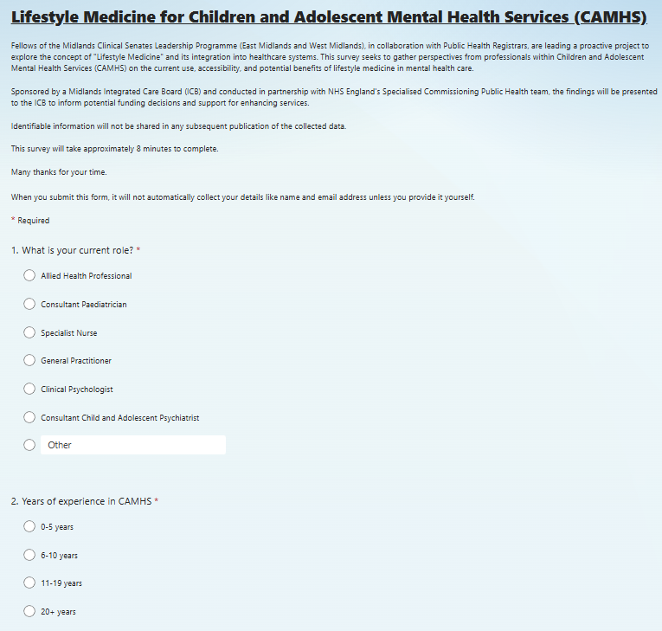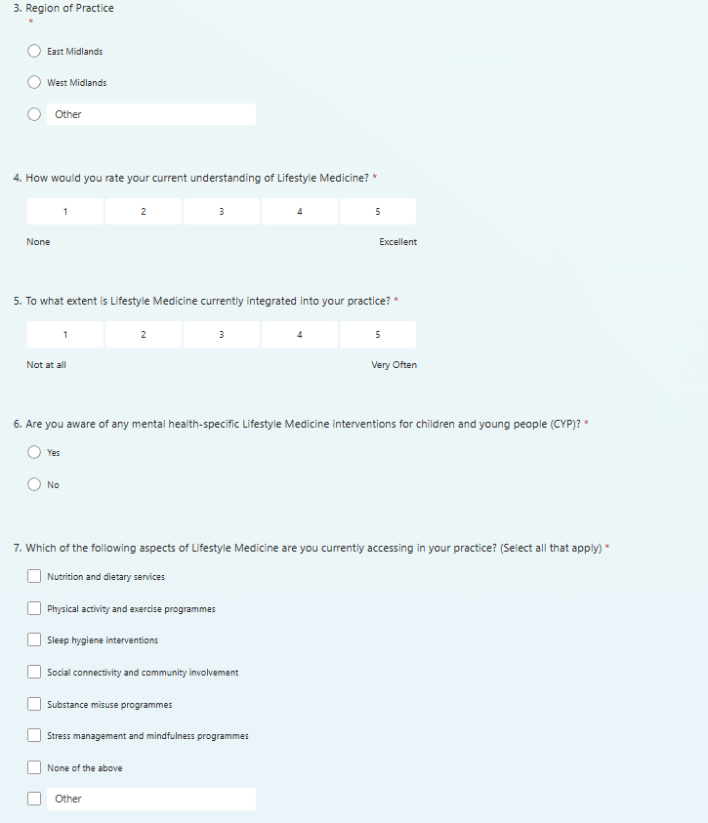
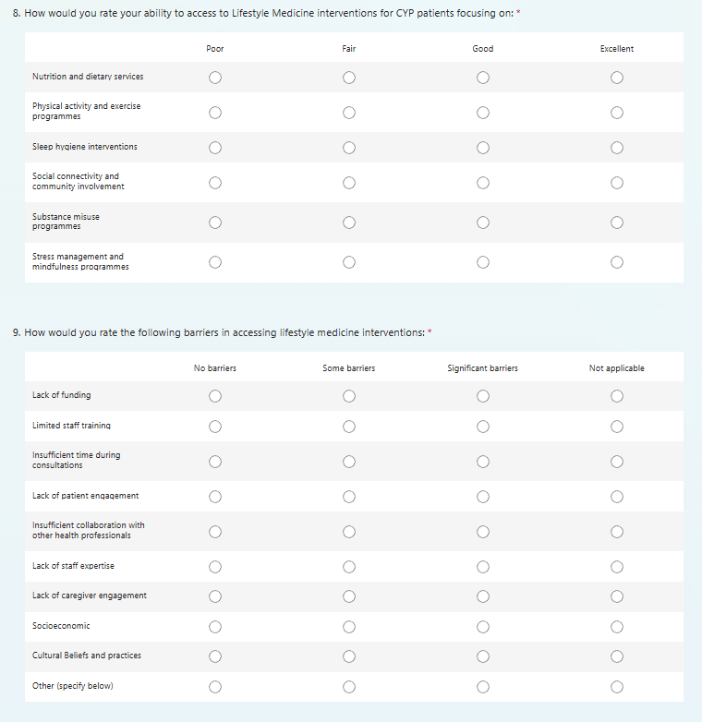
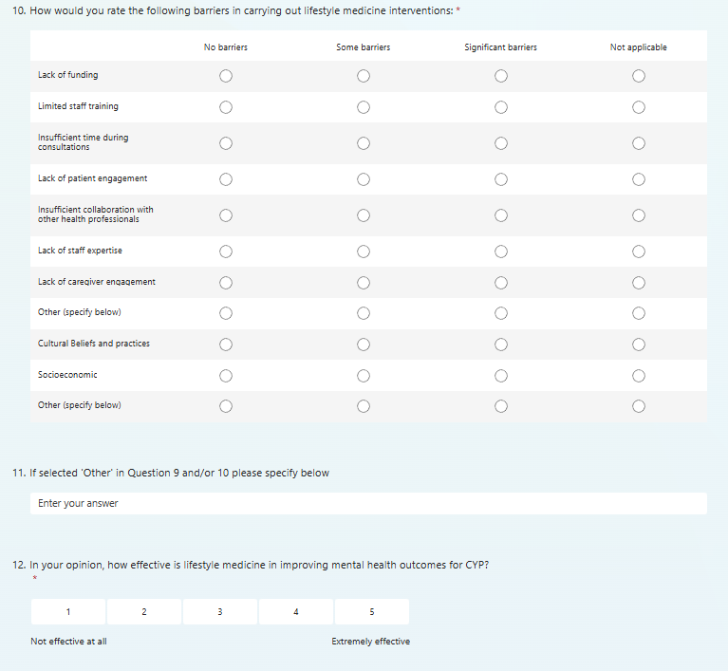
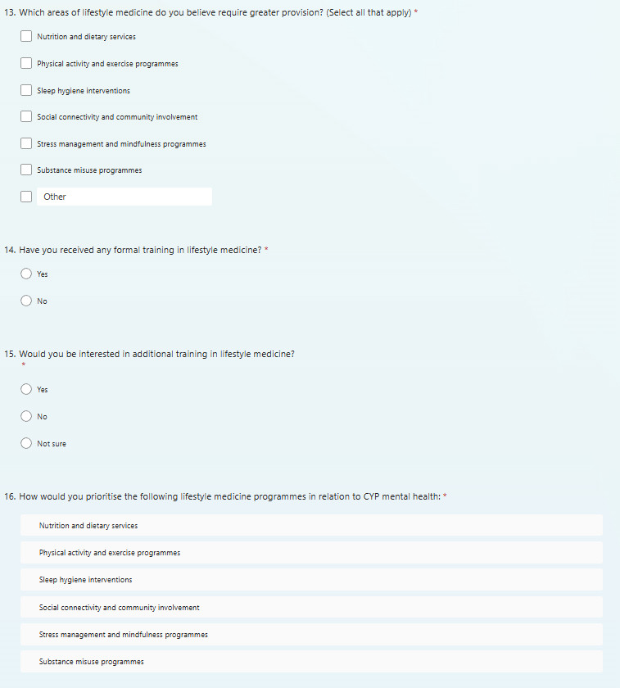
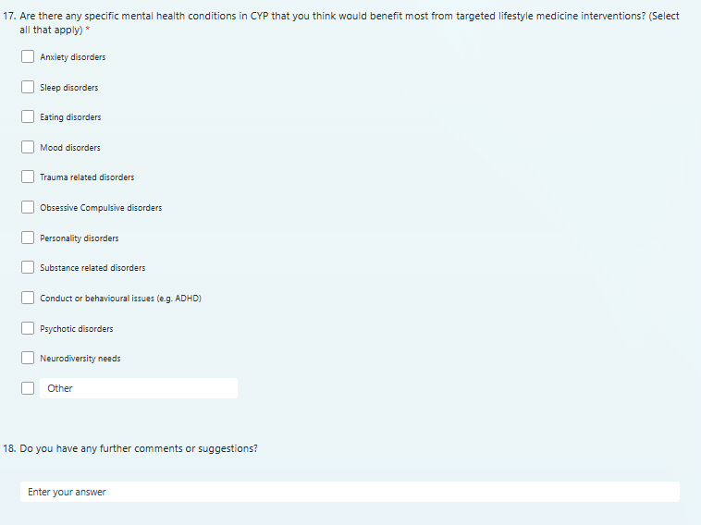

Search Strategy Results
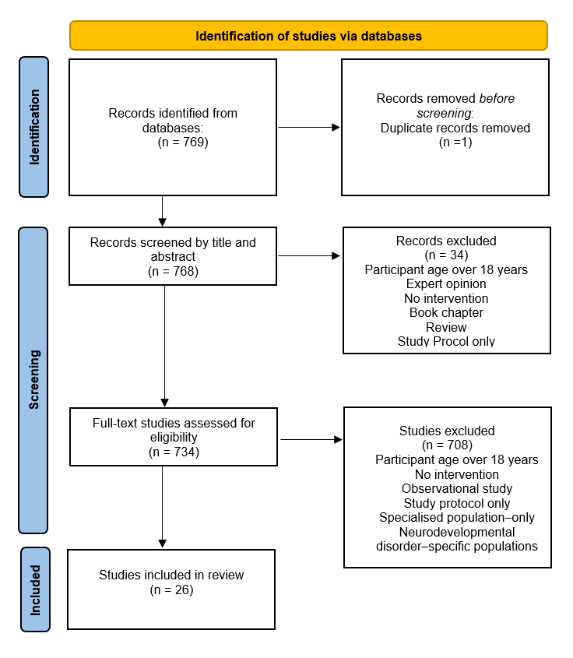
PRISMA flow diagram outlining results of search strategy

