



Multiple Site Single Service models of care: a clinical framework
A guide for senior leaders and commissioners

November 2019

Contents

- Introduction 3

- Developing the Clinical Framework: The Methodology 3

- The Clinical Framework Template 5

- A Case Study 6

Introduction
In the UK and elsewhere, there is concern how society balances the increasing population health challenges and the delivery of timely and equitable access to primary, secondary and tertiary health services. The reconfiguration of a clinical service is one of the significant changes often done to reposition services to meet this new demand. Recently, Clinical Senates are increasingly being asked to advise on reconfiguration of services, which involve the concept of providing clinical services across more than one clinical site or location, often across a regional geography, whilst describing the service as a ‘single clinical team or service’. This emerging model of care is termed ‘multiple site single service’ in this clinical framework. A preliminary assessment of completed Clinical Senate reviews found that more than half of service change proposals included this model of care. Currently, however, there is no guidance available to Clinical Senates on how this model of care could be reviewed, adopted or implemented to inform impartial decision making.
This clinical framework provides guidance for assessing MSSS models of care based on a systematic evidence review and a mixed-method qualitative approach on the definition of MSSS and consistency with experiences of others; clearly defined clinical outcomes; barriers and enablers; and consideration of other models of care.
We hope this clinical framework will be an essential toolkit for NHS senior leaders and commissioners in presenting and considering this type of model of care and other variants.

Developing the Clinical Framework: The Methodology
Public Health England, East Midlands Clinical Senate, and the University of Sheffield collaborated and undertook a systematic review on what constitutes MSSS models of care, established which clinical outcome measures are a “must-do” to ensure thorough assessment of impact on patients when designing these types of models of care and identified key enablers and barriers to implementation of MSSS models of care. The systematic review is available on gov.uk: https://www.gov.uk/government/publications/multi-site-single-service-improving-outcomes-reconfiguring-services
A table-based discussion was held with Clinical Senate Chairs and Heads of Clinical Senates to discuss their understanding and experience of reviewing MSSS models and the guidance or tools used in assessing these types of models.
The discussions enabled the further development of the clinical framework for assessing MSSS models of care. Further engagement was undertaken with East of England, South West, and West Midlands Clinical Senate Councils. Furthermore, the Chief Medical Officer at Manchester University Foundation Trust and the Programme Director at Somerset Clinical Commissioning Group appraised and made useful suggestions on the viability of the clinical framework.
The final version of the MSSS clinical framework has been ratified by the East Midlands Clinical Senate Council.
Figure 1 - Framework describing the different types of Multiple Site, Single Service (MSSS) models of care found in the included studies (from the systematic literature review)

The Clinical Framework Template

Sponsoring organisation/Provider of service:

Description of current model of care:
(Please refer to Figure 1 above)

What is your proposed model of care (future state)? What are the intended clinical benefits?
(Please refer to Figure 1 above)

What are the metrics/outcome measures for this proposed change?
- Measures related to mortality and morbidity (e.g. 30-day mortality, length of stay, rate of adverse events)
- Measures relating to specific service activity (e.g. rate of procedures completed)
- Measures related to patient experience (e.g. ease of access to service, patient satisfaction, confidence in quality and safety of care provided)
- Measures related to staff experience (e.g. staff wellbeing, staff satisfaction, staff feedback)
- Monitoring of demographics of patient cohort (i.e. are patients being treated under new MSSS model of care similar to those treated under the previous system)
- Any other valid measures?

What are the enablers and barriers of this proposed model? Are there other factors to be considered?

(e.g. finance, workforce, governance, quality of care, clinical leadership, informatics, implementation and design, organisational culture and values, communication, systems evaluation and service improvement)

In light of the identified enablers and barriers, how do these impact on the proposed outcomes and model?

(Please provide evidence for impact assessment and analysis e.g. SHAPE tool, DALY or QALY calculations)

A Case Study

This is a case study of a service reconfiguration in Buckinghamshire in 2005 (Better Healthcare in Bucks). The template clinical framework was utilised in assessing this proposed model of care (retrofitted):
https://www.nhsconfed.org/-/media/Confederation/Files/Publications/Documents/better-healthcare-bucks.pdf

- Sponsoring organisation/Provider of service: Buckinghamshire and Oxfordshire Primary Care Trust Cluster and Buckinghamshire Healthcare NHS Trust

- Description of current model of care - Clinical Network +
In 2005, trauma and emergency surgical services were centralised at Stoke Mandeville hospital with Wycombe retaining planned surgery, an Emergency Medical Centre, and specialist cardiac and stroke services. This was followed, in 2009, by Wycombe hospital transferring its paediatric inpatient activity, neonatal care and obstetric-led maternity services to Stoke Mandeville. As a result, both Stoke Mandeville and Wycombe hospitals were running 24/7 emergency services (although trauma was centralised) and general medical acute care, dividing consultants and other senior teams over two sites.

- What is your proposed model of care (future state)? - Clinical Network
Following consultation with clinicians, various stakeholders, and the public, the new model – Better Healthcare in Bucks (BHIB) – settled for a closure of the emergency Medical Centre at Wycombe Hospital and the establishment of a new minor injuries and illness unit to be opened on-site. Transfer of some inpatient medical wards and the creation of a new day unit and step-down ward.

- What are the metrics/outcome measures for this proposed change?
a. Measures related to mortality and morbidity (e.g. 30-day mortality, length of stay, rate of adverse events) – continuity of consultant time can lead to shorter length of stay and reduced mortality rates
b. Measures relating to specific service activity (e.g. rate of procedures completed) – Reduced waiting times for outpatient follow up
c. Measures related to patient experience – Travel times to Hospital, reduced waiting times
d. Measures related to staff experience (e.g. staff wellbeing, staff satisfaction, staff feedback) – Not considered
e. Monitoring of demographics of patient cohort (i.e. are patients being treated under new MSSS model of care similar to those treated under the previous system) – Similar

- What are the enablers and barriers of this proposed model?
Quality of care, Clinical sustainability, Workforce

- In light of the identified enablers and barriers, how do these impact on the proposed outcomes and model?
Proposed model: Quality of care is defined in this model as increased access to consultants and other health providers and a consortium of specialists working together in a defined place with the aim of providing excellent care and improved clinical outcomes for patients.

The impact of travel times: High Wycombe is a 30-minute drive to Stoke Mandeville by patients or health professionals to access either sites. The journey takes more than 30 minutes during the rush hour. In a population of 436,777, of which 17% are 65+, about 37,485 individuals live within a 30-minute drive and would be able to access Wycombe Hospital. However, High Wycombe is a rural dwelling in NHS Buckinghamshire CCG area where only 32.1% have access to a vehicle for a 15-minute hospital journey, while only 31.1% can access public transportation within 30 minutes. It is unlikely the proposed model can represent value for money as many individuals would be disproportionately excluded.
Therefore, balancing the effects of travel times and quality of care is very necessary. Based on the definition of quality of care for this model, it is unlikely various healthcare professionals or patients can attend their appointments on time. However, following consultation, it was agreed that improved and free travel on local bus networks would be provided and the establishment of a countywide community transport hub to provide a central information point for community and voluntary transport. Considering outcomes related to staff experience, as concerns related to travel times, it is therefore essential for the viability of this proposed model of care.
It is also pertinent for the metrics for measuring enablers and barriers to be robust and well-defined in all service reconfiguration activities.

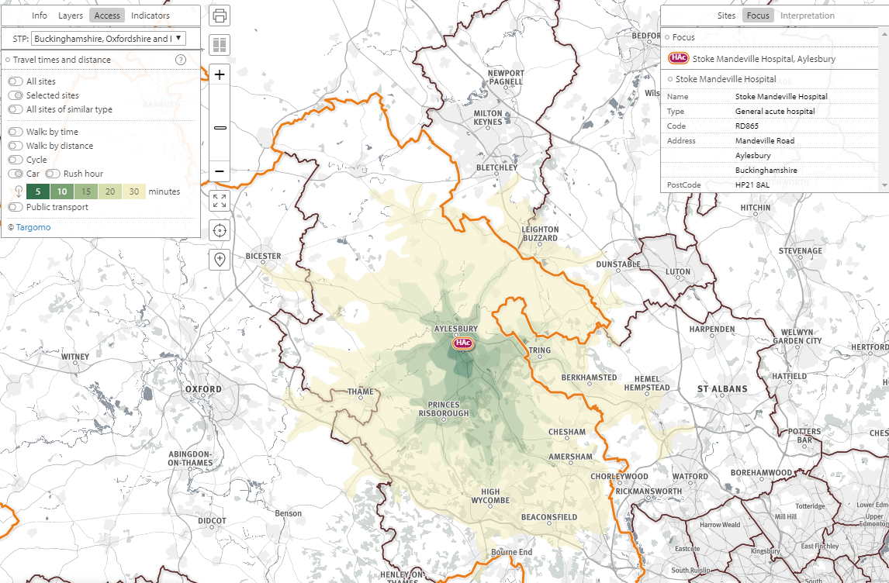
Figure 2: A gradient of travel time to the Stoke Mandeville hospital. High Wycombe is a 30-minute drive to Stoke Mandeville (yellow).

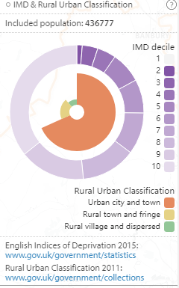
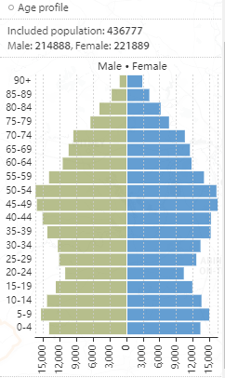
The chart above shows the age and deprivation profile of people who are living within a 30-minute drive to Stoke Mandeville hospital: i.e. all of the people living in the area covered by the green-yellow colours in Figure 2 above.
Strategic Health Asset Planning and Evaluation (SHAPE) is a web enabled, evidence-based application that informs and supports the strategic planning of services and assets across a whole health economy. Its analytical and presentation features can help service commissioners to determine the service configuration that provides the best affordable access to care.

